

School of Computer Sciences

CAT404 – Software Engineering Major Project

System Requirement and Design Document

[NewBGradSupp - New Graduate All in One Platform]

[SE22230008]

[Euphoria]

|  |  |  |  |
| --- | --- | --- | --- |
| Student Name | Matric Number | Subsystem Name | Role |
| Nurul Shafiqa Binti Mohamad Rani | 147022 | Professional Certification and Skill Enhancement | **Team Leader**  Requirements Architect |
| Siti Aisyah binti Sohimi | 148271 | Salary Comparison | Requirements Analyst |
| Siti Fatimah Binti Mohd Za’im | 145731 | What Job Are There? | Quality Assurance Analyst |

[Supervisor: TS. Dr. Mohd Heikal Husin]

[Examiner 1: Dr. Azizul Rahman Mohd. Shariff]

[Examiner 2: Dr. Azleena Mohd Kassim]

**Academic Session**

2022/2023

# Declaration

“We declare that the following is our own work and does not contain any ***unacknowledged*** work from any other sources. This report was undertaken to fulfill the requirements of the Software Engineering Major Project for the Bachelor of Computer Science (Honours) program at Universiti Sains Malaysia”.

Signature : shafiqa

Name : Nurul Shafiqa Binti Mohamad Rani

Date : 8 January 2023

Signature : aisyah

Name : Siti Aisyah binti Sohimi

Date : 8 January 2023

Signature : *fatimah*

Name : Siti Fatimah Binti Mohd Za’im

Date : 8 January 2023

# Abstract

As the number of graduates rises every year, finding suitable jobs for undergraduates is becoming increasingly difficult. They frequently need help in finding jobs that match their skills, determining a wage range for such occupations, locating employers, and determining if the position allows for remote work or hybrid. All these problems can be solved using the NewBGradSupp system which gathers all the information that is needed by the undergraduates. The purpose of this project also to assist the fresh graduates in finding jobs that aligned with their educational background. By using this system, it gives an idea of what skills they need to enhance, the responsibilities they need to take if they applied for the job position. The single most crucial component is of a job hunt is research. They can get a focus and the proper path through research. Research gives a better idea of whether a certain career might be a good fit for them or not. After research has been done, they can narrow down the list of potential career possibilities to start their careers. Hence, they will be able to find their dream job that meets their qualifications. Agile methodology is used during software development in this project. It involves constant collaboration between stakeholders and developers and continuous improvement at every stage. The project will be divided into 5 phases. Each incremental part is developed over an iteration, and iteration is designed to be small and manageable so it can be completed within a few weeks. For each development sprint, it will consist of 2 weeks and once the sprint activities have been completed, no changes are allowed.

*Keywords: undergraduates, career, jobs, educational background*

# Acknowledgements

First and foremost, we would like to express our deep gratitude to the School of Computer Sciences and Universiti Sains Malaysia for allowing us to work on this project for our Final Year Project.

We want to thank our project supervisor, Ts. Dr. Mohd Heikal Husin for helping and monitoring our progress for this project. We appreciate you always correcting us and responding to our inquiries about this project.

We also thank our examiners, Dr. Azizul Rahman Mohd Shariff and Dr. Azleena Mohd Kassim. Having both of you on the panel was a privilege. We appreciate you spending some of your valuable time with us, even though we know how important it is to you.

We are extremely thankful for our course coordinator, Ts. Dr. Mohd Heikal Husin for encouraging and guiding us in completing this Final Year Project.

We want to thank our family and friends for their love, prayers, caring, and moral support for our education and preparation for our great future.

We also want to express sincere gratitude to our team members for their cooperation and for facing the challenges together to complete this project.

Table of Contents

1. Declaration ii

2. Abstract iii

3. Acknowledgements iv

Table of Contents v

List of Figures ix

List of Tables xi

1. Software Project Management Plan (SPMP) 1

1.1 Project background 1

1.2 Organization background 2

1.3 System Overview 3

1.3.1 System Description and Function 3

1.3.2 Software Process Approach 4

1.3.3 Software Life Cycle Model 4

1.3.4 Modeling Notation 5

1.3.5 Coding Standard 8

1.4 Team Structure and Roles 1

1.4.1 Role Assignments 1

1.4.2 Development Responsibilities 2

1.5 Facilities and Computer Resources 3

1.5.1 Computer and other Hardware Resources 3

1.5.2 Software and Operating System Resource Specifications 3

1.6 Project Schedule & Milestones 4

1.6.1 Table 1.05: Hierarchy Chart of Work Division 1

1.6.2 Milestone 1: System Requirement and Design 1

1.6.3. Milestone 2: Progress Review (Prototype development) 3

1.6.4. Milestone 3: Final Presentation (Final development) 4

2. Software Requirements Specifications (SRS) 6

2.1 Background & Related Work 6

2.1.1 Existing Systems & Algorithms/Theories 6

2.1.2 Strengths and Weaknesses of the Existing Systems 9

2.1.3 Problem Summary 10

2.2 Requirements Gathering Techniques 10

2.3 Top Level Representation 1

2.4 External Interfaces Requirements 4

2.4.1 Interface 2

2.5 Internal Interfaces Requirements 4

2.5.1 “What Job Are There?” SE22230008 - Subsystem 01 6

2.5.1.1 Use Case Description Subsystem 1 8

2.5.1.2 System Sequence Diagram Subsystem 1 12

2.5.2 “Salary Expectation” SE22230031 - Subsystem 02 13

2.5.2.1 Use Case Description Subsystem 2 14

2.5.2.2 Sequence diagram Subsystem 2 18

2.5.3 “Professional Certificates and Skills Enhancement” SE22230032 - Subsystem 03 19

2.5.3.1 Use Case Description Subsystem 3 20

2.5.3.2. Sequence diagram Subsystem 3 33

2.6 Non-Functional Requirements 39

2.6.1 Performance Requirement 39

2.6.2 Other Relevant Non-Functional Requirement 40

3. Software Design Description (SDD) 42

3.1 Storyboard 42

3.1.1 Storyboard for SE22230008 - Subsystem 01: What Job are There? 42

3.1.2 Storyboard for SE22230031 - Subsystem 02: Salary Comparison 47

3.1.3 Storyboard for SE22230032 - Subsystem 03: Professional Certification and Skills Enhancement 52

3.2 High Level Design 56

3.2.1 System Architecture 57

4. Software Test Plan 2

4.1 Purpose and scope 2

4.2 Test items 3

4.3 Requirements/Features to be tested 5

4.4 Requirements/Features not to be tested 5

4.5 Test approach/strategy 5

4.6 Item pass/fail criteria 6

4. REFERENCES 8

5. APPENDICES 11

6. Use-Case: Provide Training: Company adds, and edit training details 16

7. Use-Case: Add job offered: Company adds, delete, and update jobs 17

List of Figures

Figure 1.1: System Overview 3

Figure 1.2: Software Process Approach 3

Figure 1.3: Overall system Entity Related Diagram 5

Figure 1.4: GANTT Chart for the overall project schedule 9

Figure 2.01: Overall Use Case Diagram for NewBGradSupp system 18

Figure 2.02: Overall Domain Model Class Diagram for NewBGradSupp system 18

Figure 2.03: Overall System flowchart diagram 19

Figure 2.04: Use-case diagram for “What Job Are There?” subsystem 27

Figure 2.05: Class Domain Diagram for “What Job Are There?” subsystem 27

Figure 2.06: System sequence diagram for “What Job Are There” subsystem 1 31

Figure 2.07: Use-case diagram for “Salary comparison” subsystem 32

Figure 2.08: Class Domain Diagram for “Salary comparison” subsystem 33

Figure 2.09: System sequence diagram for “Salary comparison” subsystem 2 37

Figure 2.10 : Use Case Diagram for Subsystem 3: Professional Certificates and Skills Enhancement 38

Figure 2.11: Domain Class Diagram for Subsystem 3: Professional Certificates and Skills Enhancement 38

Figure 2.12: view list of all training related to the student 52

Figure 2.13: filter training category 53

Figure 2.14: View Training based on chosen category 54

Figure 2.15: Save training as favorite 55

Figure 2.16: view saved training on the dashboard 56

Figure 2.17: company and administrator add training details 57

Figure 2.18: company and administrator add training details 58

Figure 3.1: System Storyboards for Subsystem 1 65

Figure 3.2: System Storyboards for Subsystem 2 67

Figure 3.3: System Storyboards for Subsystem 3 71

Figure 3.4: Network Diagram of NewBGradSupp Architecture 72

Figure 3.5: Design Class Diagram for NewBGradSupp 72

List of Tables

Table 1.01: Coding Standard 6

Table 1.02: Project Team Role Assignments 6

Table 1.03: Computer and other hardware Resources 7

Table 1.05: Hierarchy chart of work division 9

Table 1.06: WBS for Milestone 1 10

Table 1.07: Milestone 1 Task Assignments 11

Table 1.08: WBS for Milestone 2 11

Table 1.10: WBS for Milestone 3 13

Table 1.11: Milestone 3 Task Assignments 14

Table 2.01 : Interface 23

Table 2.02: Internal Interface Requirements 26

Table 2.03: Search for job use case description 29

Table 2.04:View job use case description 31

Table 2.05: Add to favorite use case description 32

Table 2.06: View Salary Comparison use case description 35

Table 2.07: View estimate cost living use case description 36

Table 2.08: View Salary Expectation use case description 37

Table 2.09: View all related training use case description 41

Table 2.10: Filter training use case description 43

Table 2.11: View training recommendation based on weaknesses use case description 45

Table 2.12: View training recommendation based on job suggestion use case description 48

Table 2.13: Save favorite training use case description 50

Table 2.14: View saved training use case description 52

Table 3.1: System Timing Targets 60

Table 3.2: System Performance Goals 61

Table 4.1: List of test items 75

Table 4.2: List of requirements/features to be tested 76

Table 4.3: List of requirements/features not to be tested 80

Table 4.4: Test approach and levels of testing 81

Table 4.5: List of item pass/fail criteria 82

# 1. Software Project Management Plan (SPMP)

## 1.1 Project background

Globally, the issue of graduates having difficulty finding available and suitable job positions has become a hot issue to discuss, including on television, social media, and in the newspaper. Graduates are having problems identifying job positions that align with their qualification and results. Thus, the project named NewBGradSupp is going to be developed to solve the problems that have been addressed. NewBGradSupp is stands for newbie fresh graduates student application. This project is related to Sustainable Development Goal (SDG) number 8 which is Decent Work and Economic Growth.

There are several major problems to be discussed, such as the fact that graduates cannot access job positions in their preferred locations, they do not have information about relevant salaries for job positions they dream of, and they do not acquire the skills and professional certification that meets the requirements of jobs their interesting job positions. With the existing website that provides job opportunities to those looking for a job, it makes the process of finding a job easier. However, for the student who is in the final year and for the fresh graduate who just wants to step into the world of work they need a platform that can help them before applying for the jobs offered.

Therefore, this application is going to solve those problems by providing access to existing jobs based on location and position, providing information on jobs and the relevant salary that is based on their skills and qualifications, and suggesting relevant courses and skills that the user would need for the job positions they are interested in based on their qualifications and results.

**Project Objectives**

1. We aim to produce a good quality student that has a good knowledge of the career possibilities to start their career in the job industry.
2. Help recruiters or businesses ensure they hire the most suitable candidates for given positions.
3. To help graduates identify job positions and plan the best for their job applications by giving wide knowledge about all the jobs that exist in the industry.
4. To solve those problems by providing access to existing jobs based on location and position, providing information on jobs and the relevant salary that is based on their skills and qualifications.
5. To help the students upgrade their skills and knowledge by providing training courses to improve their qualifications before applying for the job.

## Organization background

Universiti Sains Malaysia (USM) is the second university established in 1969. The management of the university is carried out through the executive power of the Board of Directors, made up of members chosen from the university, representatives from government departments and those appointed by the Ministry of Higher Education. The organization's mission is transforming higher education for a sustainable tomorrow. Along with that USM vision is a pioneering, transdisciplinary research-intensive university that empowers future talents and enables the bottom billions to transform their socio-economic well-being. This organization places great emphasis on university graduates to get a place in the field they are studying.

Every year this organization will analyze the status of graduates to ensure that they successfully get a job after completing their studies. In relation to that, the system that will be produced is very much in line with the mission and vision of this organization. Therefore, this system will be owned by Universiti Sains Malaysia. The user of the system will be the student and fresh graduates from USM. This system will be a great system for the organization to give the students and the fresh graduates the first knowledge before entering the working environment. The system will be use by the students when they are entering their final year of studies or even after they have completed their studies. The objective is to provide a prior knowledge among the students. The system will help the student to analyze the job available out there.

## System Overview

### 1.3.1 System Description and Function

This system's main purpose is to provide a platform for graduates to search for available job positions aligning with their qualifications and results. This system consists of three main subsystems: the list of available jobs based on locations, the salary expectation, and the recommendation of professional certificates and skills enhancement.

The first subsystem will collect information on the student's background, such as CGPAs, weaknesses of their skills, and courses taken. This subsystem intends to give the information while the user is identifying available job positions aligned with their qualifications, suitable salary for those positions, location of the potential employers, and whether the jobs provide remote work options. **(Develop by Siti Fatimah Binti Mohd Za’Im)**

The second subsystem shows the comparison and filters the potential salaries that the students may be offered based on their current qualifications. **(Develop by Siti Aisyah Binti Sohimi)**

The last subsystem's purpose is to supply training recommendations to enhance their skills and professional certificates based on their capabilities or weaknesses of their skills. **(Develop by Nurul Shafiqa Binti Mohamad Rani)**

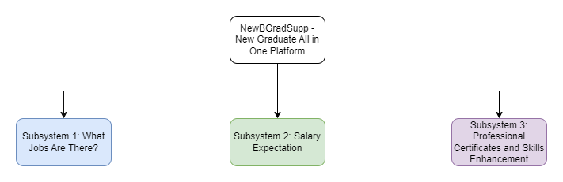

Figure 1.1: System Overview

### Software Process Approach

As discussed, the software process approach that will be use is agile methodologies. This software process approach is suitable since we are going to break the whole system into a subsystem which is going to be smaller and manageable. Besides, agile methodologies improve the productivity in term of task distribute since it has several stages such as planning, design, development, implementation, and evaluation.

By using agile methodologies, we ensure that it help in creating high-quality software in the estimate time.

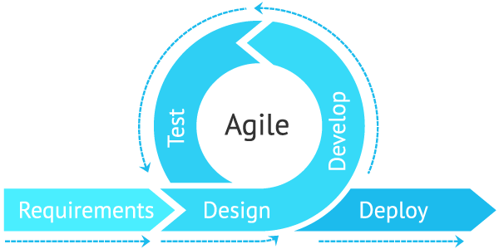

Figure 1.2: Software Process Approach

### Software Life Cycle Model

This model breaks down the project into small incremental builds and these builds provided into iterations. In this agile SDLC development process, the client is able to see the result and understand whether they are satisfied with it or not. For each iteration of agile, there will be a cross-functional teams that working on various phases, requirement gathering and analysis, design the requirements, the iteration, deployment, testing and feedback. Before starting the project, product owner will discuss the key requirements with the client to outline them including what features will be supported and the proposed end results. Once the concept is outlined, the team members are created, funding is put in place and basic environments are discussed. The software development team works to deliver the working software and the system will perform quality assurance (QA) testing before it will release to the client.

### Modeling Notation

The modeling notation used in this project is E-R Diagrams and UML. First, an entity relationship diagram (ERD), often called an entity-relationship model, is a visual depiction of the relationships between individuals, things, locations, ideas, or events in an information technology (IT) system (Biscobing, J, 2019). A relational database's base is built on data modeling techniques used in an ERD, which can help define business processes. In this project, the ERD diagram will give an overview of the relationship between multiple entities and their attributes, such as student, job, administrator, office admin, salary, training, and company. There's a link that links the entities with the relationship. Below is the ERD of the overall NewBGradSupp system.

1. A student can view many jobs, meanwhile the job can be matched with by multiple students’ data. Since it is a many-to-many relationship, there is a bridge entity named JOB_SUGGESTION.
2. A student can view many trainings, meanwhile a training can be viewed by multiple students. Since it is a many-to-many relationship, there is a bridge entity named STUDENT_TRAINING.
3. A student can view multiple cost living, and multiple cost living can be viewed by one student.
4. A student can view multiple salary expectations, and multiple salary expectations can be viewed by one student.
5. One company can manage multiple salary expectations, and multiple salary expectations can be managed by one company.
6. A company can estimate multiple cost living, multiple cost living can be estimated by one company.
7. One job suggestion is match with multiple salary comparison; multiple salary comparison is compared with one job.
8. An administrator can handle zero or many students, a student can be handled by an administrator.
9. An administrator can handle zero or many trainings, a can be handled by an administrator.
10. An administrator can handle zero or many companies, a company can be handled by an administrator.
11. An office admin can handle one or many students, a student can be handled by an office admin.
12. An office admin can manage one or many companies, a company can be handled by an office admin.

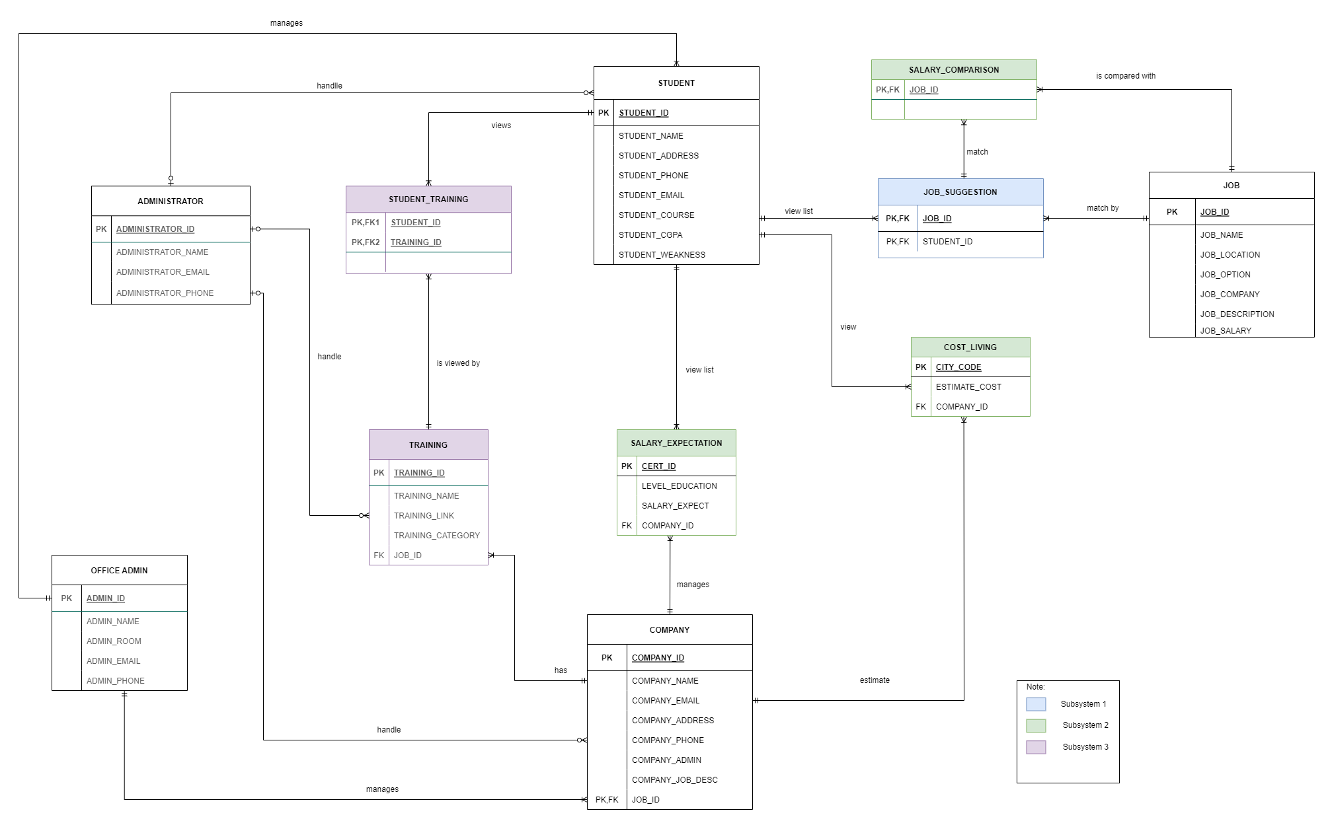

Figure 1.3: Overall system Entity Related Diagram

The other modelling notation used in this project is the UML notation. The basic objective of UML is to specify a common method for visualizing a system’s design process. To depict a system’s behaviors and structure, we utilize UML diagrams. Modeling, design, and analysis are made easier by UML for software engineers, business owners, and system architects to understand how a system works. UML is important since multiple teams must collaborate and plan for complex applications, therefore they need a clear channel of communication to do so (GeeksforGeeks, 2022). Another importance of UML is teams that can view processes, user interactions, and the static structure of the system ultimately save a lot of time. UML can be classified into two categories which are structural diagrams and behavior diagrams. For the structural diagram, this project uses class diagram meanwhile the behavior diagrams, the use case diagram, and sequence diagram are used (GeeksforGeeks, 2022).

### Coding Standard

Table 1.01: Coding Standard

|  |  |
| --- | --- |
| Programming Language | HTML, CSS, PHP, JavaScript, Bootstrap, SQL |
| Database | PhpMyAdmin |
| Development Environment | Virtual studios, PhpMyAdmin, GitHub |

## Team Structure and Roles

### Role Assignments

Each team member is automatically a developer, and one must be a Team Leader. The following additional roles must be assigned: Requirements Analyst, Architect, Quality Assurance Analyst.

Table 1.02: Project Team Role Assignments

|  |  |
| --- | --- |
| **Role** | **Team Member** |
| Project Leader/ Architect | Nurul Shafiqa Binti Mohamad Rani |
| Requirements Analyst | Siti Aisyah Binti Sohimi |
| Quality Assurance Analyst | Siti Fatimah Binti Mohd Za’Im |

### Development Responsibilities

The following team members have been assigned to the given subsystems for the project.

Table 1.03: Subsystem Development Responsibilities

|  |  |  |
| --- | --- | --- |
| Subsystem | Section | Team Member |
| SE22230008 - Subsystem 1  [What Job Are There?] | 2.5.1 What Job Are There? - Subsystem 1  2.5.1.1 Use Case Description  2.5.1.2 System Sequence Diagram  3.1.1 Story Board Subsystem 1 | Siti Fatimah Binti Mohd Za’Im |
| SE22230031 - Subsystem 2  [Salary Expectation] | 2.5.2 Salary Expectation - Subsystem 2  2.5.2.1 Use Case Description  2.5.2.2 System Sequence Diagram  3.1.2 Story Board Subsystem 2 | Siti Aisyah Binti Sohimi |
| SE22230032 - Subsystem 3  [Professional Certification and Skill Enhancement] | 2.5.3 Professional Certification and Skill Enhancement - Subsystem 3  2.5.3.1 Use Case Description  2.5.3.2 System Sequence Diagram  3.1.3 Story Board Subsystem 3 | Nurul Shafiqa Binti Mohamad Rani |

## Facilities and Computer Resources

### Computer and other Hardware Resources

Table 1.04: Computer and other hardware Resources

|  |  |
| --- | --- |
| Laptop Manufacturer | Lenovo |
| Model | LENOVO ideapad 330 |
| Version | 64bit |
| Processor | AMD A6-9225 RADEON R4, 5 COMPUTE CORES  2C+3G 2.60 GHz |
| RAM | 4.00 GB |
| Operating System | Window 10 |

|  |  |
| --- | --- |
| Laptop Manufacturer | Asus |
| Model | ASUS Laptop 14 A416 |
| Version | 64bit |
| Processor | Intel(R) Core (TM) i3-8145U CPU @ 2.10GHz 2.30 GHz |
| RAM | 8.00 GB |
| Operating System | Window 10 |

|  |  |
| --- | --- |
| Laptop Manufacturer | Acer Inc. |
| Model | Swift 3 |
| Version | 64bit |
| Processor | 11th Gen Intel(R) Core (TM) i5-1135G7 |
| RAM | 8GB |
| Operating System | Window 10 |

### 1.5.2 Software and Operating System Resource Specifications

The operating system used is Microsoft Windows, which is Windows 10, and the development tools used are Visual Studio Code editor v1.60.2 and XAMPP v3.3.0. The documentation support tool used is the GitHub website for all members to collaborate and gather all files of the projects.

## Project Schedule & Milestones

The overall project duration starts from October 2022 and ends in June 2023. Figure below shows the Gantt Chart of the project.

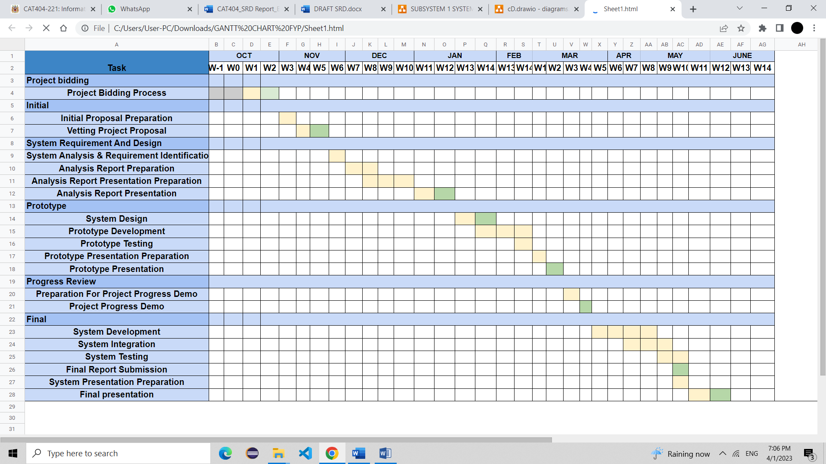Figure 1.4: GANTT Chart for the overall project schedule

### Table 1.05: Hierarchy Chart of Work Division

Hierarchy chart of work division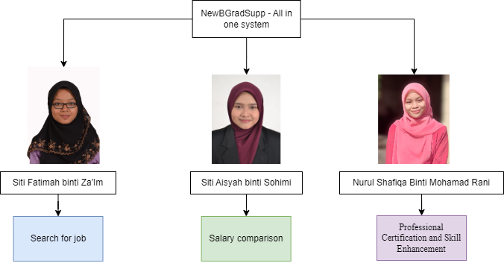

### Milestone 1: System Requirement and Design

Table 1.06: WBS for Milestone 1

|  |  |  |
| --- | --- | --- |
| **Activity** | **Task ID** | **Duration(days)** |
| 1. **Project Planning** |  |  |
| 1. Develop WBS and build schedule and then plan the work. | M1-1 | 1 |
| 1. **Analysis Task** |  |  |
| 1. Conduct meeting with supervisor | M1-2 | 1 |
| 1. Conduct meeting with other team members | M1-2 | 1 |
| 1. Gather and analyze detailed information from resources. | M1-2 | 1 |
| 1. Review and analyze existing system. | M1-2 | 1 |
| 1. Define and prioritize requirements. | M1-2 | 1 |
| 1. Analyze and model new system using UML diagrams. | M1-2 | 1 |
| 1. **Design Task** |  |  |
| 1. Design system architecture and its environment (high-level) | M1-3 | 1 |
| 1. Design low-level details of system design | M1-3 | 1 |
| 1. Design database scheme. | M1-3 | 2 |
| 1. Design screen layouts and cross links for web-browser. | M1-3 | 2 |
| 1. Identify program classes and methods. | M1-3 | 2 |
| Note: the five use cases that will be developed during this iteration are:     1. Show List of Job 2. Show Salary Comparison 3. Show Training 4. Create Personal Account 5. Verify Personal Account |  |  |

The following team members are responsible for the following tasks in Milestone 1:

Table 1.07: Milestone 1 Task Assignments

|  |  |  |
| --- | --- | --- |
| **Task ID #** | **Responsibility** | **Remarks** |
| M1-1 | All | Project Leader to coordinate individual tasks |
| M1-2 | All | Each team members analyze and identify the requirements for each subsystem |
| M1-3 | All | Each team member creates subsystem component design |

### 1.6.3. Milestone 2: Progress Review (Prototype development)

Table 1.08: WBS for Milestone 2

|  |  |  |
| --- | --- | --- |
| **Task** | **Task ID** | **Duration(days)** |
| 1. **Project Planning** | | |
| 1. Develop WBS and build schedule and then plan the work. | M2-1 | 1 |
| 1. **Analysis Task** |  |  |
| 1. Conduct meeting with supervisor | M2-2 | 1 |
| 1. Conduct meeting with other team members | M2-2 | 1 |
| 1. Gather and analyze detailed information from resources. | M2-2 | 1 |
| 1. Review and analyze existing system. | M2-2 | 1 |
| 1. Define and prioritize requirements. | M2-2 | 1 |
| 1. Analyze and model new system using UML diagrams. | M2-2 | 2 |
| 1. **Design Task** | | |
| 1. Design system architecture and its environment (high-level) | M2-3 | 2 |
| 1. Design low-level details of system design | M2-3 | 2 |
| 1. Design database scheme. | M2-3 | 2 |
| 1. Design screen layouts and cross links for web-browser. | M2-3 | 2 |
| 1. Identify program classes and methods. | M2-3 | 1 |
| 1. **Build Task** |  |  |
| 1. Build required databases. | M2-4 | 7 |
| 1. Write program code GUI for web-browser. | M2-4 | 28 |
| 1. Build test data. | M2-4 | 3 |
| 1. Perform unit test. | M2-4 | 3 |
| 1. Perform integration test. | M2-4 | 3 |
| 1. Perform system and acceptance test. | M2-4 | 3 |
| Note: During this iteration all the main function will be develop according to the subsystem. |  |  |

The following team members are responsible for the following tasks in Milestone 2:

Table 1.09: Milestone 2 Task Assignments

|  |  |  |
| --- | --- | --- |
| Task ID # | Responsibility | Remarks |
| M2-1 | All | Project Leader to coordinate individual tasks |
| M2-2 | All | Each team members analyze and identify the requirements for each subsystem |
| M2-3 | All | All members are involved in designing the system as a whole and each subsystem accordingly. |
| M2-4 | All | Each team member is involved in programming the code and involved in the testing level. |

### 1.6.4. Milestone 3: Final Presentation (Final development)

The following team members are responsible for the following tasks in Milestone 3:

Table 1.10: WBS for Milestone 3

|  |  |  |
| --- | --- | --- |
| **Task** | **Task ID** | **Duration(days)** |
| * + - 1. **Project Planning** | | |
| 1. Develop WBS and build schedule and then plan the work. | M3-1 | 1 |
| * + - 1. **Analysis Task** | | |
| 1. Conduct meeting with supervisor | M3-2 | 2 |
| 1. Conduct meeting with other team members | M3-2 | 1 |
| 1. Gather and analyze detailed information from resources. | M3-2 | 2 |
| 1. Review and analyze existing system. | M3-2 | 2 |
| 1. Define and prioritize requirements. | M3-2 | 1 |
| 1. Analyze and model new system using UML diagrams. | M3-2 | 1 |
| * + - 1. **Design Task** | | |
| 1. Design system architecture and its environment (high-level) | M3-3 | 1 |
| 1. Design low-level details of system design | M3-3 | 1 |
| 1. Design database scheme. | M3-3 | 1 |
| 1. Design screen layouts and cross links for web-browser. | M3-3 | 2 |
| 1. Identify program classes and methods. | M3-3 | 1 |
| * + - 1. **Build Task** | | |
| 1. Build required databases. | M3-4 | 1 |
| 1. Write program code GUI for mobile application. | M3-4 | 3 |
| 1. Write program code GUI for web-browser. | M3-4 | 3 |
| 1. Build test data. | M3-4 | 2 |
| 1. Perform unit test. | M3-4 | 2 |
| 1. Perform integration test. | M3-4 | 2 |
| 1. Perform system and acceptance test. | M3-4 | 2 |
| Note: the five use cases that will be developed during this iteration are:  Save list of matching job based on user details into database  Display the estimation cost of living in selected city  Display favourite training into dashboard  Provide feedback  Reply feedback |  |  |

Table 1.11: Milestone 3 Task Assignments

|  |  |  |
| --- | --- | --- |
| Task ID # | Responsibility | Remarks |
| M3-1 | All | Each team member performs unit testing before delivering the final product to the customers. |
| M3-2 | All | Each team member performs integration testing to make sure all subsystem works properly according to the user requirements. |
| M3-3 | All | Prepared the documentation for user guide. |

# 2. Software Requirements Specifications (SRS)

## 2.1 Background & Related Work

### 2.1.1 Existing Systems & Algorithms/Theories

To develop this system, there are a few existing systems that are used as the references, such as:

1. Payscale website (<https://www.payscale.com/research/US/Certification>)

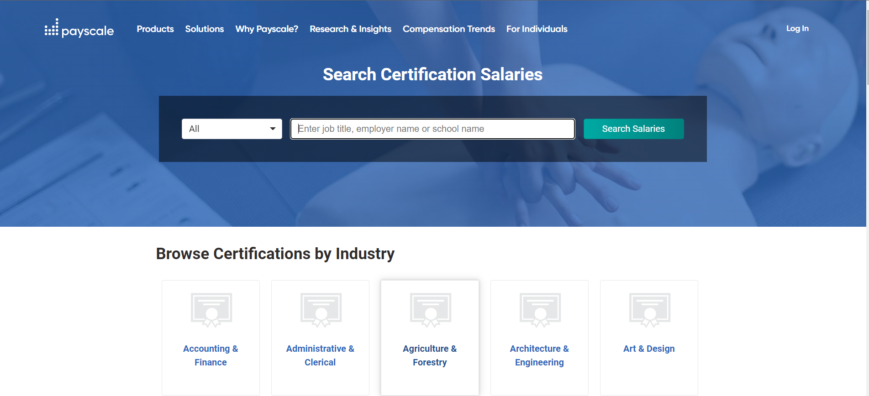

Figure 1.: Payscale website

The founders of this website are Joe Giordano and John Gaffney, and it was launched on January 1, 2002. Payscale was created to make it easier for individuals and organizations to find reliable, up-to-date information about wage trends in the labour market. Payscale website helps to give a clear overview of NewBGradSupp system since it must provide the salaries of the job positions for the students or fresh graduates to make a comparison. The feature of Payscale is to provide the average payment for a particular job position in a particular location. It also comes up with the job details such as job description, and tasks for that job. The skills needed for the job and the kind of skills that affected the salary are also included.

1. Level. fyi website (<https://www.levels.fyi/?compare=Google,Facebook,Microsoft&track=Software%20Engineer>)

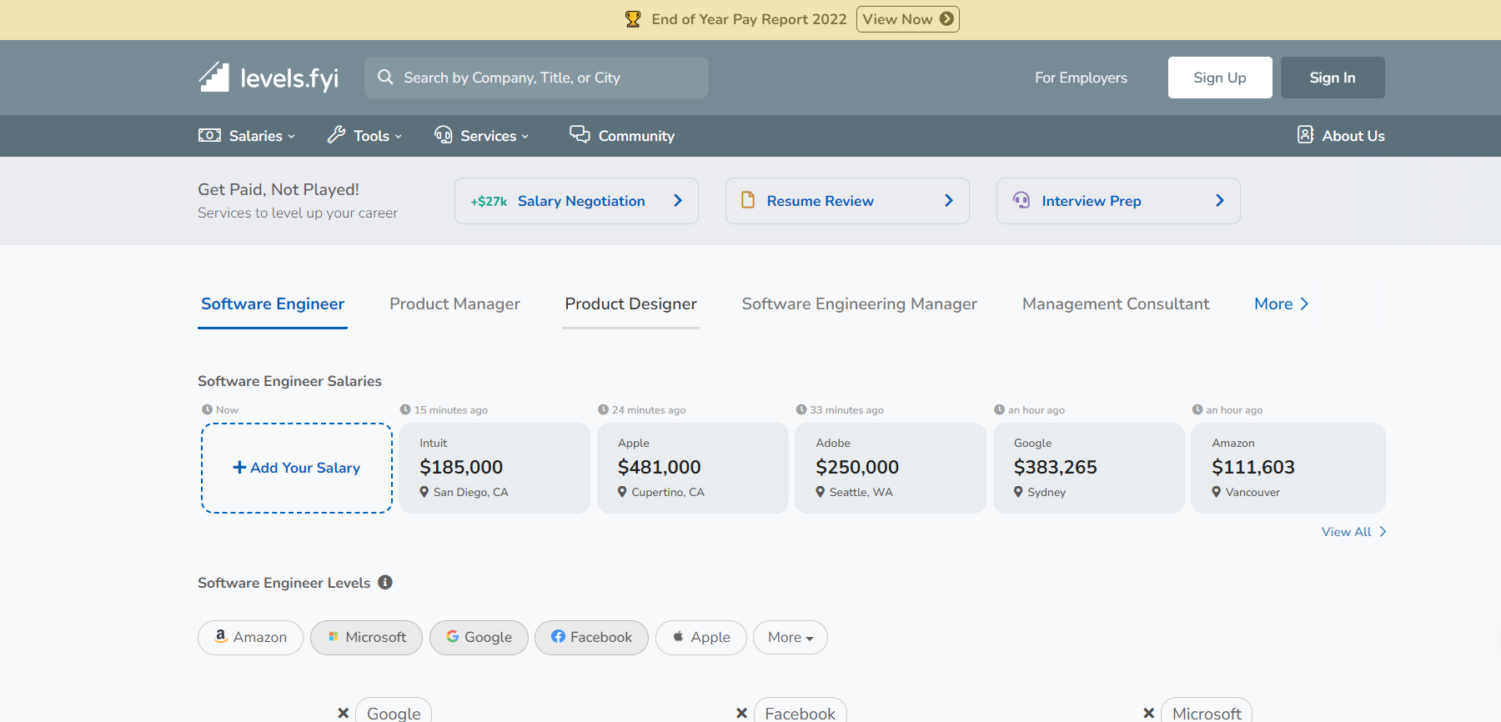

Figure 1.: levels.fyi website

In 2017, Zuhayeer Musa and his colleague Zaheer Mohiuddin launched Levels.fyi. This website compares the salary from many companies and different levels for a particular job position. Levels. fyi is the only source of pay information that offers a thorough breakdown by level, location, talents, firm size, region, and more.

1. Fishcate website (<https://fishcate.com/jobs/> )

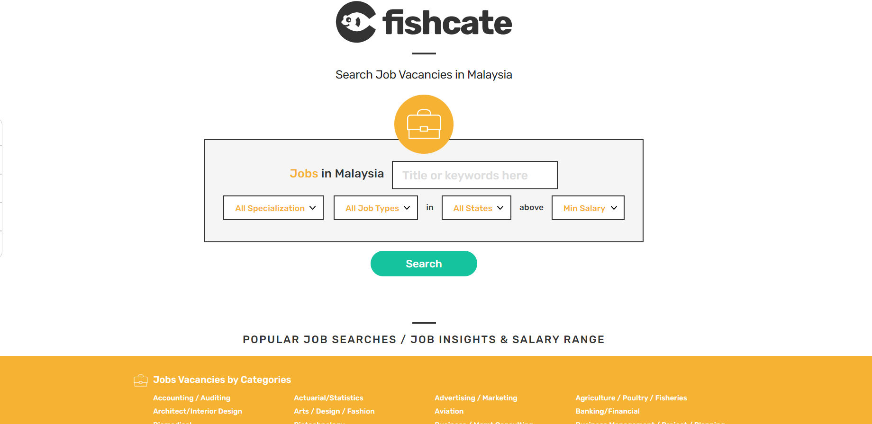

Figure 1.: Fishcate website

This website is providing the job details based on location and job positions in Malaysia. It gives the list of available job positions based on job types, job levels, and minimum salary.

**Algorithms/Theories**

In the big data era, the technique used for the recommendation system is machine learning. A few algorithms under machine learning are Random Forests and Decision Trees. First, a random forest, also known as a random choice forest, is an ensemble learning technique for classification, regression, and other tasks. It operates by building many choice trees during the learning process and then displaying the elegance of the classes (category) or implied predictions (regression) of the character trees. Next, Decision trees divide the information set into suitable values in machine learning until a tree structure appears. Recursive partitioning is the term used to describe this method. The decision tree method tries to identify the single best strategy to divide the data into portions that are as homogenous as feasible.

### 2.1.2 Strengths and Weaknesses of the Existing Systems

There is no denying the existence of systems or applications to find work already exist and even there are many out there, yet it has their own strengths and weaknesses. One of the strengths that job vacancies provided on the website (PayScale, fishcate etc.) are they can reach all over the world. It does not have limitation on the location. This can provide more chances to the applicant who did not have a problem with the work location based.

Besides, employee/Company can post a job gives existing employees a chance to express interest in a position that may not have been previously known. Posting jobs publicly may be cheaper and faster in many cases than paying to headhunt. Thus, it is beneficial to the company to cut their costs. Most job posts – and replies – appear in real-time. This can help either increase the efforts to attract more candidates, a different set of candidates (early- instead of mid-career professionals, for example) or even stop candidates from applying if you’ve already found the right person for the job.

However, the high volume of applicants from the website may result in many candidates to review. Thus, the company/employee might need more time to review the applicant one-by-one. This could be the weakness of the existing system. Posting a high volume of job applicants doesn't guarantee the applicants will have the necessary qualifications. It is a disadvantage for employees who are looking for applicants that meet their requirement only.

### 2.1.3 Problem Summary

Currently, there are a few available websites that provide the same purpose as NewBGradSupp, which helps fresh graduates in finding a suitable job that matches their qualifications. For example, levels.fyi, fishcate, numbeo.com and etc. This might be burdensome to student since there are so many website that they need to visit in order to complete their research. NewBGradSupp mainly focused on providing prior knowledge to undergraduate students before entering working environments. It doesn't matter if fresh graduates have a specific salary requirement or not, it might be helpful to learn about average compensation for the jobs if they intend to apply for it. Besides, a study has found that salary is an important factor when job seekers make job choices because the main purpose of working is to earn a salary to meet personal needs. This system will help them to see the relevant salary they will get for specific jobs in different locations. This website called as ‘all in one platform’ provide job suggestions and trainings to the students while also providing student awareness on the estimation cost of living in certain city based on location they chose. This might help students in making decisions when they want to pursue the job if there are many option for them to choose whether remote, hybrid or onsite. This website also able to layout the training available that helps them improve their weaknesses of their skills and enhance their skills and knowledge.

## 2.2 Requirements Gathering Techniques

The main objective of requirement gathering techniques is to help the requirement engineers to identify the requirement and stakeholders' knowledge. For the NewBGradSupp system, we use a survey technique to gather the requirements. The survey questionnaire collects the stakeholders' complete and exact information about their preferences. We provided multiple-choice questions for the stakeholders to answer for our survey, and we got 17 respondents.

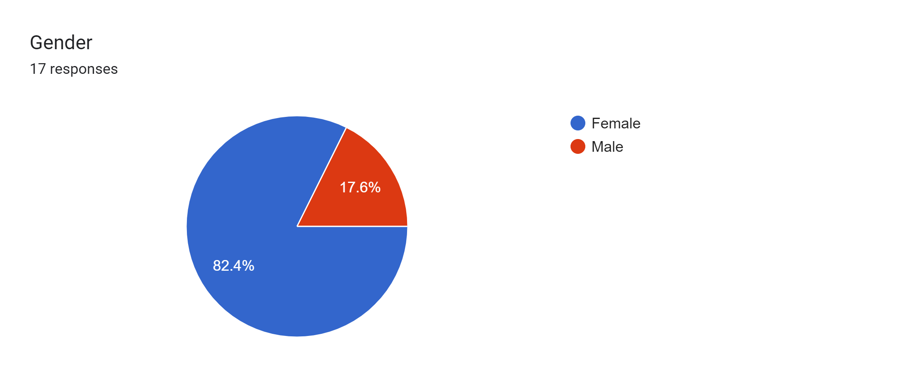

Figure 1.8: Questionnaire result

The questions asked in the study are about the users' preferences about the job recommendation system and their experiences using other techniques with the same feature as our system. Most of the respondents are degree students, and only half of them have experienced searching for a first job. Based on the survey, a few respondents need help understanding their career aspirations before hunting for a job. Therefore, all the respondents agreed that knowing job details is important before pursuing a specific job.

They also agree that this recommendation system is a good platform for students or fresh graduates to search for or move in to get their first job. They think the job scope is the most important criterion in reviewing a job. They also believed that qualification is the most challenging thing in finding a job among fresh graduates. Therefore, they agree that the enhancement of skills and abilities of new graduates before they apply for the job is a crucial step. They also agree that getting information about training or professional certificates online is helpful for students to improve their results. All respondents are concerned about the estimated cost of living in the specific area, and the working environment also affects their career decisions.

## 2.3 Top Level Representation

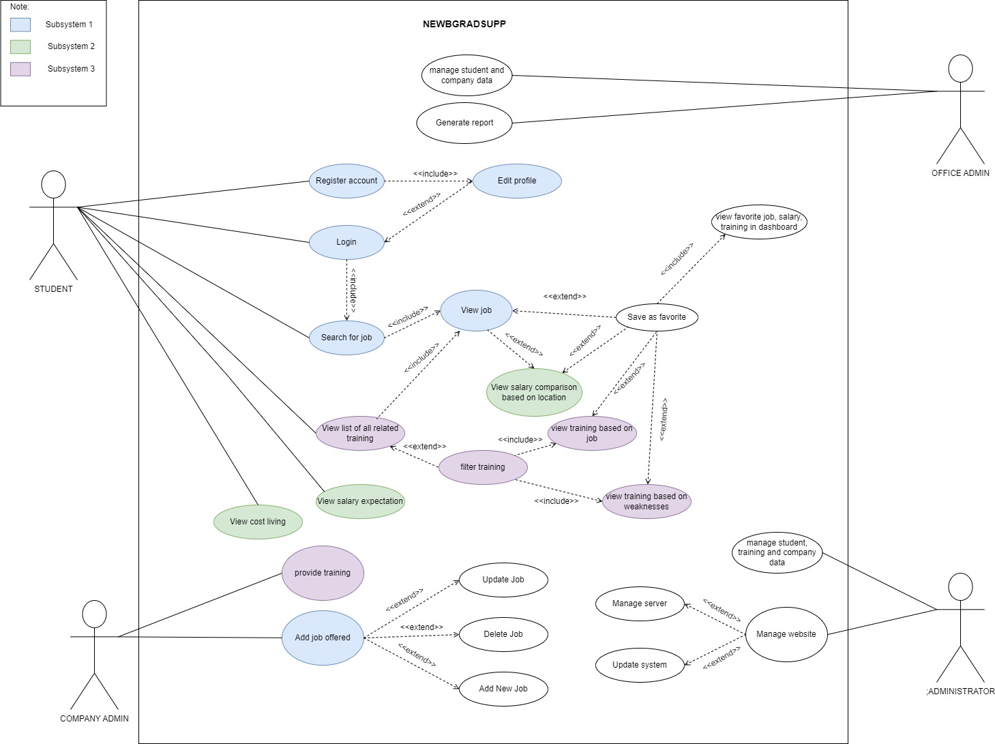

Figure 2.01: Overall Use Case Diagram for NewBGradSupp system

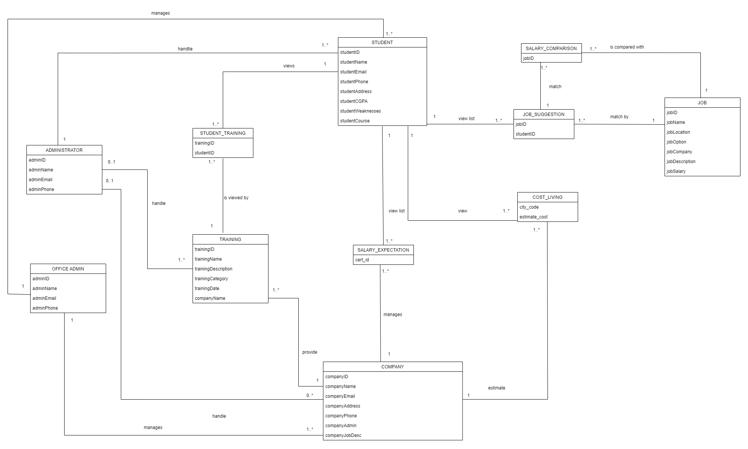

Figure 2.02: Overall Domain Model Class Diagram for NewBGradSupp system

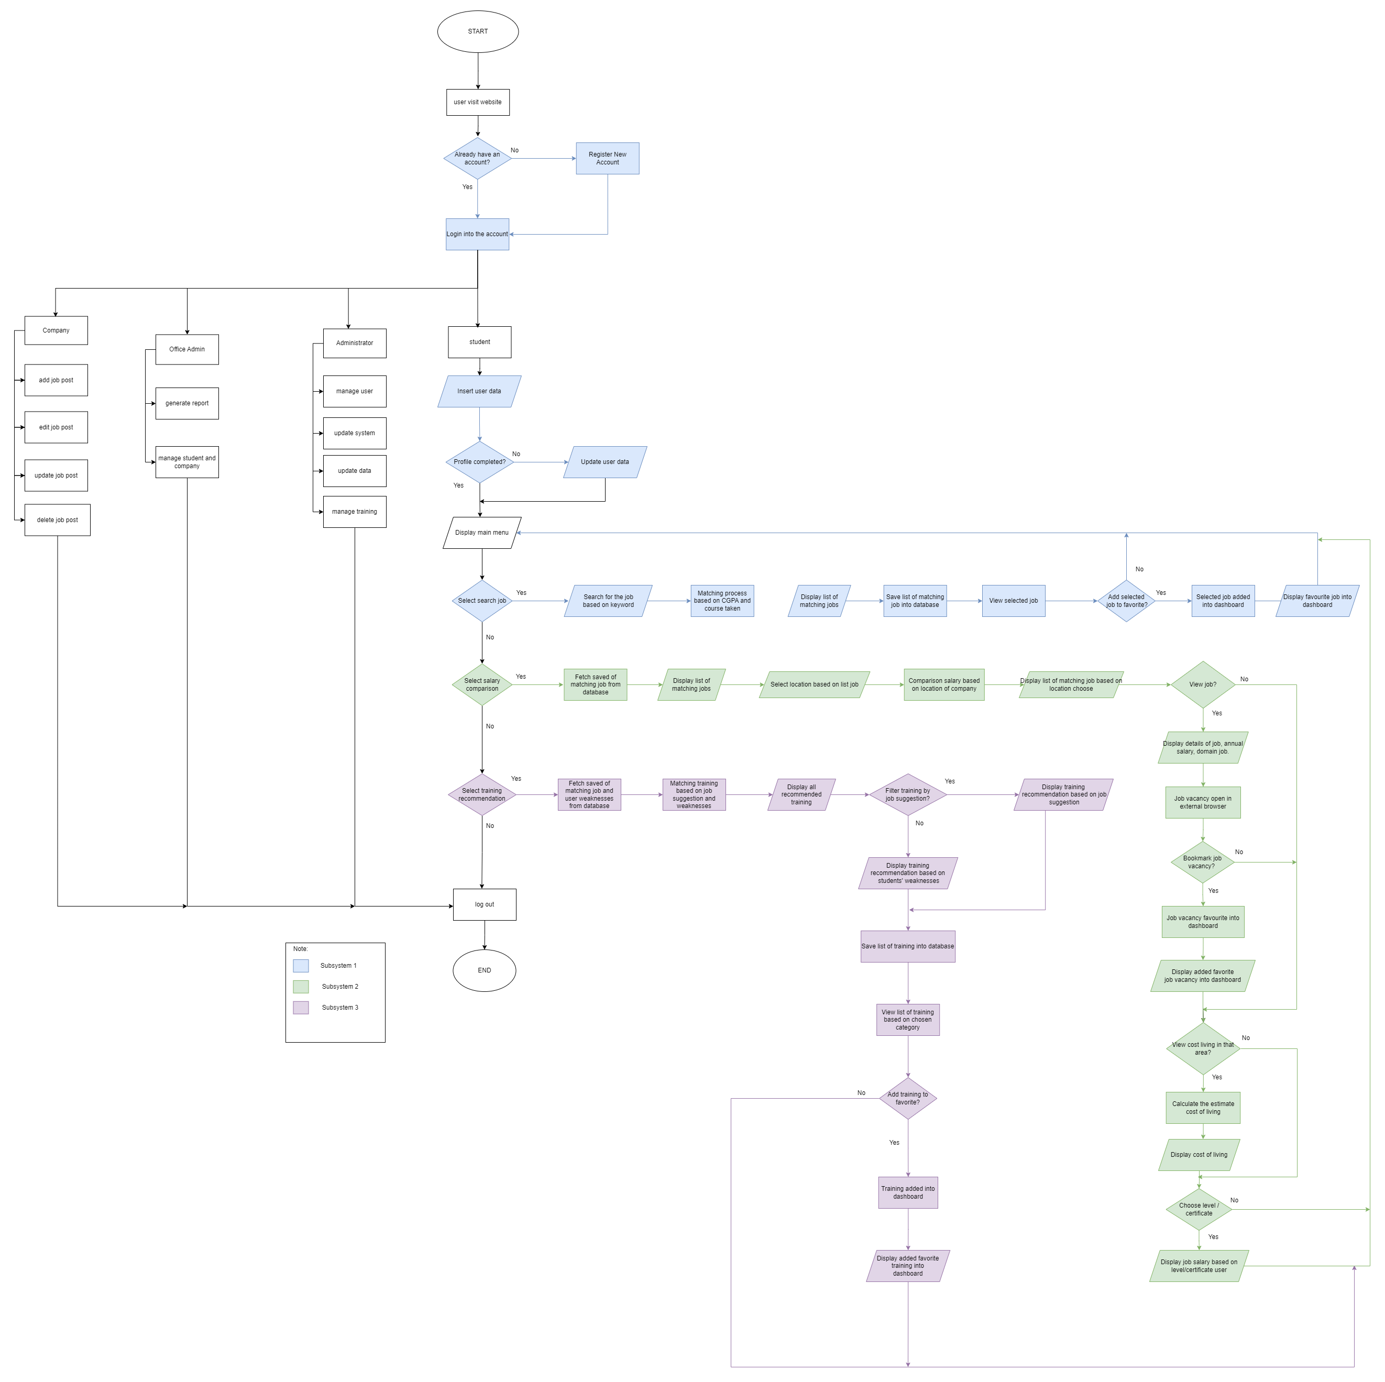

Figure 2.03: Overall System flowchart diagram

## 2.4 External Interfaces Requirements

The external interfaces requirements include the user interfaces, hardware interfaces, software interfaces, and communications interfaces of NewBGradSupp system.

**System User Interfaces**

NewBGradSupp system user interface has a simple and user-friendly design for the students or fresh graduates to access this system. They will save time exploring and learning how to use this system since it provides a straightforward user interface. In addition, this system uses simple and easy-to-understand instructions so that they can directly use this system’s functions, for example, search for a job, view salary comparisons, and view training recommendations. If the plan requires the users to log in or sign up, it will directly prompt the user to do so. Also, there’s a simple button for the user to click if they want to sign in or sign up. This system also provides a dashboard once they create their account to ease the user to track what they browse in this system briefly. For example, the user can view the job positions that suit their qualification, the training recommendation, and their saved or favorites jobs and training within the dashboard. The buttons in the sidebar have also been designed on every page in this system to make the users comfortable using this system. Therefore, the users do not need to go to the main page to use the buttons. Next, the screen layout design is consistent. For example, the sidebar will remain on the left of the screen on every page included in this system. The function on the screen is displayed when users access it.

1. **User interface of SE22230008 - Subsystem 1: What Job Are There? (By Siti Fatimah)**

The system user interface for this project focuses on simpler and user-friendly design. This subsystem also follows the same concept where we want to make the system more easily to be accessible. In Subsystem 1, the student directly introduces the search bar for the job searching process. Along with that the filter option allows the student to navigate which area should be covered in their job suggestion. This filter feature is optional for the student to use, and it is not compulsory. By entering the keyword in the search bar, they can easily view the job suggestion. The job suggestion will be displayed horizontally to make it easier for the user to scroll down the listing. Other than that, user also allow to click on the Job title which is bind with the hyperlink to navigate to the short job description. Users are also given the choice to visit the job site or ignore it. Besides, the add to favorite button will make it easier for the student to keep track of the job that they are interested in applying for. This adds to favorite button will also act as a bookmark. A straight-forward interface will be reducing the time spend on the website which makes the student perform the purpose of using the system.

1. **User interface of SE22230031 - Subsystem 2: Salary comparison (By Siti Aisyah)**

The students of fresh graduates can view the salary comparison based on the location they chose to see. Students can choose the location they want to view from the list of job suggestions available and the system will filter the location and provide a comparison of salary from each company listed for that location. The system is also accompanied with information sharing which is the estimated cost of living. This will provide students with living expenses if they want to pursue their career in that certain area. Other than that, since some of the students might want to pursue their study to a higher level, they might wonder about the salary that they can get if they reach a certain level of study or if they possess any certification in some areas. The other feature of the system is salary expectation where student can enter their level of study, or their qualification and the system will display the expectation of salary for that particular qualification.

1. **User interface of SE22230032 - Subsystem 3: Professional Certificates and Skills Enhancements (by Nurul Shafiqa)**

The students or fresh graduates easily view the training recommendations since it will directly display the training recommendations. They also will be provided with the button to choose their preference, whether they want to view the training recommendations based on their weaknesses of their skills or the suggested job positions in subsystem 1. Next, the training consists of links that link to websites; therefore, the students or graduates don't need to manually open other tabs on their browsers to search the training recommended on the NewBGradSupp website. Besides, they can easily use this system's "save as favorite" feature since it provides a simple GUI, such as the heart shape button for their favorite training. The other users, like office admin, administrator, and company admin, also can insert the training data easily as it uses simple and easy-to-understand instructions.

**Hardware Interfaces**

The connectors, sockets, cables, and electrical impulses that travel via each line between the CPU and a peripheral device or communications network are described by a hardware interface. NewBGradSupp system is developed as a web-based application. Therefore, it can only be browsed or accessed in a browser using a laptop or PC. The devices also need to be connected to the network and wireless network such as Wi-Fi.

**Software Interfaces**

The software interface is a location where many components interact. The user's ability to engage with the program through the usage of both the hardware and the software itself is covered by this interaction. It includes front-end and back-end development and database management. The front end of this system is user-friendly, provides the best data visualizations, and contains good graphical user interfaces. The language used in this system is JavaScript and PHP, which allow the system to operate and function well to give what the users need. XAMPP and PhpMyAdmin are used as a database to keep and retrieve multiple data.

**Communication Interfaces**

The NewBGradSupp system is available only on laptops and computers. The users can use this system for free and do not need to pay for subscriptions.

### 2.4.1 Interface

Table 2.01: Interface

|  |  |  |  |  |
| --- | --- | --- | --- | --- |
| **Interface Actor/ NewBGradSupp** | **Identifier** | **Type** | **Description** | **Association** |
| Student/Fresh graduate | [REQ-0001] | Person | This actor is a primary actor for the system. This actor can perform most of the features in the system. This actor can access the system by registering his/her profile and log in into the system. This actor can perform the main features in the system such as job searching, salary comparison and training recommendation. | The actor communicates with the following use cases:   1. Search job 2. View job 3. Compare salary 4. View training recommendation 5. Save job, training, and salary as favorite |
| Office Administrator | [REQ-0002] | Person | This actor can perform a management feature in the system. This actor acts to ensure the system runs smoothly by managing student/fresh graduate and company administrator. This actor is responsible for generating a report on the activities done. | The actor communicates with the following use cases:   1. Manage student and company 2. Generate reports |
| Administrator | [REQ-0003] | Person | This actor is responsible for maintaining the system to act accordingly as it required. This actor will handle all the background management of the system. | The actor communicates with the following use cases:   1. Manage students, training, and company. |
| Company Administrator | [REQ-0004] | Person | This actor can perform the posting/update/delete job vacancy in the system. This actor is responsible for all the postings he/she made for the job available. | The actor communicates with the following use cases:   1. Provides Training 2. Match Salary 3. Estimate Living Cost |

## 2.5 Internal Interfaces Requirements

Table 2.02: Internal Interface Requirements

|  |  |  |
| --- | --- | --- |
| **Use Case** | **Identifier** | **Description** |
| **Login** | SRS-0001 | Users log in their account using their username and password. |
| **View Profile** | SRS-0002 | Users view profile which includes their details |
| **Search For Job** | SRS-0003 | Students need to enter the keyword and the result will be display based on their matching keyword |
| **View Job Description** | SRS-0004 | Student to choose to view the job description that listed for he/her. |
| **Add Job to Favorite** | SRS-0005 | Save the job into the favorite which is also act as a bookmark for the student. |
| **View salary comparison** | SRS-0006 | Student able to view salary comparison based on location they chose |
| **View estimate cost living** | SRS-0007 | Student able to view the estimation of cost living in city they chose |
| **View salary expected** | SRS-0008 | Student able to enter their level of qualification and view salary expected |
| **View all related trainings** | SRS-0009 | Students can view all related training recommendations in both training categories. |
| **Filter Trainings** | SRS-0010 | Students can filter training based on student weaknesses of their skills and job suggestions. |
| **View Training Recommendations based on Weaknesses** | SRS-0011 | Students can view the training recommendation based on their weaknesses |
| **View Training Recommendations based on Job Suggestion** | SRS-0012 | Students can view the training recommendation based on the job suggestions |
| **Save Favorite Training** | SRS-0013 | Students can add or save interested training to favorite |
| **View Saved Training** | SRS-0014 | Students can view all saved or favorited trainings in the dashboard |
| **Provide Training** | SRS-0015 | Company can provide all training details into the system |
| **Add job offered** | SRS-0016 | Company can add, update, and delete the job details. |
| **Edit Profile** | SRS-0017 | Users can update or delete the information in their profile. |
| **Manage Student Data** | SRS-0017 | Office admins can add, update, and delete students in the system. |
| **Manage Company Data** | SRS-0018 | Office admins can add, update, and delete company admin in the system. |
| **Generate Report** | SRS-0019 | Office admin can generate report |

For use-cases description that are not included in each subsystem, refer to Appendix 1 for the detailed description of use cases.

For system sequence diagrams that are not included in each subsystem, refer to Appendix 2 for the detailed description of use cases.

## 2.5.1 “What Job Are There?” SE22230008 - Subsystem 01

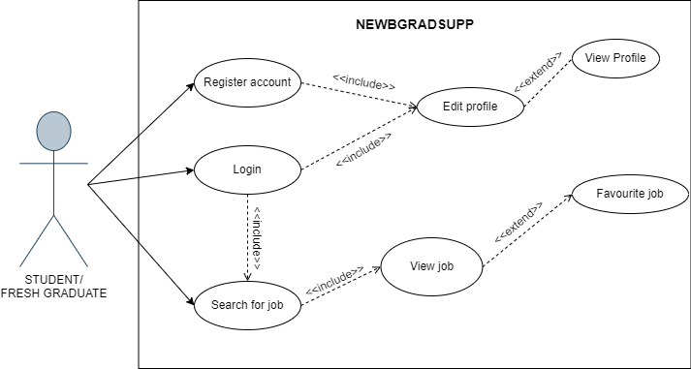

Figure 2.04: Use-case diagram for “What Job Are There?” subsystem

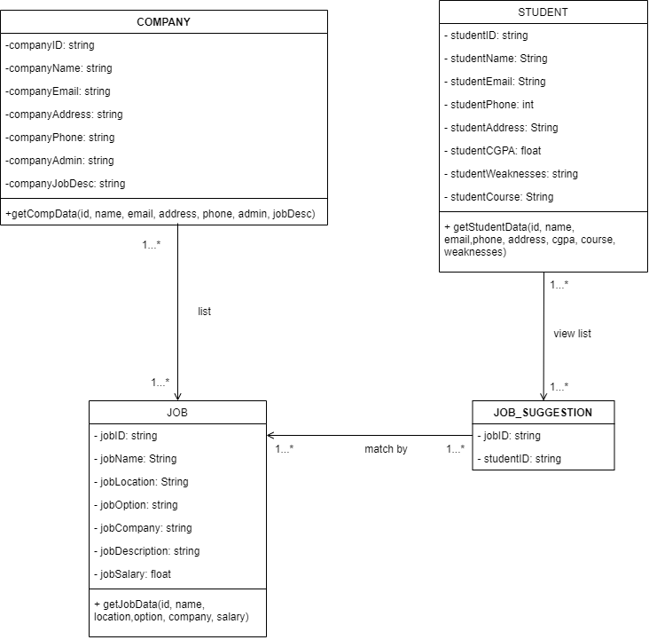

Figure 2.05: Class Domain Diagram for “What Job Are There?” subsystem

### 2.5.1.1 Use Case Description Subsystem 1

1. *“Search for job”* use case

#### The *“Search for job”* use-case for student to search for their job suggestion that is based on their keyword enter

Table 2.03: Search for job use case description

|  |  |  |
| --- | --- | --- |
| **Use Case Name:** | Search for job | |
| **Scenario:** | Student want to search for he/her job suggestion based on keyword enter | |
| **Event Trigger:** | Student enter keyword and click search button | |
| **Descriptions:** | Student need login to the account and go to search bar and enter the keyword and the result will be display based on their matching keyword | |
| **Actor:** | Student | |
| **Related Use Cases:** | Extend: View Job  Extend: Add job to the favorite | |
| **Stakeholders:** | Office Department/Company administrator | |
| **Preconditions:** | Keyword must be entered before job is display | |
| **Postconditions:** | Job suggestion list are display based on matching keyword found | |
| **Normal/**  **Alternate Flow:** | **Actor** | **System** |
|  | * Student login to their account * Student click on search bar to find a job * Student enter keyword then click search | 1. The system checks the account validation and returns with the result of login  2. The system tell and evaluate the keyword enter by student and return the result with appropriate search “if found”  3. The system display the search result |
| **Exception Flow:** | 1. Invalid input of credentials  2. If the keyword enters not found the system will prompt a notification “keyword not found” | |

2. *“View Job”* use case

#### The *“View Job”* use-case for student to view the short job description that listed for him/her.

Table 2.04: View job use case description

|  |  |  |
| --- | --- | --- |
| **Use Case Name:** | View job | |
| **Scenario:** | When the student clicks on any job title that list for him/her, the system will briefly display the job description. | |
| **Triggering Event:** | Students click on job title link | |
| **Brief Description:** | Result for student job suggestion is displayed. Student want to view a short description of the job. | |
| **Actors:** | Students | |
| **Related Use Cases:** | Extend: Add to favorite | |
| **Stakeholders:** | Company Administrator: Provide job vacancy in the system | |
| **Preconditions:** | Student must search for job | |
| **Postconditions:** | A short job description is displayed on the screen with correct detail and link associate. | |
| **Normal/**  **Alternate Flow:** | **Actor** | **System** |
|  | 1. Students display all the job suggestions for him/her. 2. Student click on the job title to view short description. | 1. The system navigates to view job description page after student click job title.  2. The system will display job descriptions with correct detail and link associate. |
| **Exception Flow:** | Invalid input of credentials. | |

3. *“Add to Favorite”* use case

#### The *“Add to Favorite”* use-case is to save the job into the favorite which is also act as a bookmark for the student.

Table 2.05: Add to favorite use case description

|  |  |  |
| --- | --- | --- |
| **Use Case Name:** | Add to favorite | |
| **Scenario:** | After student view the short job description. Student add their favorite job into the favorite list | |
| **Triggering Event:** | Students click on add button | |
| **Brief Description:** | When the student views the job description, he/she can add the job into favorite bookmark. They refer to the bookmark when they want to use it later | |
| **Actors:** | Students | |
| **Related Use Cases:** | Extend: View Job | |
| **Stakeholders:** | Company Administrator: Provide job vacancy in the system | |
| **Preconditions:** | Students must view the job description first. | |
| **Postconditions:** | The job saved as favorite must be displayed with its correct name, description, links, etc. | |
| **Normal/**  **Alternate Flow:** | **Actor** | **System** |
|  | 1. Student view short job description.  2. Student click on add button to add job into favorite bookmark | 1. System display the job description  2. System store data added into database |
| **Exception Flow:** | Invalid input of credentials. | |

### 2.5.1.2 System Sequence Diagram Subsystem 1

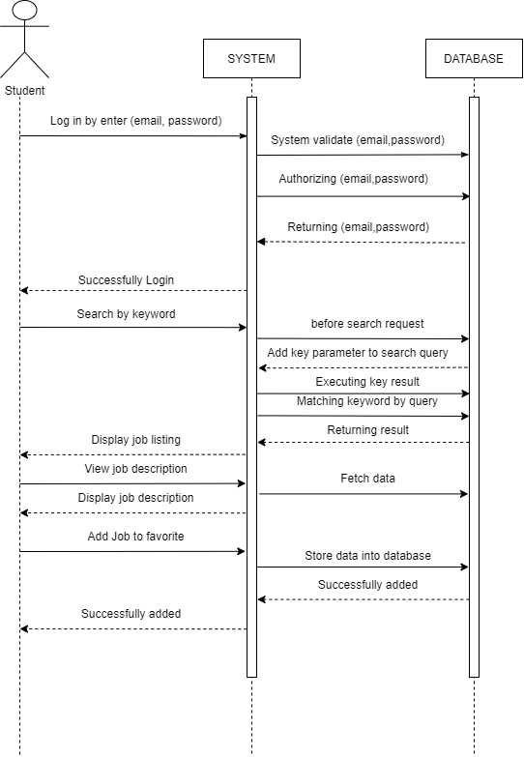

Figure 2.06: System sequence diagram for “What Job Are There” subsystem 1

Figure 2.06 above shows the overall system sequence diagram (SSD) of subsystem 1. It starts with user identification. User authentication will be executed, after logging into the system, user can choose from menu to navigate to different screen to either search for a job or do the salary comparison or skill and certificates recommendation. In this system sequence diagram, it focuses on the job searching process up until the adding job into the favorite list.

## 2.5.2 “Salary Expectation” SE22230031 - Subsystem 02

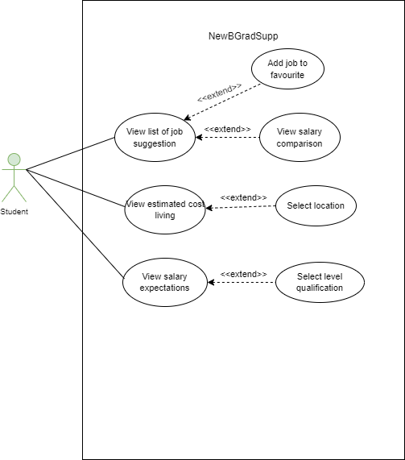

Figure 2.07: Use-case diagram for “Salary comparison” subsystem

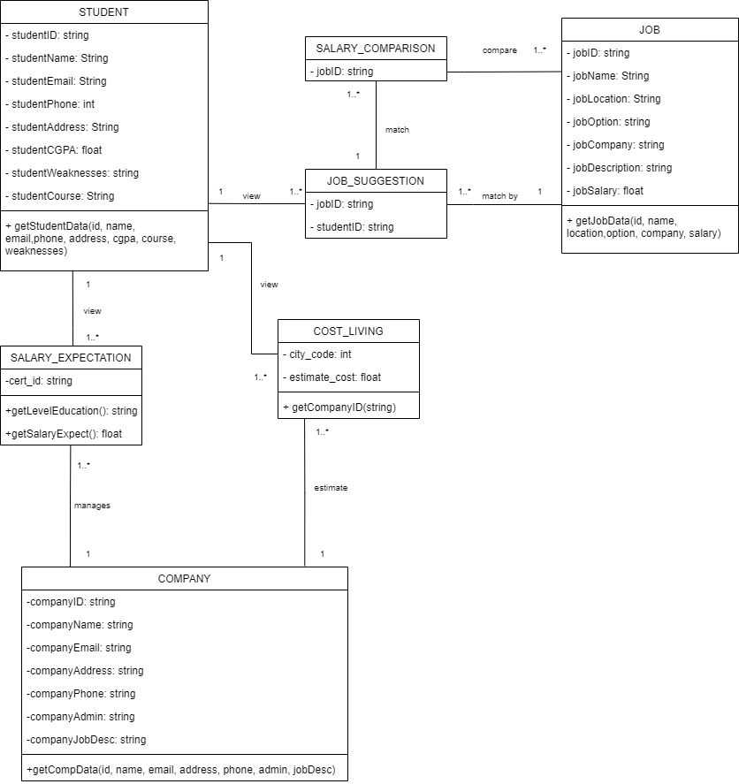

Figure 2.08: Class Domain Diagram for “Salary comparison” subsystem

### 2.5.2.1 Use Case Description Subsystem 2

1. “*View salary comparison*” use case

The “***View salary comparison***” use-case for student to view the comparison of salary from the listing of job suggestions that available to them based on their location they chose.

Table 2.06: View Salary Comparison use case description

|  |  |  |
| --- | --- | --- |
| **Use Case Name** | View salary comparison | |
| **Scenario** | Student choose the location that they want to see the comparison of salary from the list of job suggestions. | |
| **Event Trigger** | Student choose location and click search button | |
| **Description** | Student needs to choose the location and the result will be display based on their location they pick | |
| **Actor** | Student | |
| **Related Use Cases:** | Extend: Add job into favorite | |
| **Stakeholders** | Office Department/Company administrator | |
| **Preconditions** | Location must be chosen before the salary comparison can be display | |
| **Postconditions** | Salary comparison list are display based on location they pick | |
| **Flow** | **Actor** | **System** |
| 1. Student/fresh graduate enters the system. 2. Student/fresh graduate select location they want. 3. Student/fresh graduate click search button. | 1. The system displays the job within the location. 2. The system displays the salary comparison between job that available in that location. |
| **Exception** | Invalid input of credentials. | |

2. “*View estimated cost living*” use case

The “***View estimated cost living***” use case for students to know the living expenses for certain areas that they would like to pursue their careers.

Table 2.07: View estimate cost living use case description

|  |  |  |
| --- | --- | --- |
| **Use Case Name** | View estimate cost living | |
| **Scenario** | Student chose the location that they want to see the estimation of cost living from the list of cities available | |
| **Event Trigger** | Student chose location and click search button | |
| **Description** | Student needs to choose the location and the result will be display based on their location they pick | |
| **Actor** | Student | |
| **Related Use Cases:** | Extend: Select location | |
| **Stakeholders** | Office Department/Company administrator | |
| **Preconditions** | Location must be chosen before the estimate of cost living can be display | |
| **Postconditions** | Estimate cost of living are display based on location they pick | |
| **Flow** | **Actor** | **System** |
| 1. Student/fresh graduate enters the system. 2. Student/fresh graduate select available city in the search bar. 3. Student/fresh click the search button. | 1. The system displays the estimated cost of living within the area. |
| **Exception** | Invalid input of credentials. | |

3. “*View salary expectation*” use case

The “***View salary expectation***” use case for students to know the expected salary they will get if they possess a certain level of study of qualifications.

Table 2.08: View Salary Expectation use case description

|  |  |  |
| --- | --- | --- |
| **Use Case Name** | View salary expectation | |
| **Scenario** | Student choose the qualification that they possess, or they inquire about to view the salary expected. | |
| **Event Trigger** | Student choose qualification from the search bar | |
| **Description** | Student needs to choose the qualification and the result will be display based on qualifications they pick | |
| **Actor** | Student | |
| **Related Use Cases:** | Extend: Select level qualification | |
| **Stakeholders** | Office Department/Company administrator | |
| **Preconditions** | Qualification must be chosen before the expected of salary can be display | |
| **Postconditions** | Salary expectation are display based on the level of qualification they pick | |
| **Flow** | **Actor** | **System** |
| 1. Student/fresh graduate enters the system. 2. Student/fresh graduate select level of qualification. 3. Student/fresh graduate click search button. | 1. System displays the list of job for the level qualifications. 2. System displays the details of the job with the salary expectation for each job displayed in the list. |
| **Exception** | Invalid input of credentials. | |

### 2.5.2.2 Sequence diagram Subsystem 2

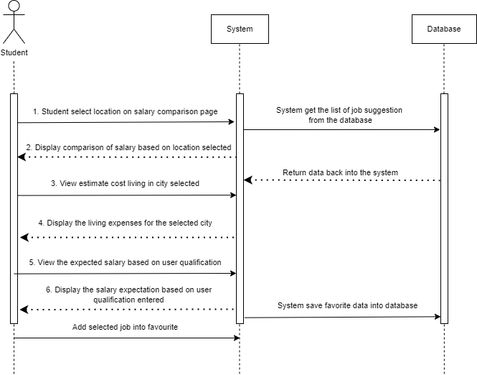

Figure 2.09: System sequence diagram for “Salary comparison” subsystem 2

## “Professional Certificates and Skills Enhancement” SE22230032 - Subsystem 03

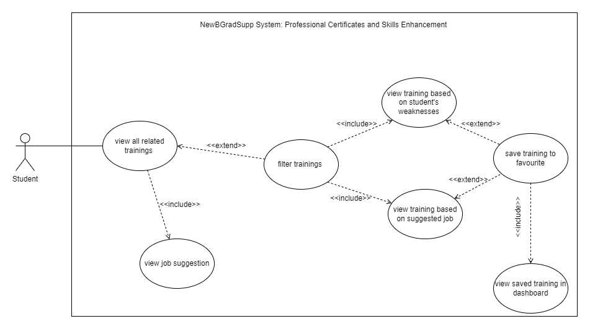

Figure 2.10: Use Case Diagram for Subsystem 3: Professional Certificates and Skills Enhancement

**Class diagram subsystem**

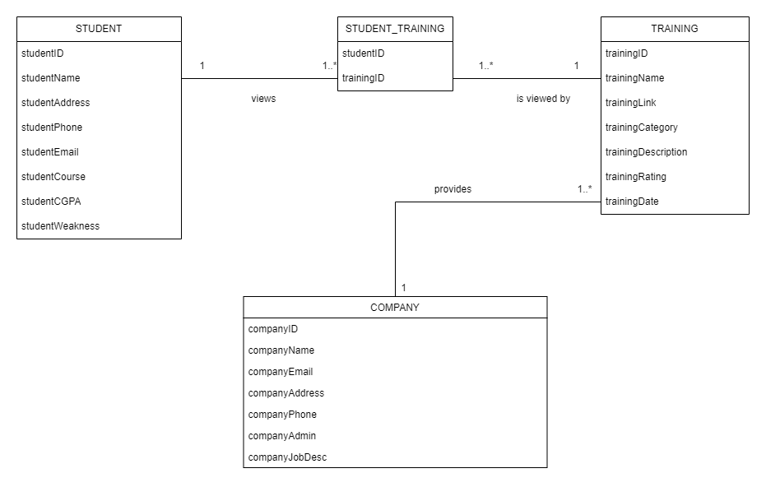

Figure 2.11 : Domain Class Diagram for Subsystem 3: Professional Certificates and Skills Enhancement

### 2.5.3.1 Use Case Description Subsystem 3

Use-Case: View all related trainings: Student navigates to “Training Recommendation” page.

#### The *View all related trainings* use case for student navigates to “Training Recommendation” page scenario has 3 alternate flows and 2 exception flows

Table 2.09: View all related training use case description

|  |  |  |
| --- | --- | --- |
| **Use Case Name:** | View all related trainings | |
| **Scenario:** | Student navigates to “Training Recommendation” page | |
| **Triggering Event:** | Students click on “Training Recommendation” in menu | |
| **Brief Description:** | If students click the “Training Recommendations” on menu and they will be navigated to the Training Recommendation page. On that page, all training that related to that student will be displayed on that page. | |
| **Actors:** | Students | |
| **Related Use Cases:** | Include: View Job Suggestion | |
| **Stakeholders:** | Admin department: Add training details into the system  Company department: Provide training details | |
| **Preconditions:** | Student must login, key in all required data including their weakness, and search for the job first, then the system will automatically recommend the training based on student weaknesses of their skills and job suggestion. Students must go to the Training Recommendation page to view the training.  Training details must exist for the system to generate training recommendation and display on the screen | |
| **Postconditions:** | List of all training recommendations that related to that student and its details such as training name, description, and links must be displayed on the screen correctly. | |
| **Normal/Alternate Flow:** | **Actor** | **System** |
|  | 1. Students click “Training Recommendation” on main menu. 2. Students select “view by weaknesses”.          1. Students view all training recommendations. | 1. Navigate to Training Recommendation page.  2.1 Identify student’s weaknesses of their skills and job suggestion for that student  2.2 Display list of all training related to that student |
| **Exception Flow:** | 2.1 If the list of trainings cannot be found and displayed on that page, the system will ask the student to check for job suggestion and their weaknesses of their skills first.    2.2 If the training recommendations cannot be displayed due to error AI generator, the students can   1. Refresh the page and select “Training Recommendation” page again main menu, or 2. Students go back to main page. | |

Use-Case: Filter Trainings: Students click “Filter Training” button.

#### The *Filter Training* use case for student clicks “Filter Training” button scenario has 4 alternate flows and 3 exception flows

Table 2.10: Filter training use case description

|  |  |  |
| --- | --- | --- |
| **Use Case Name:** | Filter trainings | |
| **Scenario:** | Student clicks “Filter Training” button | |
| **Triggering Event:** | Students click on “Filter Training” button on Training Recommendation page | |
| **Brief Description:** | Students click on “Filter Training” button to filter training and views them based training categories which is by weaknesses and by job suggestion instead of viewing all trainings at the same time. | |
| **Actors:** | Students | |
| **Related Use Cases:** | Include: View all related trainings | |
| **Stakeholders:** | Admin department: Add training details into the system  Company department: Provide training details | |
| **Preconditions:** | Students must go to the Training Recommendation page and click on “Filter Training” button.  Training details must exist for the system to generate training recommendation and display on the screen | |
| **Postconditions:** | The category of training will be shown once the student clicks the “Filter Training” button. The categories are view training by job suggestion, and view training by weaknesses. | |
| **Normal/Alternate Flow:** | **Actor** | **System** |
|  | 1. Students click “Training Recommendation” on main menu. 2. Students select “view by weaknesses”.          1. Students view all training recommendations. 2. Students click “Filter Training” button | 1.1. Navigate to Training Recommendation page.  2.1. Identify student weaknesses.  2.2. Identify job suggestion for that student  2.3. Display list of all training related to that student      4.1 The categories of training are shown which are “View training by job suggestion” and “View training by weaknesses”. |
| **Exception Flow:** | 2.1 If the list of training courses cannot be found and displayed on that page, the system will ask the student to check for job suggestions and the weaknesses of their skills first.    2.2 If the training recommendations cannot be displayed due to error AI generator, the students can   1. Refresh the page and select “Training Recommendation” page again main menu, or 2. Students go back to main page.   4.1 If the categories of the trainings are not shown, students and click the button again or refresh the page. | |

Use-Case: View Training Recommendations based on Weaknesses: Select “view training by weaknesses” within “Filter Training” button.

#### The *View training based on weaknesses* use case for student select “view training by weaknesses” within “Filter Training” button scenario has 3 alternate flows and 2 exception flows

Table 2.11: View training recommendation based on weaknesses use case description

|  |  |  |
| --- | --- | --- |
| **Use Case Name:** | View training recommendations based on weaknesses | |
| **Scenario:** | Select “view training by weaknesses” within “Filter Training” button | |
| **Triggering Event:** | Students select “view training by weaknesses after they click on “Filter Training” button on Training Recommendation page. | |
| **Brief Description:** | When the student selects “view training by weaknesses”, the system will display the training recommendations that aligned with their weaknesses | |
| **Actors:** | Students | |
| **Related Use Cases:** | Include: Filter Training | |
| **Stakeholders:** | Admin department: Add training details into the system  Company department: Provide training details | |
| **Preconditions:** | Students must enter their weaknesses of their skills during registration.  Training details must exist for the system to generate training recommendation and display on the screen | |
| **Postconditions:** | The training recommendations based on students’ weaknesses of their skills and their details such as training name, description and links must be displayed on the screen correctly. | |
| **Normal/Alternate Flow:** | **Actor** | **System** |
|  | 1. Students click “Filter Training” button. 2. Students select “view training by weaknesses”.          1. Student view training recommendations based on student’s weaknesses of their skills. | 2.1. Filter training and classify training based on job from all trainings  2.2 Display training recommendations based on students’ weaknesses in their skills. |
| **Exception Flow:** | 2.1 If a student cannot view training based on weaknesses, the student needs to refresh the page.  2.2 If the training recommendations cannot be displayed due to error AI generator, the students can   1. Refresh the page and click “Filter Training” button, then select “view training by weaknesses” again, or 2. Students go back to main page. | |

Use-Case: View Training Recommendations based on Job Suggestion: Select “view training by Job” within “Filter Training” button.

#### The *View training based on Job Suggestion* use case for student select “view training by Job” within “Filter Training” button scenario has 3 alternate flows and 2 exception flows.

Table 2.12: View training recommendation based on job suggestion use case description

|  |  |  |
| --- | --- | --- |
| **Use Case Name:** | View training recommendations based on Job Suggestion | |
| **Scenario:** | Select “view training by Job” within “Filter Training” button | |
| **Triggering Event:** | Students select “view training by Job” after they click on “Filter Training” button on Training Recommendation page. | |
| **Brief Description:** | When the student selects “view training by Job”, the system will display the training recommendations based on the job suggestion. | |
| **Actors:** | Students | |
| **Related Use Cases:** | Include: Filter Training | |
| **Stakeholders:** | Admin department: Add training details into the system  Company department: Provide training details | |
| **Preconditions:** | Student must search for the job first to get the list of job suggestions.  Training details must exist for the system to generate training recommendation and display on the screen | |
| **Postconditions:** | The training recommendations based on the list of job suggestions and its details such as training name, description and links must be displayed on the screen correctly. | |
| **Normal/Alternate Flow:** | **Actor** | **System** |
|  | 1. Students click “Filter Training” button. 2. Students select “view training by job”.          1. Student view training recommendations based on the suggested job. | 2.1. Filter training and classify training based on job suggestion from all trainings  2.2 Display training recommendations based on the list of suggested jobs. |
| **Exception Flow:** | 2.1 If a student cannot view training based on job, student need to refresh the page or get the list of job suggestion again.  2.2 If the training recommendations cannot be displayed due to error AI generator, the students can   1. Refresh the page and click “Filter Training” button, then select “view training by job” again, or 2. Students go back to main page. | |

Use-Case: Save Favorite Training: Click heart shape button

#### The *Save Favorite Training* use case for student click heart shape button scenario has 3 alternate flows and 1 exception flows

Table 2.13: Save favorite training use case description

|  |  |  |
| --- | --- | --- |
| **Use Case Name:** | Save favorite training | |
| **Scenario:** | Click heart shape button | |
| **Triggering Event:** | Students click heart shape button to save their favorite training | |
| **Brief Description:** | When the student clicks the heart shape button once they view the training, the heart shape will change color and those saved training will be displayed on student’s dashboard. | |
| **Actors:** | Students | |
| **Related Use Cases:** | Extend: View training based on suggested job  Extend: View training based on student’s weaknesses | |
| **Stakeholders:** | Admin department: Add training details into the system  Company department: Provide training details | |
| **Preconditions:** | Students must view the training first.  Training details must exist for the system to generate training recommendation and display on the screen | |
| **Postconditions:** | The training recommendations and its details such as training name, and links must be displayed on the screen correctly.  The heart shape button is displayed, clickable, and changes the color when it is clicked. | |
| **Normal/Alternate Flow:** | **Actor** | **System** |
|  | 1. Students click on training that is displayed on the screen.              1. Students click on the heart shape button to save training as favorite          1. Students view the notification. | 1.1. Display all the training details clicked by student including training name, description, link, etc.  1.2. The heart shape button is displayed on the same section as training details    2.1 The color of the heart shape button is changed to red color.  2.2 Display notification “successfully added as favorite training” |
| **Exception Flow:** | 2.2 If the color is not changed when the student clicked on it, student need to go training recommendation page and click the training again. Then, try to click the heart shape button again. | |

Use-Case: View Saved Training: Student click “View Saved Training” button on the dashboard.

#### The *View saved training* use case for student click “View Saved Training” button scenario has 3 alternate flows and 1 exception flows

Table 2.14: View saved training use case description

|  |  |  |
| --- | --- | --- |
| **Use Case Name:** | View saved training | |
| **Scenario:** | Students click “View Saved Training” button on the dashboard. | |
| **Triggering Event:** | Students click “View Saved Training” button on the dashboard to view the saved training. | |
| **Brief Description:** | When the students add training to favorite, student can view it back on the student’s dashboard once they click “View Saved Training” button on the dashboard. | |
| **Actors:** | Students | |
| **Related Use Cases:** | Include: Save Training to Favorite | |
| **Stakeholders:** | Admin department: Add training details into the system  Company department: Provide training details | |
| **Preconditions:** | Students must view the training and training to favorite first. | |
| **Postconditions:** | The training saved as favorite must be displayed with its correct name, description, links, etc.  Favorite training must be displayed on the dashboard. | |
| **Normal/Alternate Flow:** | **Actor** | **System** |
|  | 1. Students go to dashboard to view saved training        1. Students view the favourited training in the dashboard. | 1.1. Display all the favorite training details added by student including training name, description, link, etc. in the dashboard. |
| **Exception Flow:** | 1.1. If the favorited training is empty:   * 1. it will display “no training has been added”, or   2. Prompt student to view the training on the Training Recommendation page. | |

### 2.5.3.2. Sequence diagram Subsystem 3

#### Student: View list of all training related to the student

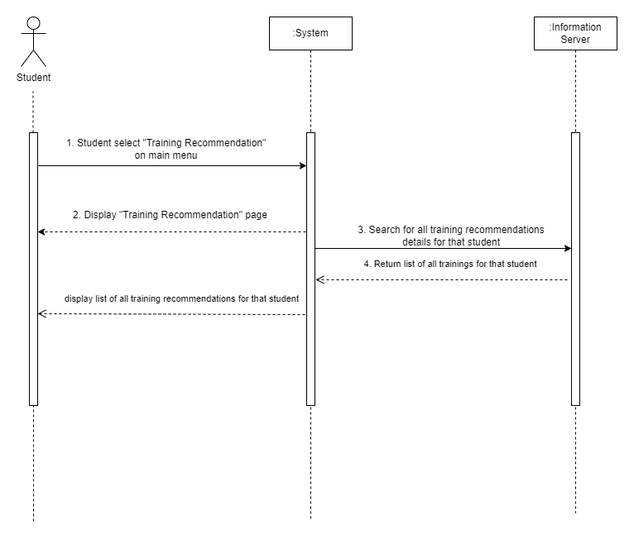

Figure 2.12: view list of all training related to the student

If students want to view training recommendations, they must select “Training Recommendation” on the main menu. Still, they need to ensure that they already have the list of job suggestions generated by the system and their weaknesses. The information server will return all the related training to the system. Then, a list of all training will be displayed on the Training Recommendation page, and students can view them.

**Students: Filter Training Category**

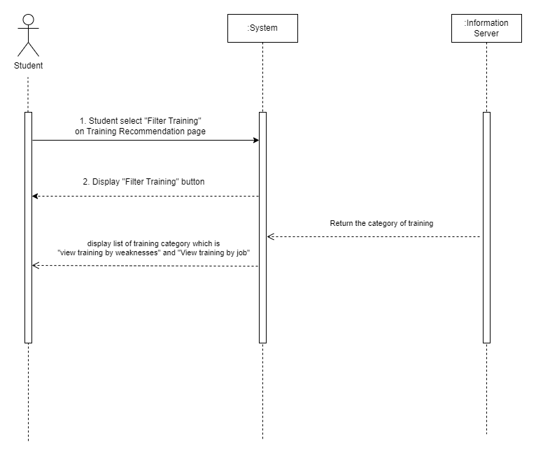

Figure 2.13: filter training category

Students can filter the training based on the training category on the Training Recommendation page. A student may click “Filter Training”, then the information server will return the list of training categories. Those categories are “View training by weaknesses” and “View training by the job”. Therefore, the student can view the list of training categories.

**Students: View training based on chosen category**

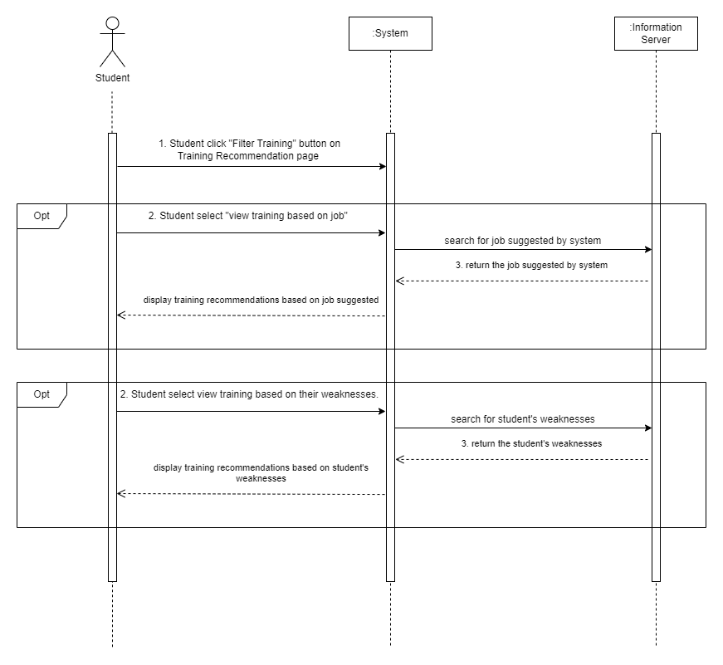

Figure 2.14: View Training based on chosen category

A student may choose the training category by clicking the "Filter Training" button on the Training Recommendations page. Students have two options: view training based on job suggestions or view training based on weaknesses of their skills. If they choose "View training by the job," the server will get that student's list of job suggestions and generate training recommendations based on job suggestions. Else, the server will contact the student's weaknesses and develop training recommendations based on student weaknesses. Students can view training based on a chosen category on that page.

**Students: Save training as favorite**

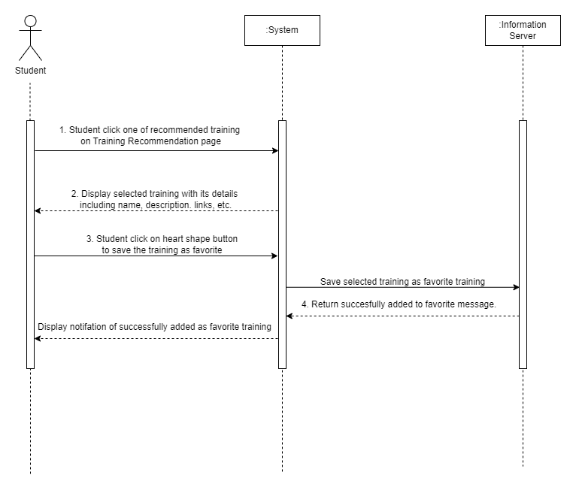

Figure 2.15: Save training as favorite

When students view the training list on the Training Recommendation page, they may click on any training they are interested in. Then, the training details, with their name, links, description, etc., will be displayed on that page. There’s a heart-shaped button on the same container as the training details. Students need to click that button to save the selected training as their favorite training. The information server will keep the favorite training information and return successfully added training to the favorite message. The system will show the alert notification of successfully added as a favorite training student.

**Student: View saved training on the dashboard**

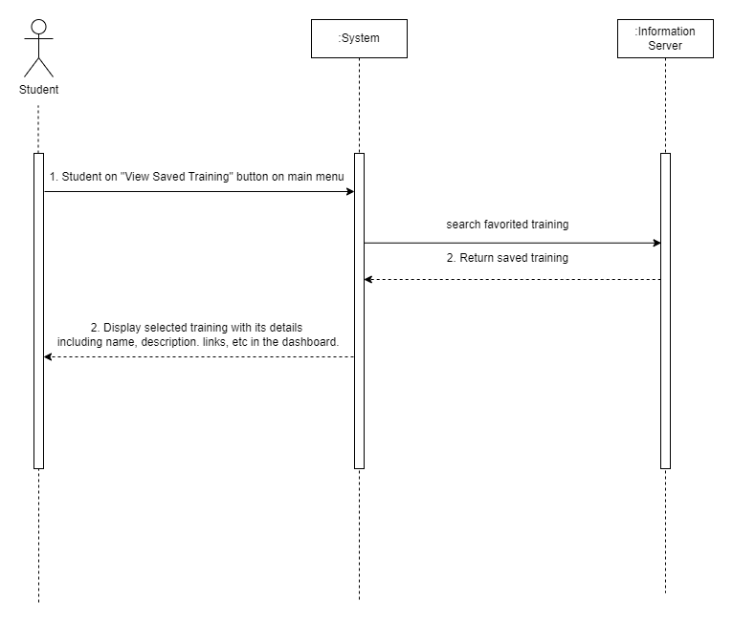

Figure 2.16: view saved training on the dashboard

Once the student saves training as favorite training, they can view all their favorite training on the dashboard. Students need to click on the “View Saved Training” button on the main menu, and the information server will search and get their favorite training and return to the system. The favorite training and its details, including name, description, links, and others, will be displayed on the dashboard.

**Administrator and Company: Add training details**

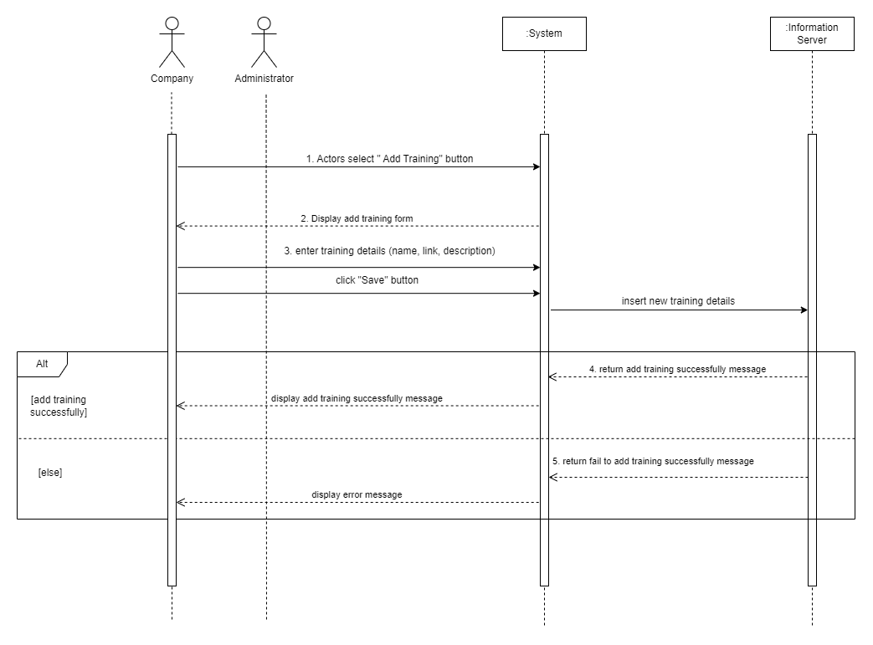

Figure 2.17: company and administrator add training details

The company and administrator can add training details by clicking the “Add Training” button, and the system will display added training form. Both actors must enter training details such as name, links, and description. Then they need to click the save button so the system can insert all components into the server. The server returns a successfully added training message, and the system will display all the training and its details on the Training Recommendation page. Else, the server will return an error message, and the actors will receive an error.

**Administrator and Company: Edit training details**

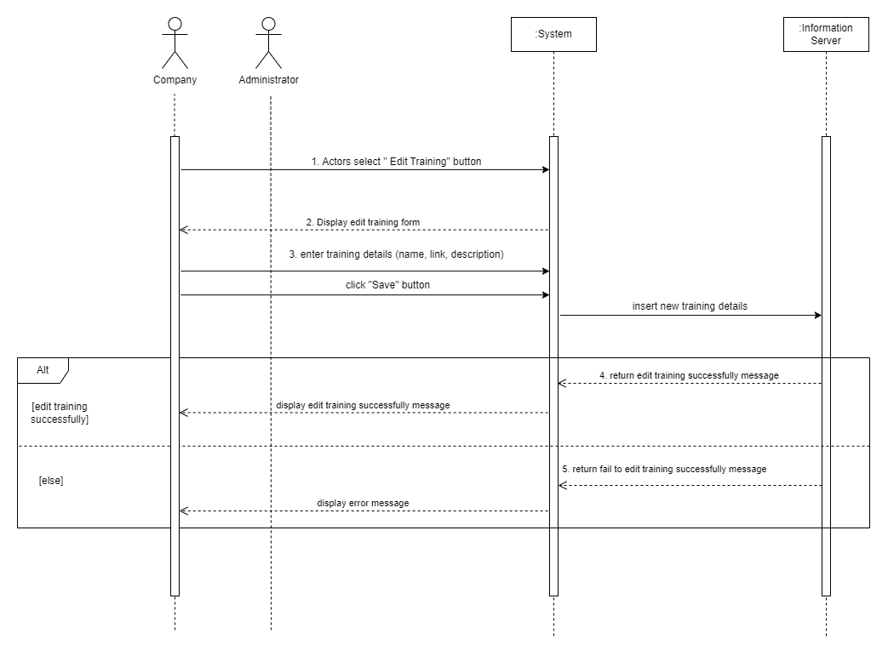

Figure 2.18: company and administrator add training details

The company and administrator can edit training details by clicking the “Edit Training” button, and the system will display the edit training form. Both actors must enter training details such as name, links, and description. Then they need to click the save button so the system can insert all elements into the server. The server returns a successfully edited training message, and the system will display all the training and its details on the Training Recommendation page. Else, the server will return an error message, and the actors will receive an error.

## 2.6 Non-Functional Requirements

### 2.6.1 Performance Requirement

The following table indicates the system response time limits for processing inputs:

Table 3.1: System Timing Targets

|  |  |  |  |
| --- | --- | --- | --- |
| Response Time | Input | Description | Output |
| 1s ~ 2.5s | User details | Users fill in the user details | List of jobs matching their details. |
| 0.5s ~ 1s | Job keyword | Users search for job | List of jobs matching the keyword entered. |
| 0.5s ~ 1s | Location | Users select location | List of jobs with salary comparison in that location. |
| 0.5s ~ 1.2s | City/location | Users select location | The estimated cost of living in that area. |
| 1.5s ~ 2s | Training filter | Users select training filter | List of training based on filter they selected. |
| 0.5s ~ 1.5s | Job training | Company admins/system admin add/edit job training in the system | List of available job training save into database. |
| 0.5s ~ 1s | Level of qualification | Users select level of qualification at the search bar | Details of salary expectation for that qualification. |

### 2.6.2 Other Relevant Non-Functional Requirement

The final system will have to meet the following performance goals:

Table 3.2: System Performance Goals

|  |  |  |
| --- | --- | --- |
| **Metric** | **Description** | **Goal** |
| Throughput | The number of transactions can be processed simultaneously. Usually measured in transactions per second, or TPS. | Min. 5,000 TPS.  The more throughput, the more effectively the resource may be used. |
| Scalability | The highest workloads under the system that can still meet the performance requirements | Min. 1,000 simultaneous transactions |
| Usability | The effective or how easy the users to use the user interfaces | The error rate of users to get the job or training recommendations must not exceed 10% |
| Security | The data inside the system must be protected against unauthorized access and malware attack | The security verification must not exceed 5 minutes. |
| Reliability | Rate of failure occurrences; The software performance is expected to be performed without failures for exact number of users or times | The system must perform without failure in 95% of use cases. |
| Availability | Users have access to the system at a specific time. | The system must be available to users 90% of the time. |
| Maintainability | The time of the system to be recovered after a failure | The mean time to restore system (MTTRS) after the system had some failure must not exceed 10 minutes. |
| Portability | Number of target systems | Program must be running without changing the behavior and system performance in different Windows versions. |

# 3. Software Design Description (SDD)

## 3.1 Storyboard

### 3.1.1 Storyboard for SE22230008 - Subsystem 01: What Job are There?

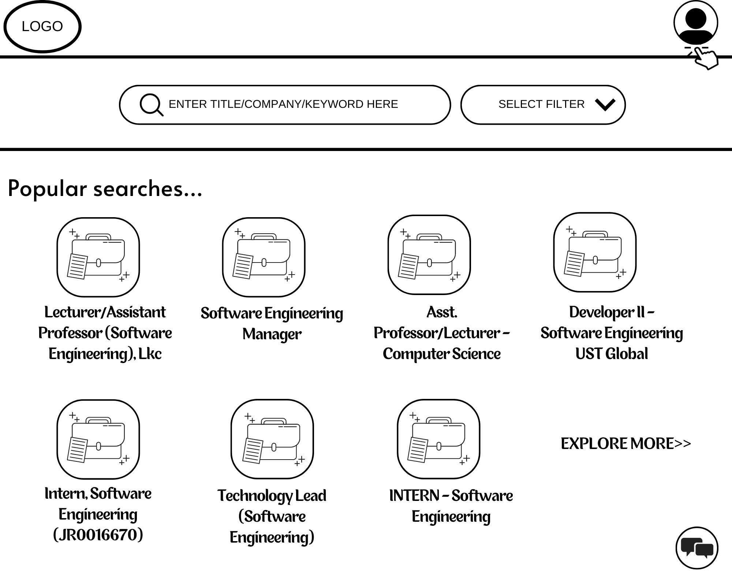

1. Students visit the website

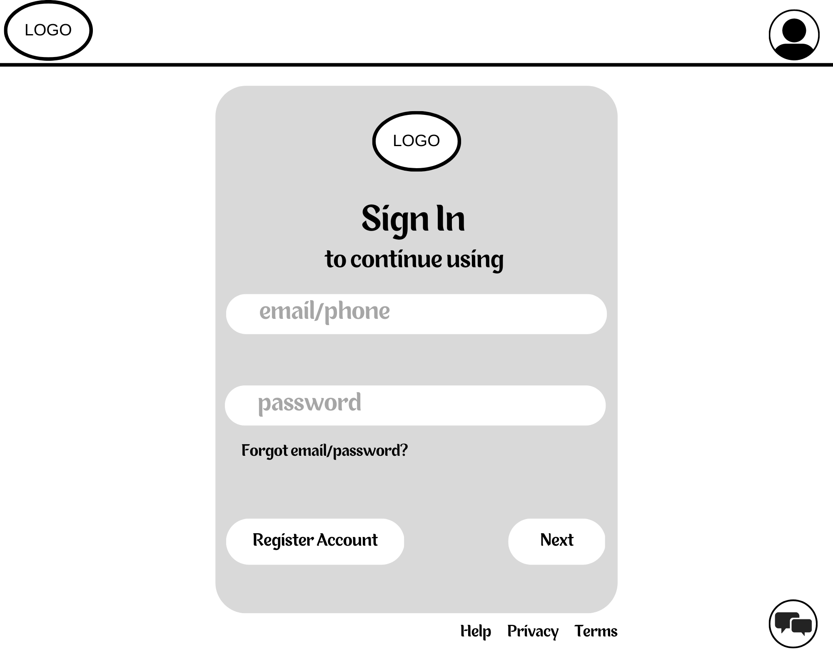

1. If the student has account, they can sign into their account. If the student doesn’t have any account, they can register to continue using the extended features in the system.

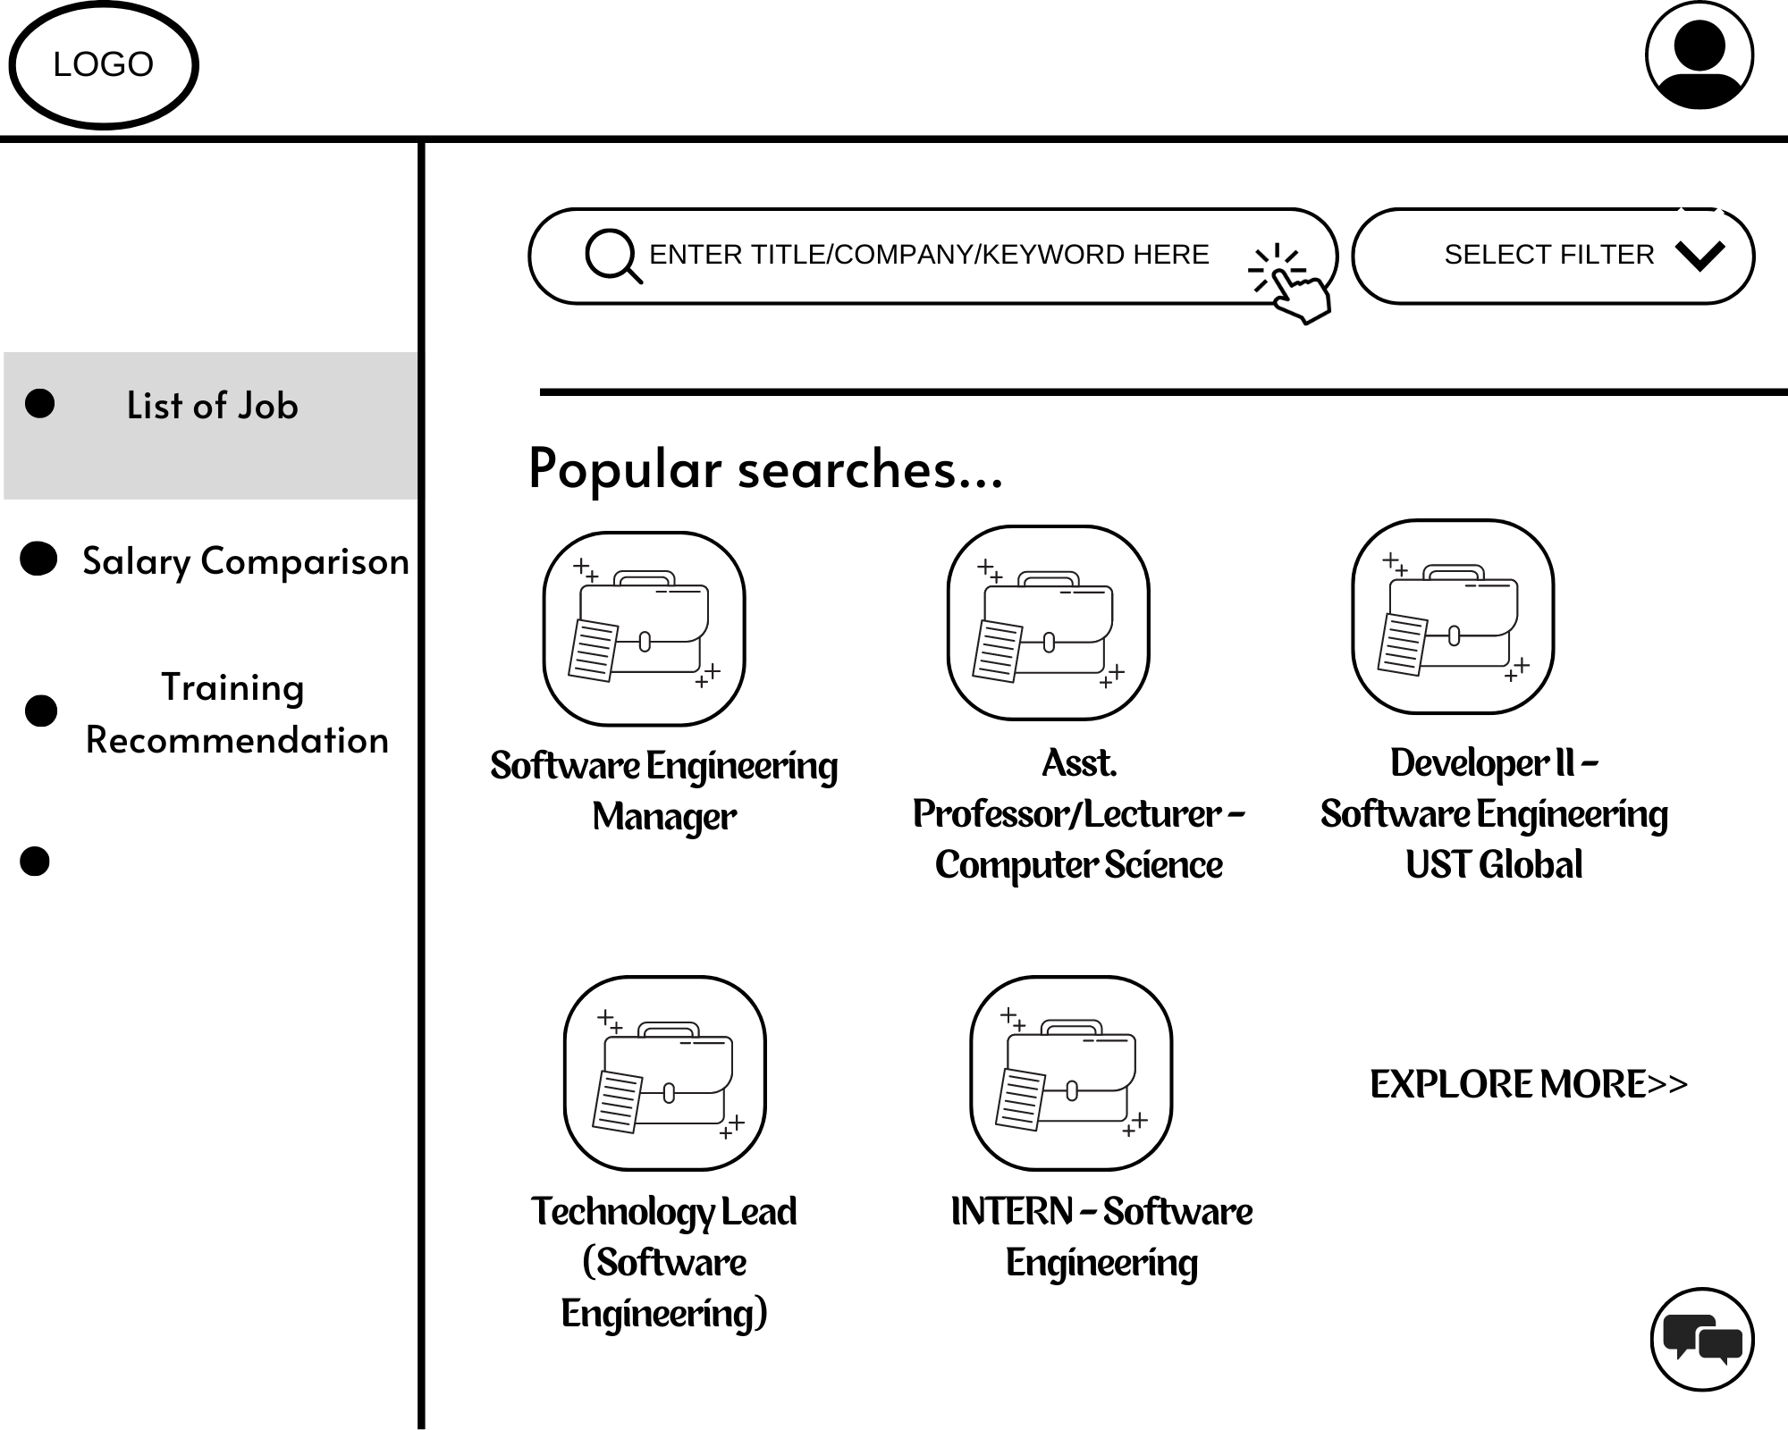

1. After student successfully login to their account, they can see a dashboard with 3 options. Besides, they can also view their profile by clicking the profile icon.

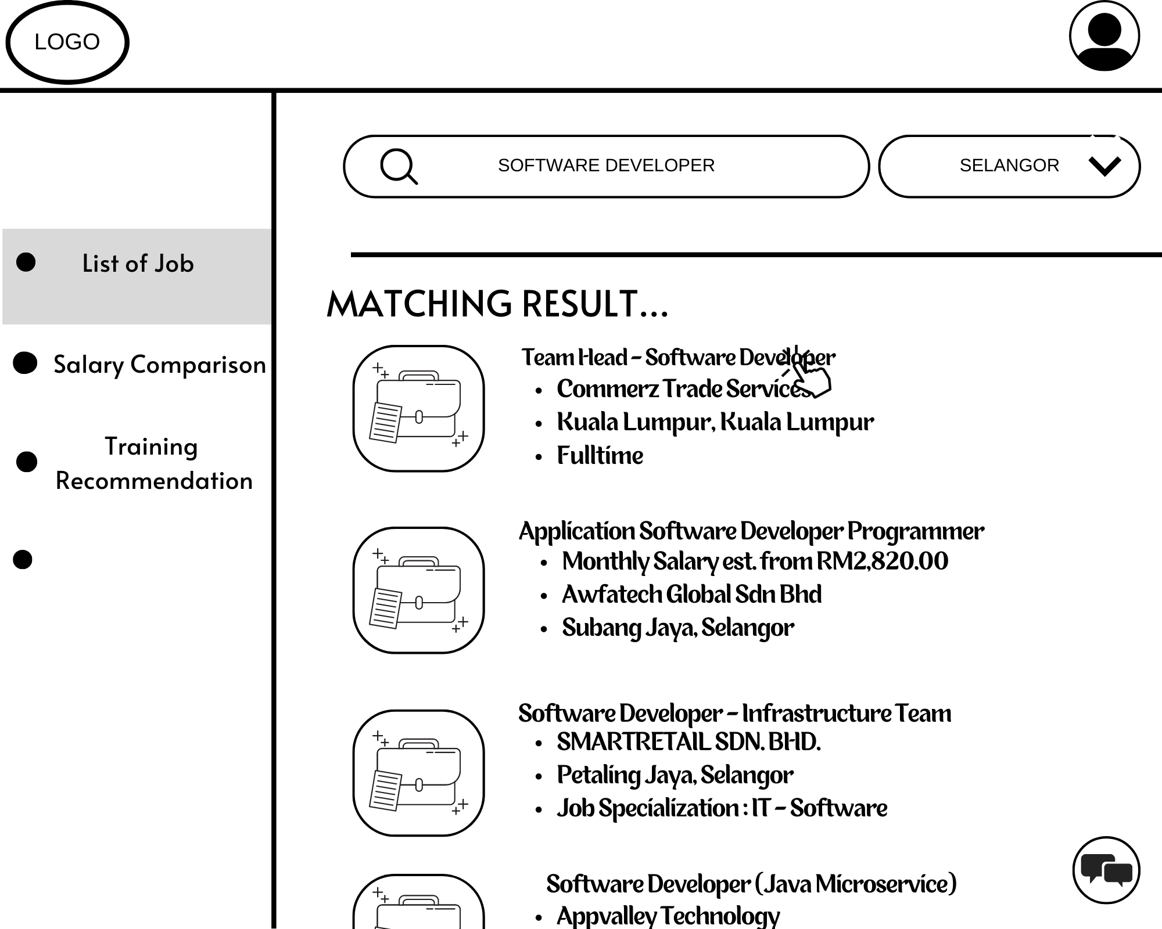

1. Students need to click on the search bar and enter the keyword to view the job suggestion list by the system. After the student clicking on the search button, student will be able to display the list of job that suggested by the system. To view the job description student, need to click on the job title.

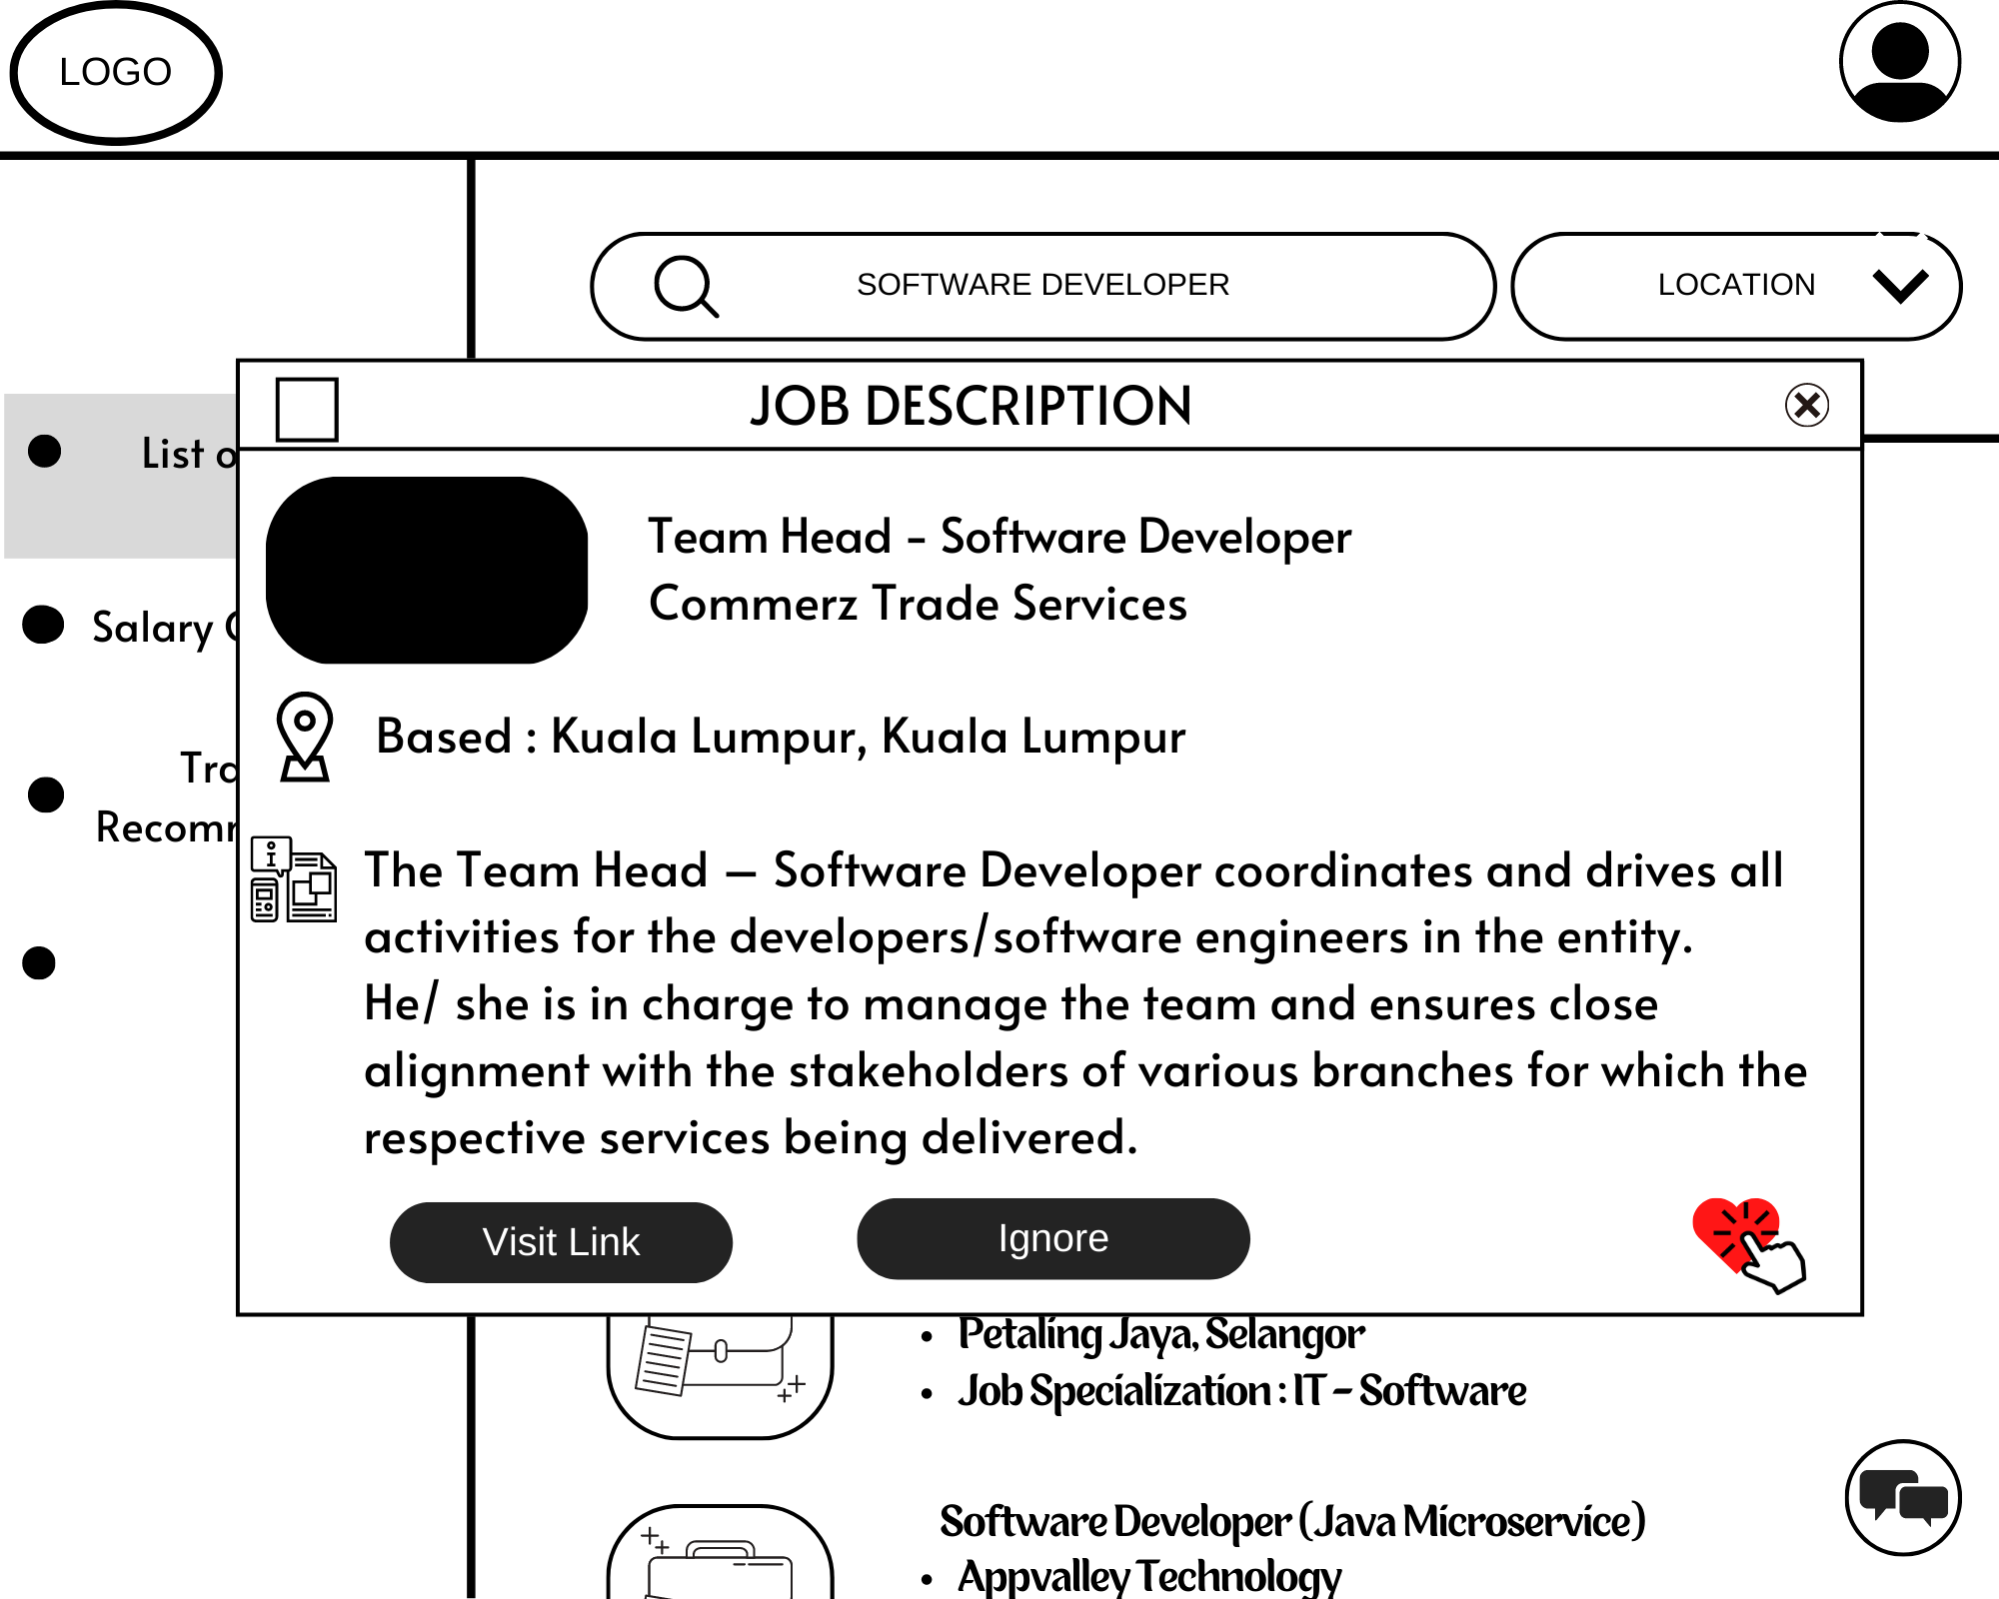

1. After the student clicking on the job title, a short description of the job vacancy will be displayed. Student are having the choice either to visit the job site or to ignore it. Student also can add the job into favorite list.

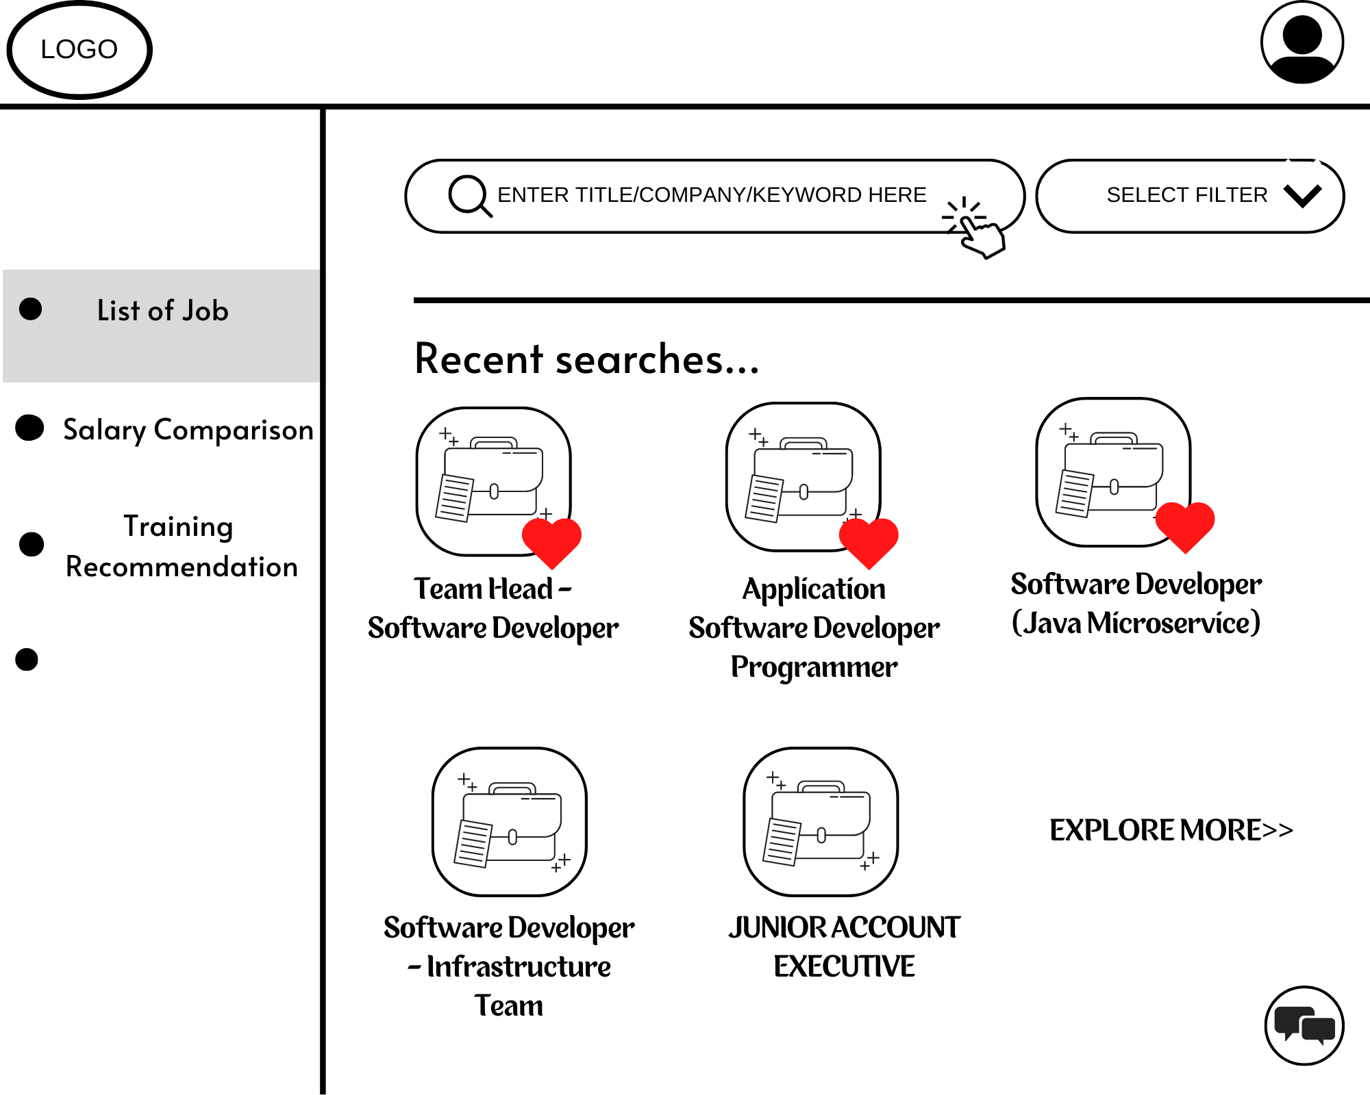

1. The job that has been added into favorite list will be save into the database and student are allowed to display the same job again if they wish to.

Figure 3.1: System Storyboards for Subsystem 1

### 3.1.2 Storyboard for SE22230031 - Subsystem 02: Salary Comparison

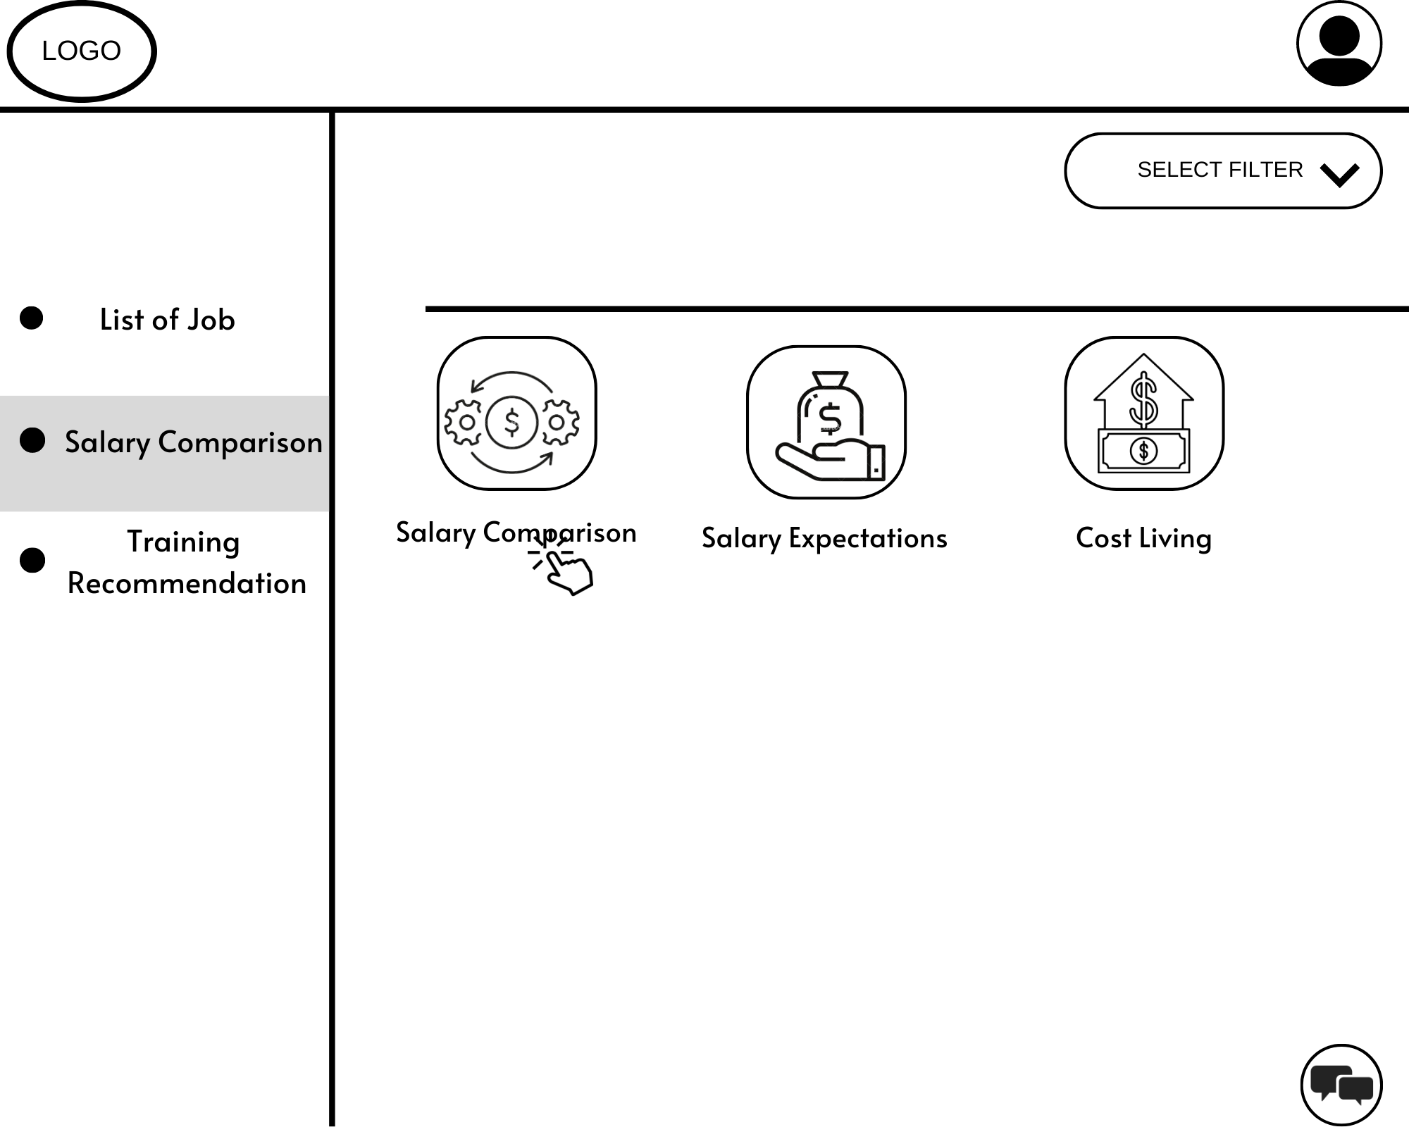

* 1. Student visits salary comparison page and click on salary comparison menu.

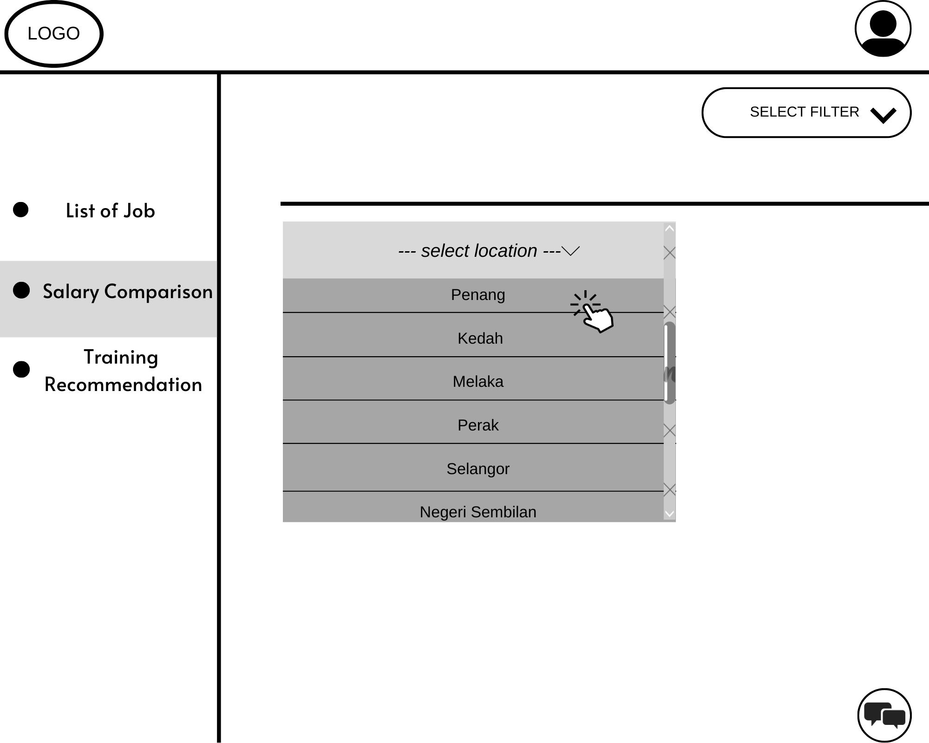

2. Student choose location they want to view salary comparisons.

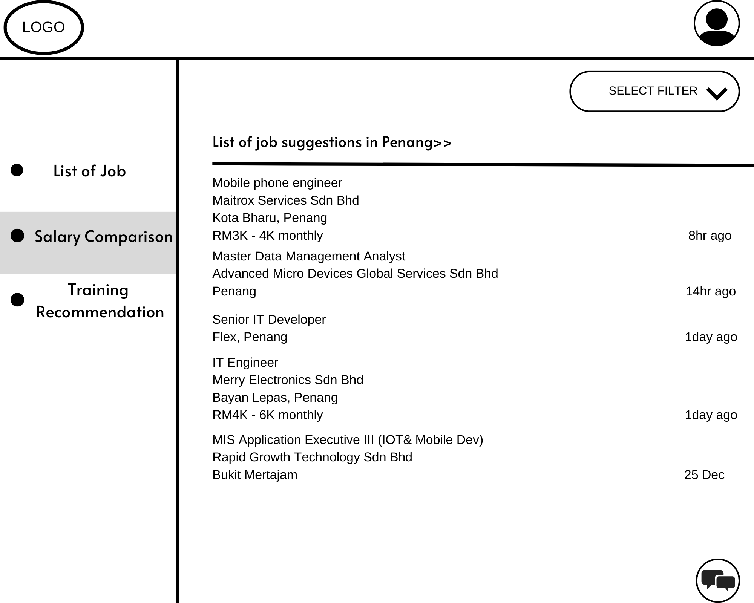

3. The system displays the list of job suggestions based on the location chosen by the student.

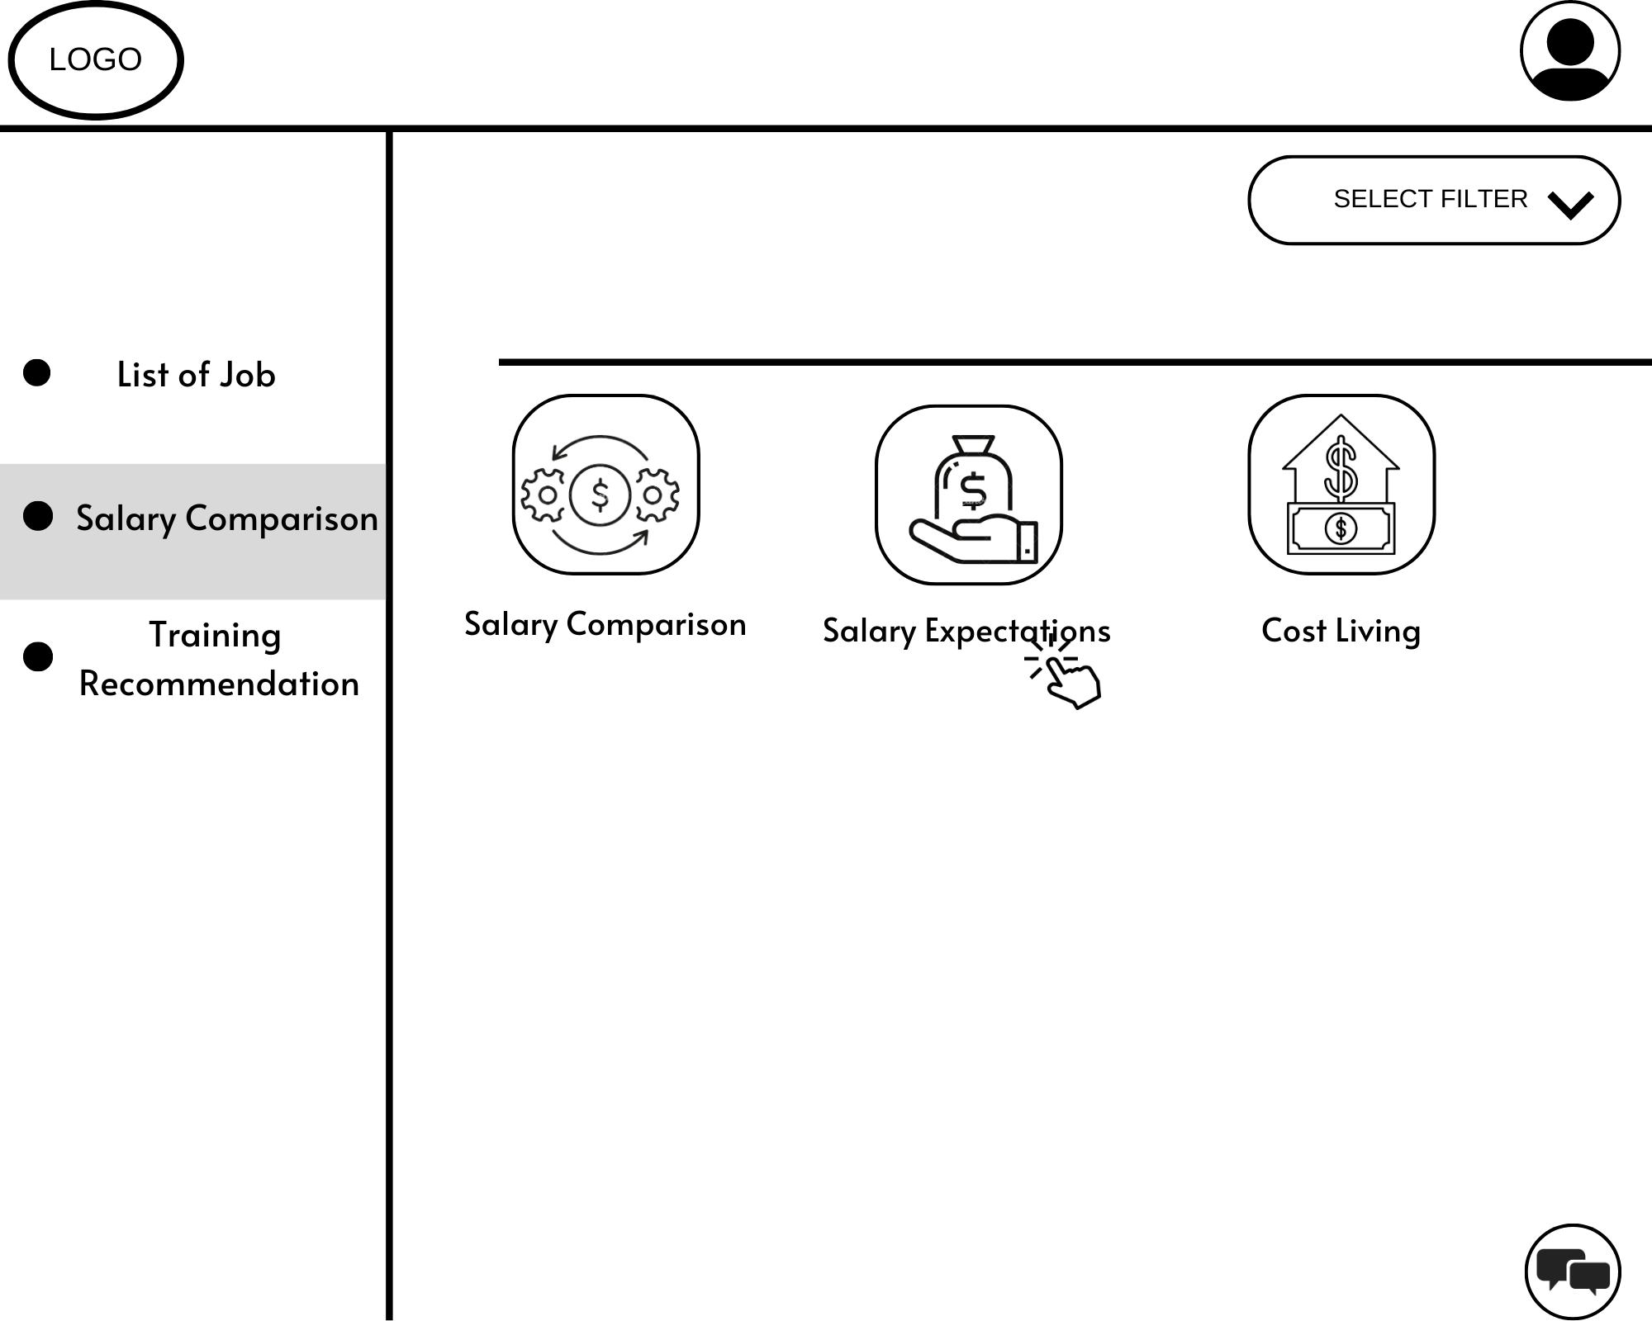

4. Student clicks salary expectations menu on the salary comparison page.

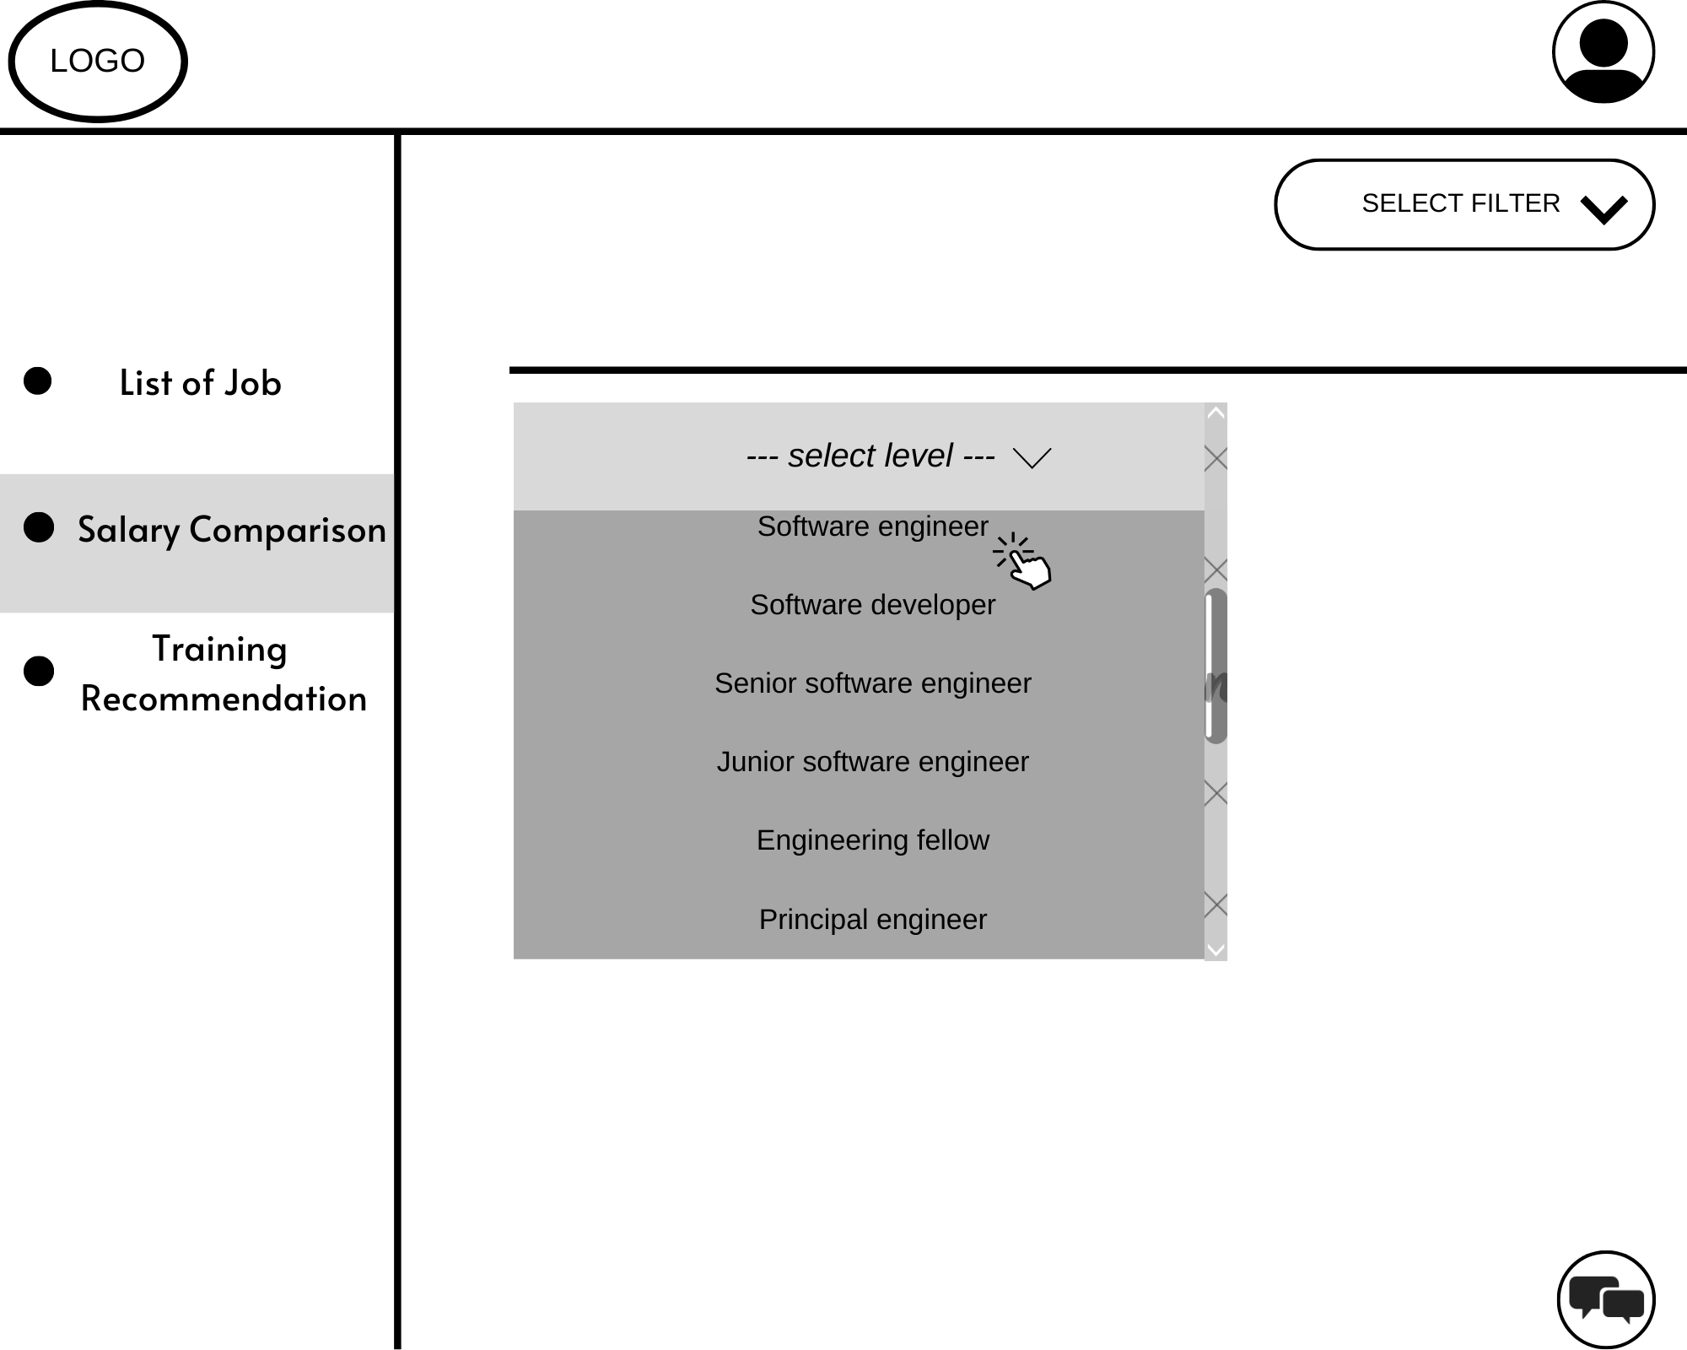

5. Student can choose level of position he/she wonder about the salary.

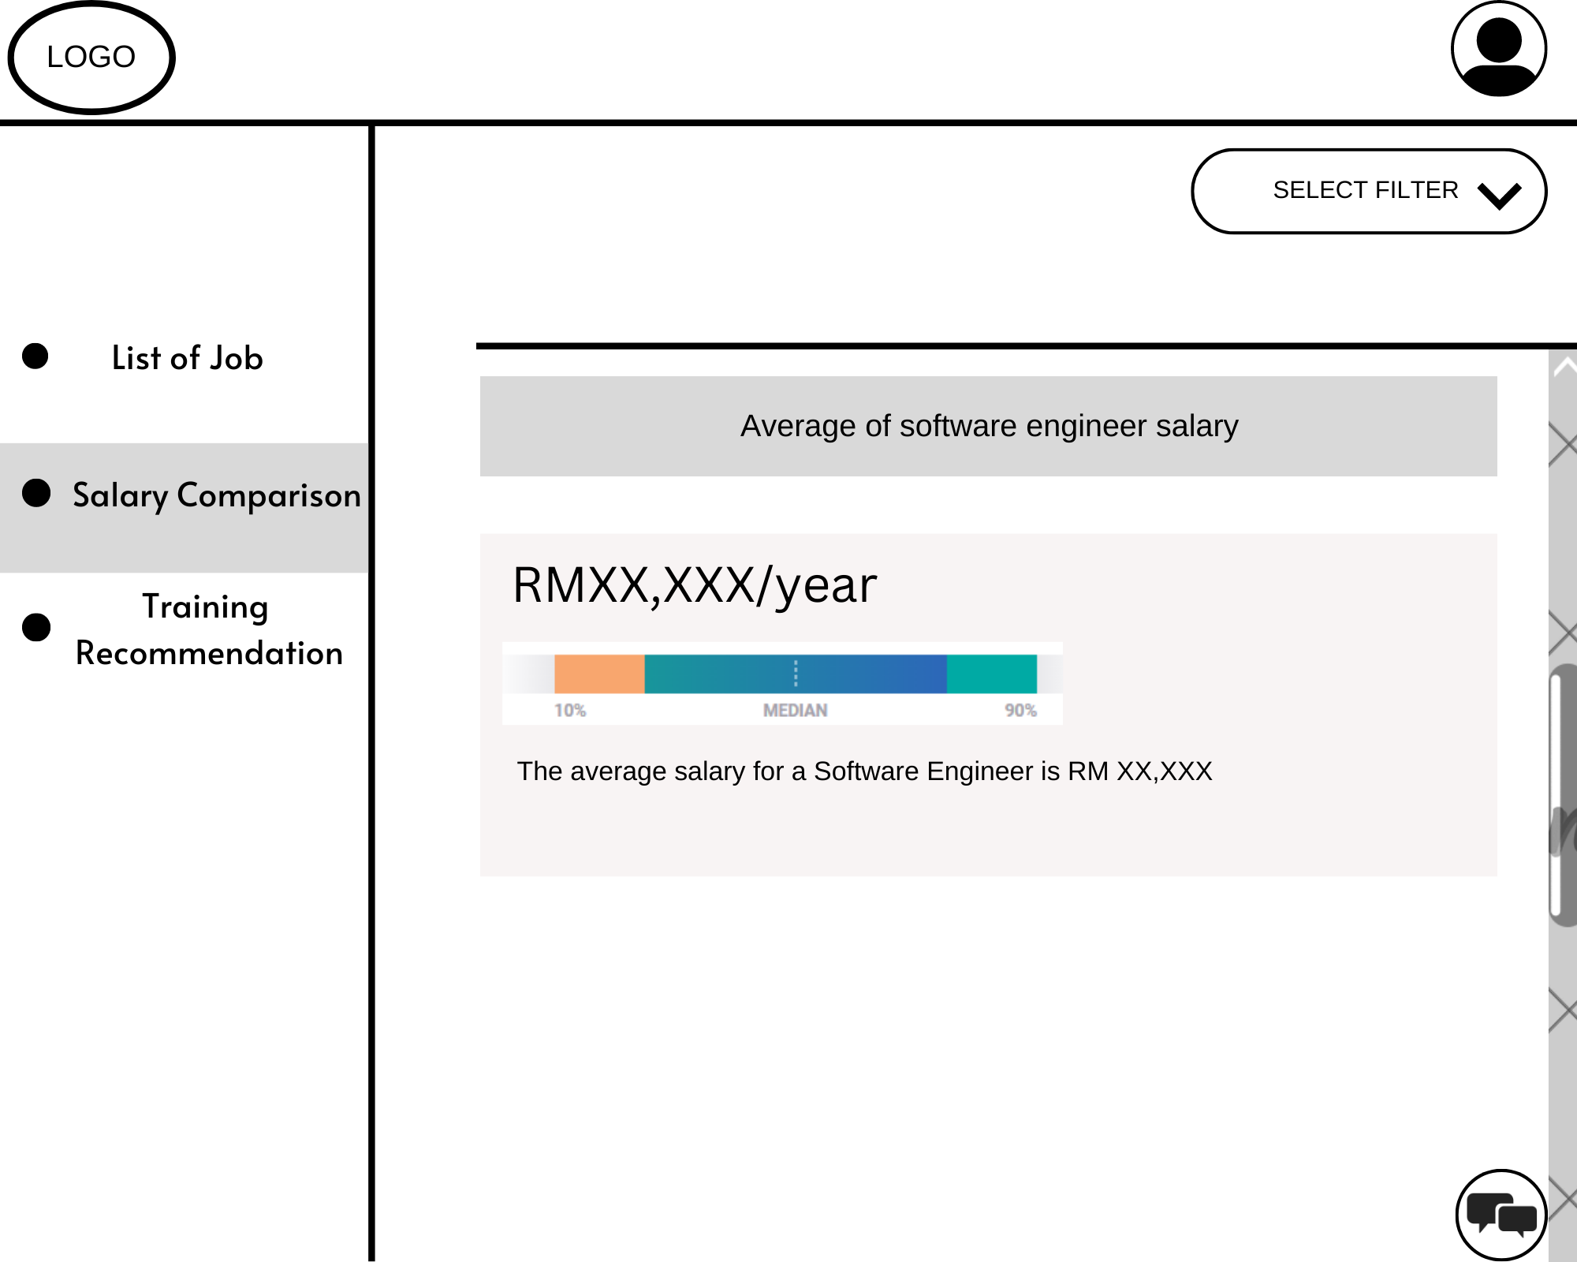

6. The system displays the average salary per year for the level student chooses.

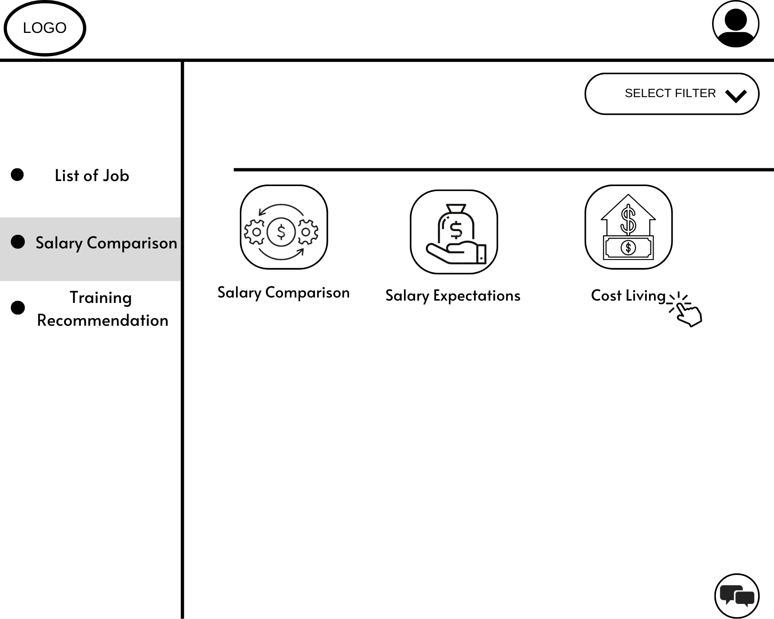

1. Student clicks on cost of living menu on salary comparison page.

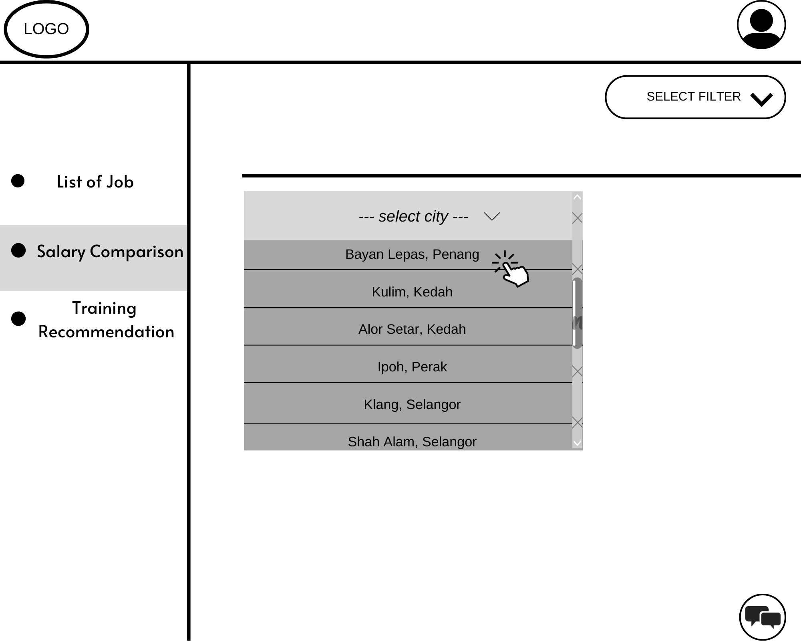

1. Student can select location they might want to see the estimated cost of living.

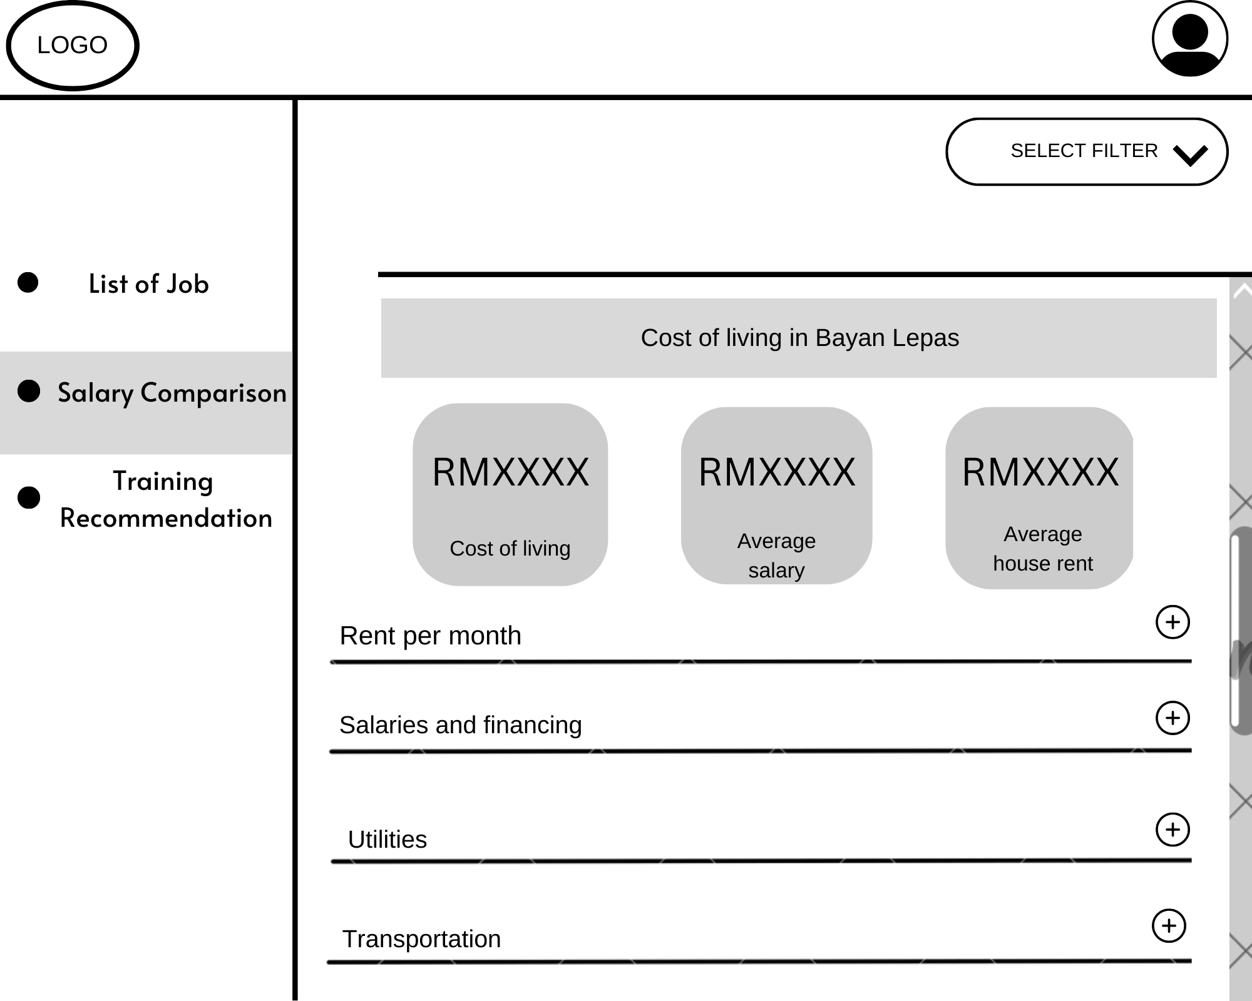

1. The system displays the cost of living with the details for each category for the chosen location.

Figure 3.2: System Storyboards for Subsystem 2

### 3.1.3 Storyboard for SE22230032 - Subsystem 03: Professional Certification and Skills Enhancement

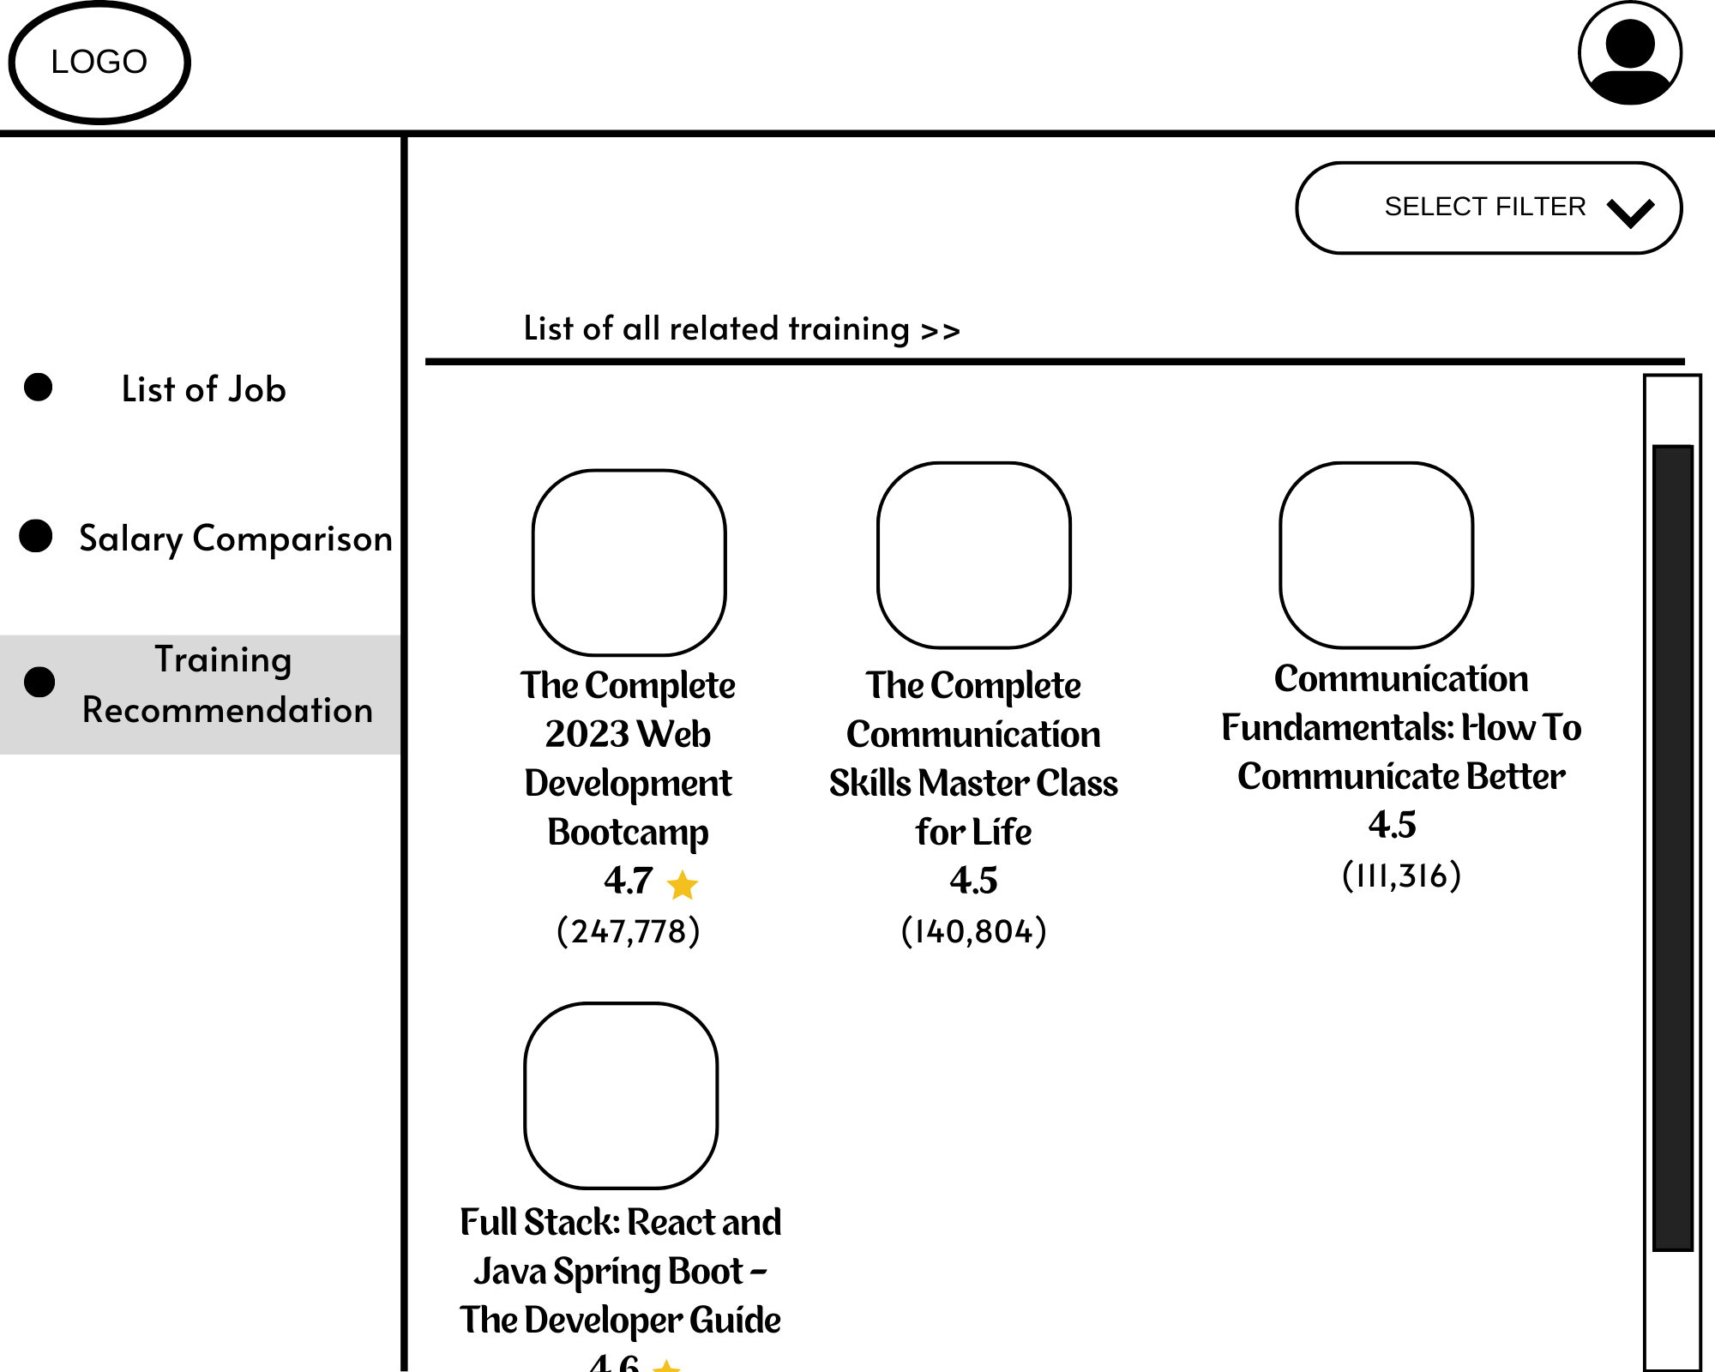

1. Students go to the Training Page and view all related training recommendations in both categories.

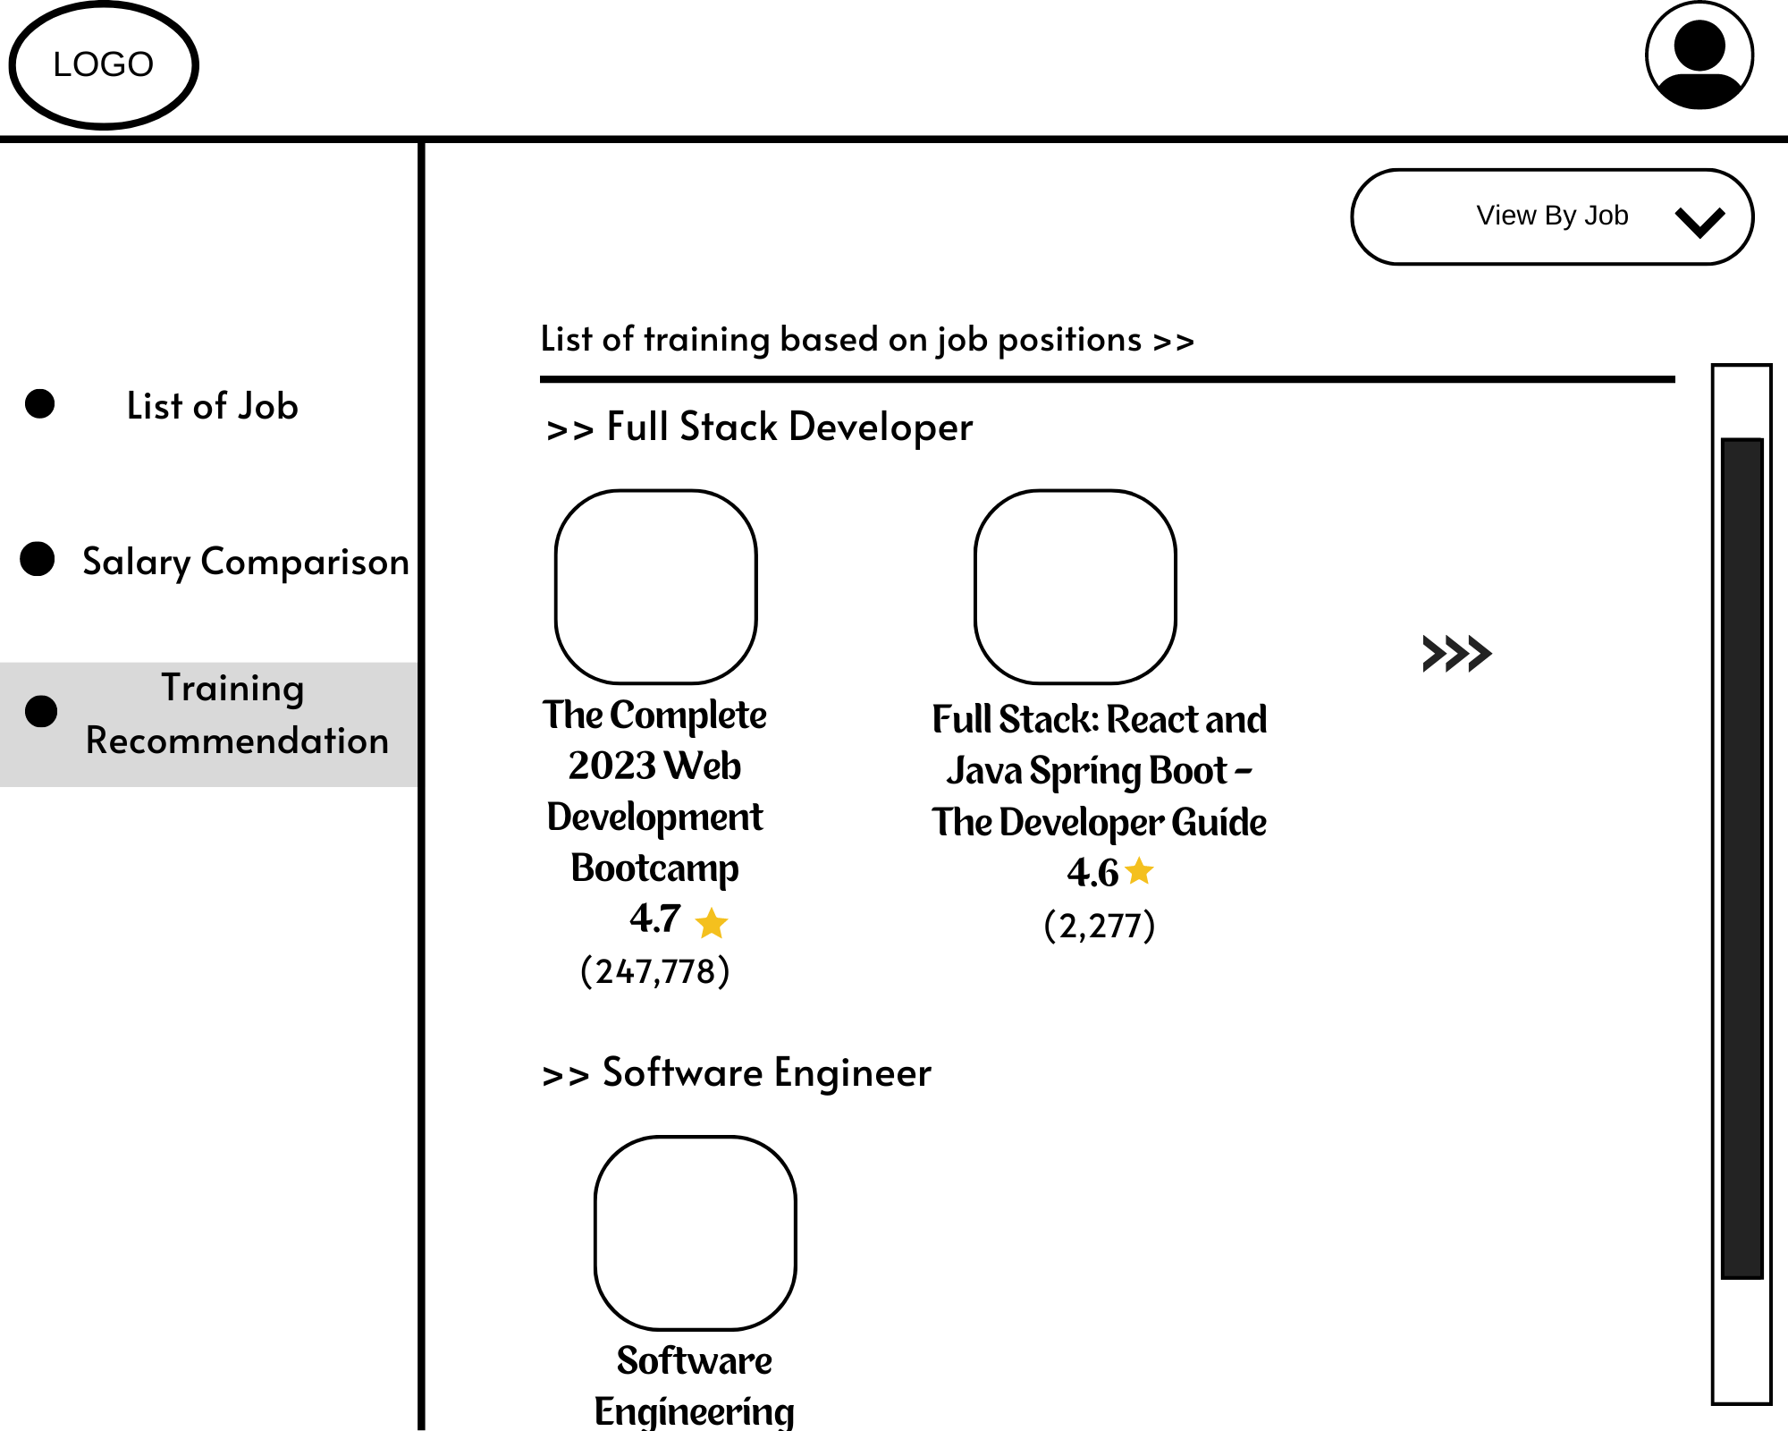

1. Students filter training category and select “View by Job”, the training based on job is displayed on the Training Recommendation Page.

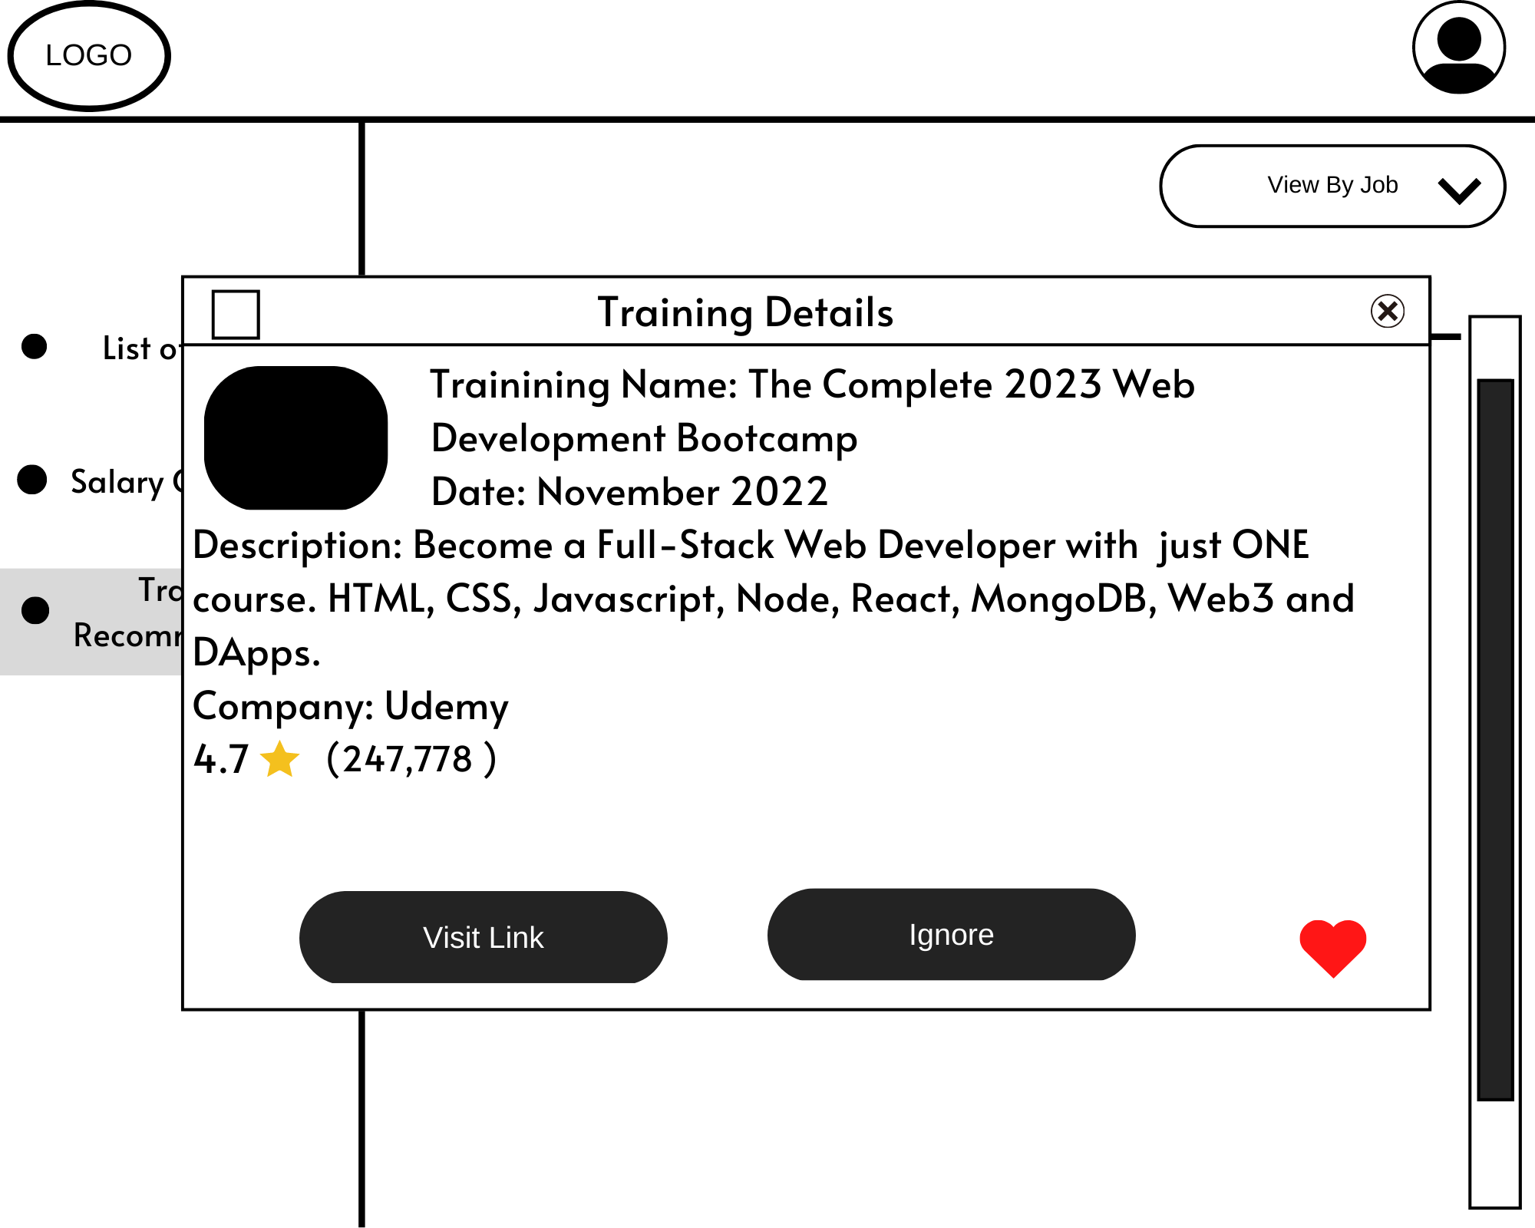

1. Students select any training to view the training details. The details are shown in the box.

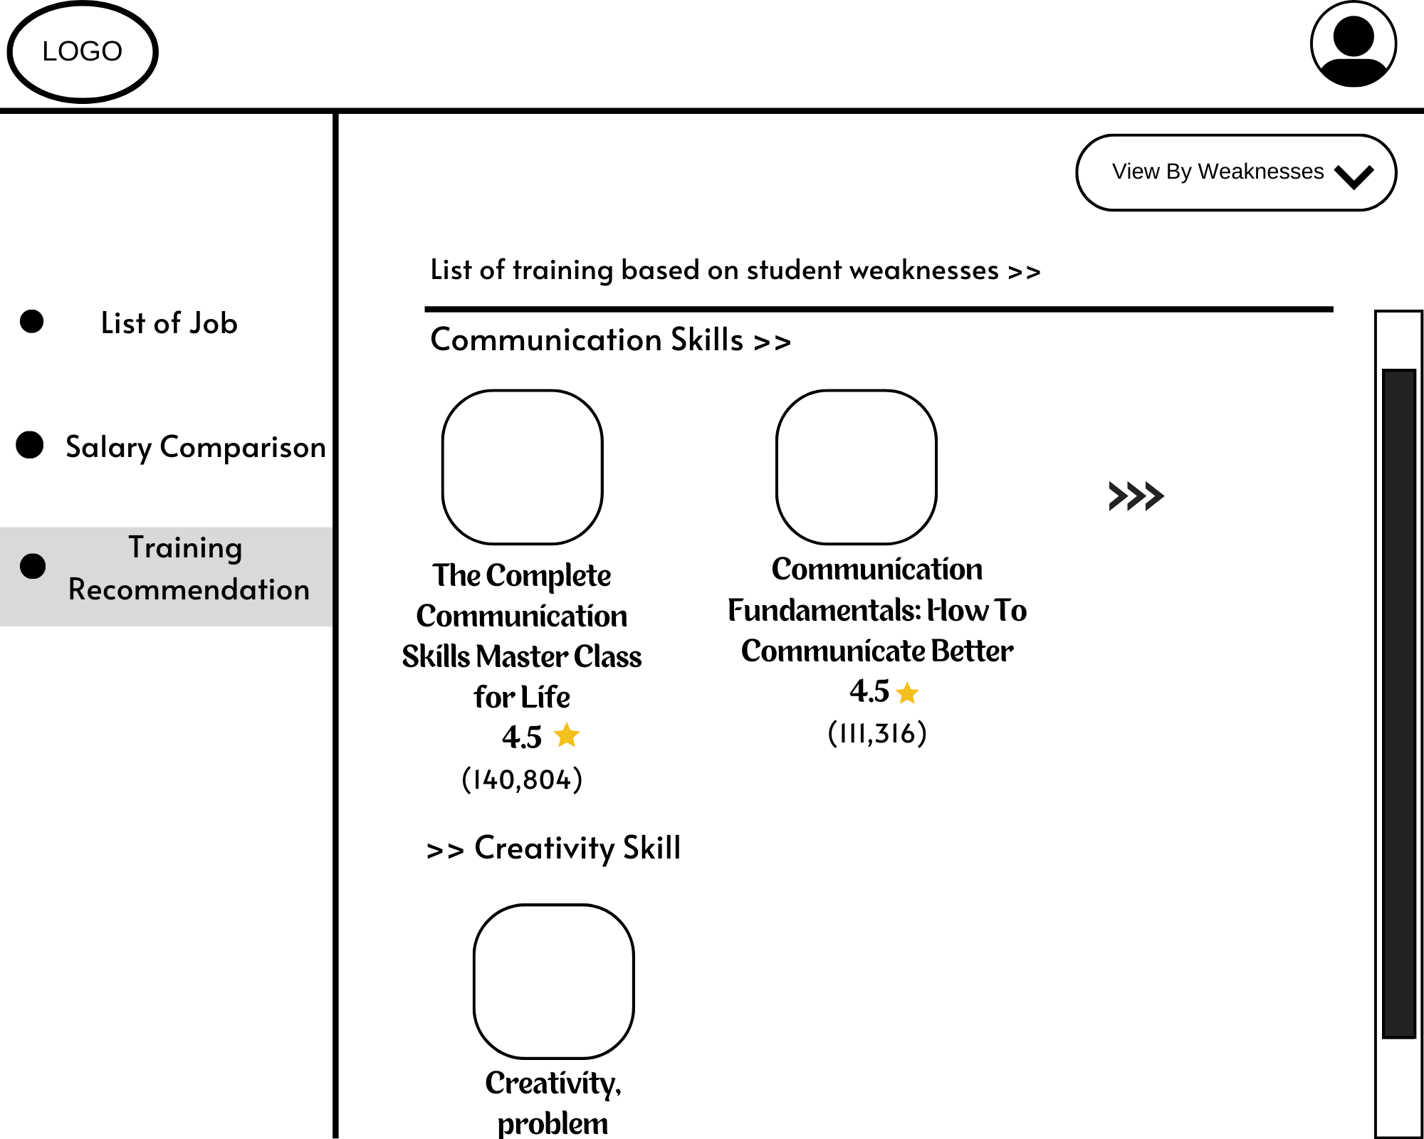

1. Students filter training category and select “View by Weaknesses”, the training based on weaknesses of their skills is displayed on the Training Recommendation Page.

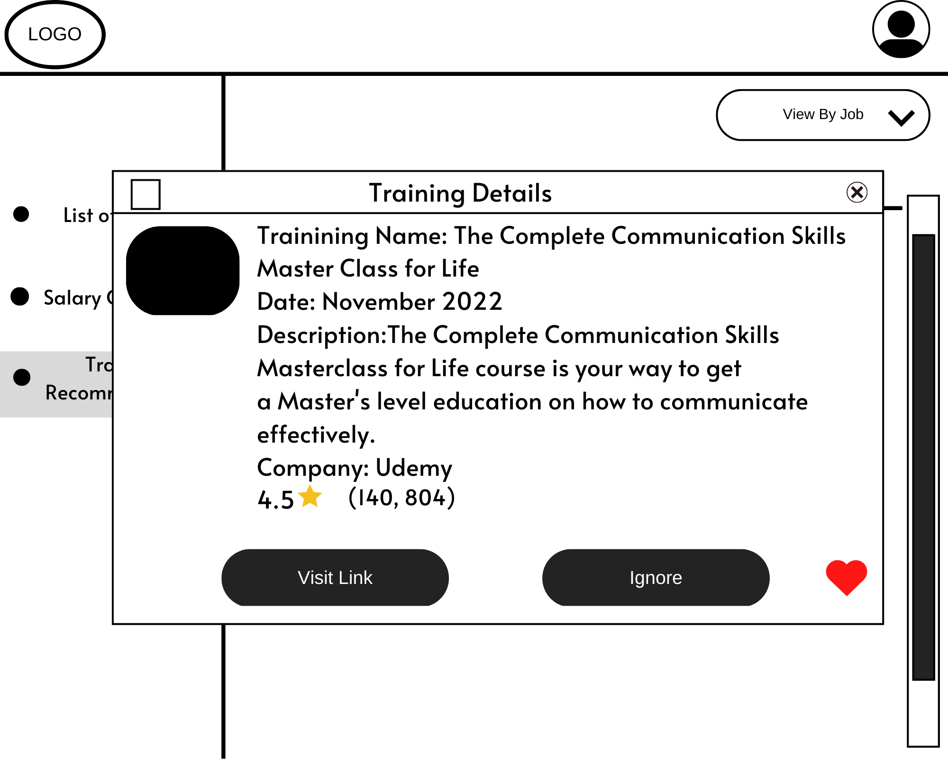

1. Students select any training to view the training details. The details are shown in the box.

**Figure 3.3: System Storyboards for Subsystem 3**

## 3.2 High Level Design

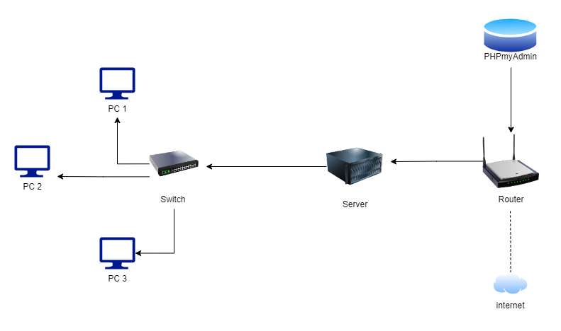

Figure 3.4: Network Diagram of NewBGradSupp Architecture

### 

### 3.2.1 System Architecture

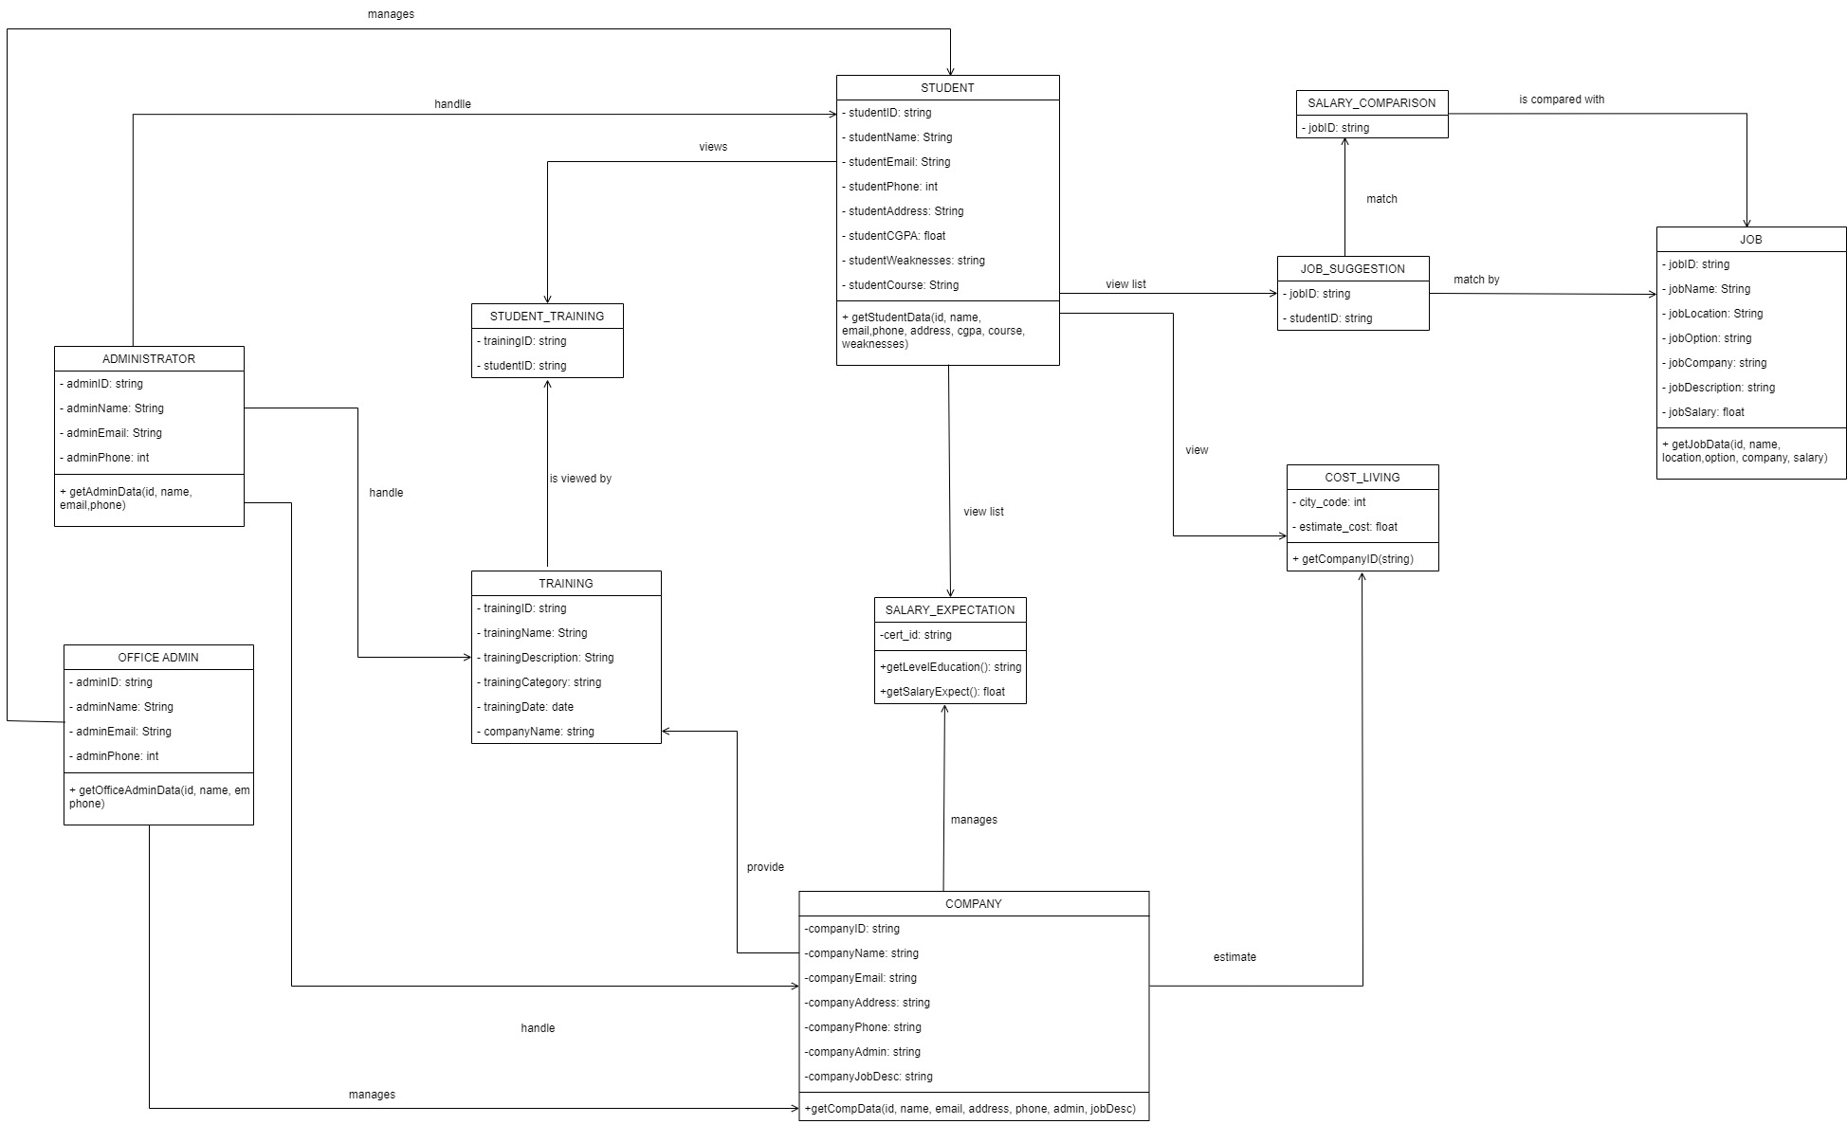

Figure 3.5: Design Class Diagram for NewBGradSupp

# 4. Software Test Plan

## 4.1 Purpose and scope

The purpose of having a test plan for the system is to introduce the standard of a quality to prevent error from the system before it can be delivered. It is also to make sure that the system follows all the requirements as it is planned during the requirement and design phase. The test will be done throughout the development process and before the product is released to the end-user. The test case will be done for functionality, usability, security and other cases that are involved in the system. For example, the registration features, user should be able to register into the system with a verification of the password for the security measure

## 4.2 Test items

Table 4.1: List of test items

|  |  |
| --- | --- |
| **Test items** | **Descriptions** |
| Login | Users log in their account using their username and password. |
| View job suggestion | Students view job suggestion after key in their details. |
| Search job | Students search for job by entering a keyword in search bar. |
| Add job to favorite | Students add the selected job to favorite and display job into dashboard. |
| View salary comparison | Students choose location and the salary comparison, and the system will display based on location. |
| View estimate cost living | Students choose city that available, and the system will display the estimation of cost living for the specific city. |
| View salary expectation | Students select level of qualification, and the system will display the expectation of salary. |
| View training suggestion | Students should be able to view all trainings and its details related to him/her which is based on the job suggestion and weaknesses of their skills. |
| Filter training | Students should be able to filter training and the training, and its details will be displayed based on selected category (based on job suggestion or based on student’s weaknesses of their skills). |
| Save selected trainings as favorites. | Students should be able to save selected training as favorite training and view all favorite trainings in the dashboard. Students should be able to save selected training as favorite training and view all favorite trainings in the dashboard. |
| Add and edit training | Company and system administrator should be able to add and edit training by inserting the details using the form and save into database. |

## 4.3 Requirements/Features to be tested

Table 4.2: List of requirements/features to be tested

|  |  |  |  |  |
| --- | --- | --- | --- | --- |
| **SE22230008 - Subsystem 01: What Job Are There?** | | | | |
| Test Case Type | Description | Test Step | Expected Result | Status |
| Security | Verify password rules are working accordingly | Create a new password in accordance with rules | The password entered should be accepted if it is following the rules | Pass or Fail |
| Functionality | Valid in email and invalid email | The email use must be correct and verified | The email enters able to receive verification link/code | Pass or Fail |
| Usability | User able to enter their keyword for the job searching | Users enter keyword | The result return must be corresponded to the keyword entered by the user | Pass or Fail |

|  |  |  |  |  |
| --- | --- | --- | --- | --- |
| **SE22230031 - Subsystem 02: Salary comparison** | | | | |
| Test Case Type | Description | Test Step | Expected Result | Status |
| Functionality | The system must display the list of job that matching user details. | Students already get the list of job matching their details and want to view the salary comparison. | Students choose location and the system only display the job within the location chosen and display the salary comparison for that location. | Pass or Fail |
| Functionality | The system must display the estimate cost of living in selected city. | Students choose city that available in the system and click search button. | The system must return the result of estimation cost of living in the area of city. | Pass or Fail |
| Usability | Students able to choose their location in the search bar. | Students choose location | The list of job display must be corresponded to the location choose by the user | Pass or Fail |
| Usability | Students able to choose their level of qualifications in the search bar. | Students choose level qualification. | The list of expected salary from different company will be displayed on the screen. | Pass or Fail |
| Usability | Button save job matching into favourite and display into main dashboard | Students click the heart shape button | The button can be clicked, and the color is changed. The selected job is saved. | Pass or Fail |
| Performance | The speed of the system loading to display output. | Students choose any features in salary comparison, estimate cost of living and salary expectation. | When user click the list of job based on location or the estimate cost of living in that area or the salary expectation details, its take only a few seconds to display on the screen. | Pass or Fail |

|  |  |  |  |  |
| --- | --- | --- | --- | --- |
| **SE22230032 - Subsystem 03: Professional Certification and Skills Enhancement** | | | | |
| Test Case Type | Description | Test Step | Expected Result | Status |
| Functionality | The system must display the training recommendation with its details | Students already get the list of job suggestion and have saved weaknesses of their skills in the system | Students get to view the training based on their weaknesses of their skills and job suggestion | Pass or Fail |
| Functionality | The system must display the training selected or filtered by students | Students click button to filter training and select the training category | The system must return the result exactly based on the training category chosen by students. | Pass or Fail |
| Usability | Students click button to filter training only once to view the training category.  Selected category will change color when students clicked or hover over it | Students click on the button and select the training category | The button can be clicked only once, and the training category will be displayed. The color also changes when students click or hover on it | Pass or Fail |
| Usability | Students can view the lists of training with its detail such as image, name, and description directly. | Students select Training Recommendation on main menu | The system will return the lists of training with its detail such as image, name, and description | Pass or Fail |
| Usability | Button save training as favorite is clickable and change its color right after students click on it | Students click the heart shape button | The button can be clicked, and the color is changed. The selected training is saved. | Pass or Fail |
| Performance | The speed of the system in loading the training recommendations | Students select Training Recommendations in main menu | The list of training and its details take only a few seconds to display on the screen. | Pass or Fail |

## 4.4 Requirements/Features not to be tested

Table 4.3: List of requirements/features not to be tested

|  |  |
| --- | --- |
| Non-functional aspect | Non-functional requirement |
| Usability | The system should have a user-friendly interface |
| Reliability | The application should be functioning all day long |
| Compatibility | This system is a web-based application, and it is not supported in mobile version |

## 4.5 Test approach/strategy

NewBGradSupp Testing Strategy outlines how project testing approach will be done. The approach considers the attributes of the system to be constructed, the project schedule and budget, and plans the breadth and depth of the testing effort. The testing strategy will have an impact on activities including test planning, test types, test script creation, and test execution. The objectives of testing strategy are to determine the type of tests needed for each testing task, determine if a systems integration test is necessary by identifying the important system interfaces, and establish the conditions for performance assurance.

Table 4.4: Test approach and levels of testing

|  |  |  |  |
| --- | --- | --- | --- |
| **Testing Type** | **Objective** | **Method/ techniques** | **Levels of Testing** |
| Usability testing | Check the system user interface to see whether it is easy to use. | Black Box | User Acceptance Testing |
| Security testing | Ensure that data in the system is being protected | White Box | System Testing |
| Use case testing | Look into the path used by the user functioning as expected | Black Box | User Acceptance Testing  System Testing  Integration Testing |
| Functional testing | Test the software functionality | Black Box | User Acceptance Testing  System Testing |
| Performance testing | Testing the speed, response time, stability of software under certain amount of workloads | Black Box | Any level |
| Exploratory testing | Testing the user experience validations | Ad hoc | User Acceptance Testing  System Testing |

## 4.6 Item pass/fail criteria

**SE22230008 - Subsystem 01: What Job Are There?**

Table 4.5: List of item pass/fail criteria

|  |  |
| --- | --- |
| **Testing Title** | **Item pass/ fail criteria** |
| Search for job | Student should be able to search for the job based on keywords entered. The system should be able to display job listing suggestions based on the keyword match in the database. |
| View Job | Student should be able to click on the job title hyperlink. The system should display the job description page. |
| Add to favorite | Student should be able to click on the add button. The system will store the information in the database. |

**SE22230031 - Subsystem 02: Salary comparison**

|  |  |
| --- | --- |
| **Testing Title** | **Item pass/ fail criteria** |
| Salary comparison | Students should be able to view salary comparison based on location they had chosen from the list of job suggestion available. |
| Estimate cost living | Students should be able to view the estimation of cost living for the certain location that they had chosen. |
| Salary expectation | Students should be able to view the salary expectation based on the level of qualification they had entered at the search bar. |

**SE22230032 - Subsystem 03: Professional Certification and Skills Enhancement**

|  |  |
| --- | --- |
| **Testing Title** | **Item pass/ fail criteria** |
| Training Recommendation – View all trainings | Students should be able to view all trainings and its details related to him/her which is based on the job suggestion and weaknesses of their skills. |
| Training Recommendation – Filter training | Students should be able to filter training and the training, and its details will be displayed based on selected category (based on job suggestion or based on student’s weaknesses of their skills). |
| Training Recommendation – Save selected trainings as favorites. | Students should be able to save selected training as favorite training and view all favorite trainings in the dashboard. |
| Training Recommendation – Add and edit training | Company and system administrator should be able to add and edit training by inserting the details using the form and save into database. |

# REFERENCES

Al-Abri, N., & Kooli, C. (2018). Factors Affecting the Career Path Choice of Graduates: A Case of Omani. *International Journal of Youth Economy*, *2*(2), 105–117. <https://doi.org/10.18576/ijye/020203>

Biscobing, J. (2019, September 11). *What is entity relationship diagram (ERD)?: Definition from TechTarget*. Data Management. Retrieved January 5, 2023, from <https://www.techtarget.com/searchdatamanagement/definition/entity-relationship-diagram-ERD>

D.MhamdiEnvelope, R.Moulouki, Ghoumari, M. Y. E., M.Azzouazi, L.Moussaid, & AbstractThis article presents a recommender system that aims to help job seekers to find suitable jobs. First. (2020, August 6). *Job recommendation based on job profile clustering and job seeker behavior*. Procedia Computer Science. Retrieved January 5, 2023, from <https://www.sciencedirect.com/science/article/pii/S1877050920318020>

Editor. (2020, February 27). *Quality Assurance, quality control and testing - the basics of software quality management*. AltexSoft. Retrieved January 5, 2023, from <https://www.altexsoft.com/whitepapers/quality-assurance-quality-control-and-testing-the-basics-of-software-quality-management/>

F.O.IsinkayeaPersonEnvelope, a, Y.O.Folajimib, b, B.A.Ojokohc, c, & Internet, A. O. the. (2015, August 20). *Recommendation systems: Principles, methods and evaluation*. Egyptian Informatics Journal. Retrieved January 5, 2023, from <https://www.sciencedirect.com/science/article/pii/S1110866515000341>

*Goal 8 | Department of Economic and Social Affairs*. (2022). Un.org. <https://sdgs.un.org/goals/goal8>

Li, J., & Ye, Z. (2020, December 28). *Course recommendations in online education based on collaborative filtering recommendation algorithm*. Complexity. Retrieved January 5, 2023, from <https://www.hindawi.com/journals/complexity/2020/6619249/>

*Machine learning in recommendation systems: An overview*. Machine Learning in Recommendation Systems: an Overview. (n.d.). Retrieved January 5, 2023, from <https://www.itransition.com/machine-learning/recommendation-systems>

Mohammad, H. (2015, November 18). *Implementation of a training courses recommender system based on K-means algorithm*. Academia.edu. Retrieved January 5, 2023, from <https://www.academia.edu/18622940/Implementation_of_a_Training_Courses_Recommender_System_based_on_k_means_algorithm>

Nur Idayu Badrolhisam, Achim, N., & Nurfitriah Zulkipli. (2019). EMPLOYEE CAREER DECISION MAKING: THE INFLUENCE OF SALARY AND BENEFITS, WORK ENVIRONMENT AND JOB SECURITY. *Journal of Academia*, *7*, 41–50. <https://myjms.mohe.gov.my/index.php/joa/article/view/8250>

Predicting career adaptability of fresh graduates through personal factors | Emerald Insight. (2020). *European Journal of Training and Development*, *46*(3/4), 302–316. [https://doi.org/10.1108\/EJTD](https://doi.org/10.1108/EJTD)

*Recommendation system to improve students performance using machine ...* (n.d.). Retrieved January 5, 2023, from <https://www.researchgate.net/publication/342502156_Recommendation_system_to_improve_students_performance_using_machine_learning>

*Role of UML class diagram in object-oriented software development*. (n.d.). Retrieved January 5, 2023, from <https://www.researchgate.net/publication/220625913_Role_of_UML_Class_Diagram_in_Object-Oriented_Software_Development>

*Unified modeling language (UML): An introduction*. GeeksforGeeks. (2022, December 15). Retrieved January 8, 2023, from <https://www.geeksforgeeks.org/unified-modeling-language-uml-introduction/>

Visual Paradigm. (2022). Type of actor in use case model. Retrieve January 1, 2023, from <https://www.visual-paradigm.com/guide/uml-unified-modeling-language/types-of-actor-in-use-case-model/>

# APPENDICES

APPENDIX 1

**Use-case Description**

1. “Login” use-case

|  |  |  |
| --- | --- | --- |
| **Use Case Name:** | Login | |
| **Scenario:** | User logins into the system | |
| **Event Trigger:** | User logins into the system website | |
| **Description:** | User login into the system using their identity to use the system. | |
| **Actors:** | Student/Fresh graduate/Office admin/Company admin/Administrator | |
| **Related Use Case:** | Extend: Edit Profile  Extend: View Profile | |
| **Stakeholders:** | Office admin/Administrator | |
| **Preconditions:** | User has an existing account in the system. | |
| **Postconditions:** | User successfully login into the system. | |
| **Normal/**  **Alternate Flow:** | Actor | System |
|  | 1. User enters the system. 2. User enter their credentials. 3. User confirms their information. | 1. Website system prompts login form. 2. Server validates token with credentials. 3. Prompt notification upon successful login. |
| **Exception** | Invalid input of credentials. | |

1. “Edit Profile” use-case

|  |  |  |
| --- | --- | --- |
| **Use Case Name** | Edit Profile | |
| **Scenario** | User enters the profile screen to view profile | |
| **Event Trigger** | User clicks on the edit profile button. | |
| **Description** | User can edit their profile on the system | |
| **Actor:** |  | |
| **Related Use-cases:** | Extend: View Profile | |
| **Stakeholders** | Office Admin | |
| **Preconditions** | User has an existing account in the system. | |
| **Postconditions** | User successfully edit their profile | |
| **Normal/**  **Alternate Flow:** | Actor | System |
|  | 1. Users press the edit profile button. | 1. System update user information. |
| **Exception** |  | |

1. “View Profile” use-case

|  |  |  |
| --- | --- | --- |
| **Use Case Name:** | View Profile | |
| **Scenario:** | User enters the profile screen to view profile | |
| **Event Trigger:** | User clicks on profile button. | |
| **Description:** | User can view their profile on the map | |
| **Actors:** | Student/Fresh graduate/Office admin/Company admin/Administrator | |
| **Related Use Case:** | Extend: Edit Profile | |
| **Stakeholders** | Office Admin | |
| **Preconditions:** | User has an existing account in the system. | |
| **Postconditions:** | User successfully view their profile | |
| **Normal/Alternate Flow:** | Actor | System |
|  | 1. Users press the profile button. | 1. Display user profile. |
| **Exception:** | Invalid input of credentials. | |

1. “Manage Student Data” use-case

|  |  |  |
| --- | --- | --- |
| **Use Case Name:** | Manage Student Data | |
| **Scenario:** | The office admin wants to delete the student account that does not exist. | |
| **Event Trigger:** | Admin clicks the delete button on the student account. | |
| **Description:** | Admin can add, update and delete the student account. | |
| **Actors:** | Office admin | |
| **Related Use Case:** | None | |
| **Stakeholders** | Office Admin | |
| **Preconditions:** | Office admin must have the authorities to perform such process (add/update/delete) in the system. | |
| **Postconditions:** | Office admin able to perform the process (add/update/delete) on student account | |
| **Normal/Alternate Flow:** | Actor | System |
|  | 1. Office admin login into account.  2. Office admin deletes non-existing student accounts. | 1. The system verifies office admin identification.  2. The system allows office admin to perform tasks. |
| **Exception:** | Invalid input of credentials. | |

1. “Manage Company Data” use-case

|  |  |  |
| --- | --- | --- |
| **Use Case Name:** | Manage Company Data | |
| **Scenario:** | The office admin wants to add a new company that wants to contribute to the system. | |
| **Event Trigger:** | Admin clicks the add new button on the company. | |
| **Description:** | Admin can add, update and delete the company. | |
| **Actors:** | Office admin | |
| **Related Use Case:** | Extend: Generate Report | |
| **Stakeholders** | Office Admin | |
| **Preconditions:** | Office admin must have the authorities to perform such process (add/update/delete) in the system. | |
| **Postconditions:** | Office admin able to perform the task. | |
| **Normal/Alternate Flow:** | Actor | System |
|  | 1. Office admin login into account.  2. Office admin click add new company button. | 1. The system verifies office admin identification.  2. The system allows office admin to perform tasks. |
| **Exception:** | Invalid input of credentials. | |

1. “Generate Report” use-case

|  |  |  |
| --- | --- | --- |
| **Use Case Name:** | Generate Report | |
| **Scenario:** | Office admins want to generate a report for an audit session. | |
| **Event Trigger:** | Office admins click on generate report section. | |
| **Description:** | Office admins click on generate report section. | |
| **Actors:** | Office admin | |
| **Related Use Case:** | None | |
| **Stakeholders** | Office Admin | |
| **Preconditions:** | Office admin must have the authorities to perform such process (add/update/delete) in the system. | |
| **Postconditions:** | Office admin able to perform the task. | |
| **Normal/Alternate Flow:** | Actor | System |
|  | 1. Office admin login into account. | 1. The system verifies office admin identification. |
| **Exception:** | Invalid input of credentials. | |

### Use-Case: Provide Training: Company adds, and edit training details

|  |  |  |
| --- | --- | --- |
| **Use Case Name:** | Provide Training | |
| **Scenario:** | Company adds and edit training details | |
| **Triggering Event:** | Company adds and edits training details in respective form | |
| **Brief Description:** | Company can add and edit training details by clicking “add” or “edit” button. | |
| **Actors:** | Company | |
| **Related Use Cases:** | None | |
| **Stakeholders:** | Admin department: Create add and edit training details form  Company department: Save added or edited training details | |
| **Preconditions:** | Company must open the form first | |
| **Postconditions:** | The required training details that need to be filled in appear and can be added and edited. | |
| **Normal/Alternate Flow:** | **Actor** | **System** |
|  | 1. Company goes to add or edit training details page 2. Company fills in the form | 1.1 Navigates to add or edit training details page.   * 1. Display add or edit training details form   2. Save the training details entered by company |
| **Exception Flow:** | * 1. If the training details entered by company do not align with the validation, company is prompted the error message. | |

### Use-Case: Add job offered: Company adds, delete, and update jobs

|  |  |  |
| --- | --- | --- |
| **Use Case Name:** | Add job offered | |
| **Scenario:** | Company adds, delete, and update jobs | |
| **Triggering Event:** | Company adds, delete, and update job in the form | |
| **Brief Description:** | Company can add and edit training details by clicking “add”, “delete” or “update” button. | |
| **Actors:** | Company | |
| **Related Use Cases:** | Extend: Update Job  Extend: Delete Job  Extend: Add New Job | |
| **Stakeholders:** | Admin department: Create form for job details  Company department: Save job details | |
| **Preconditions:** | Company must open the form first | |
| **Postconditions:** | The required job details that need to be filled in appear and can be added, deleted, and updated. | |
| **Normal/Alternate Flow:** | **Actor** | **System** |
|  | 1. Company goes to add, delete, or update job details page 2. Company fills in the form | 1.1 Navigates them to the page where the job details can be updated, added, and deleted.   * 1. Display adds or update job details form   2. Save the job details entered by company. |
| **Exception Flow:** | * 1. If the job details entered by company do not align with the validation, company is prompted the error message. | |

APPENDIX 2

**Sequence Diagram**

1. Sequence Diagram for login scenarios

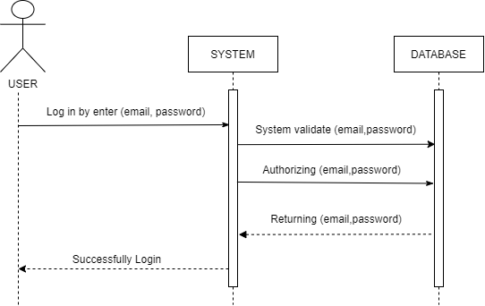

1. Sequence diagram for view profile and edit profile

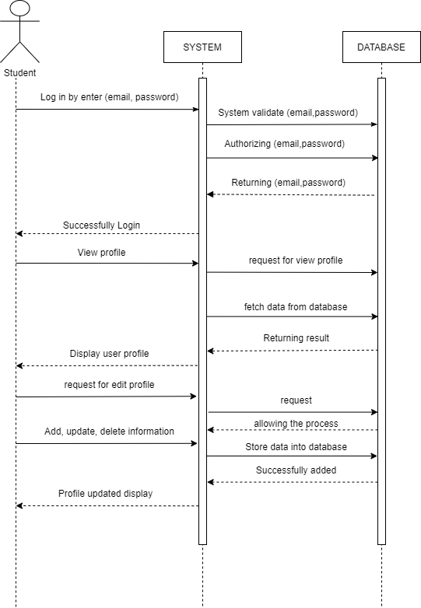

1. Sequence diagram for manage student, company admin and generate report

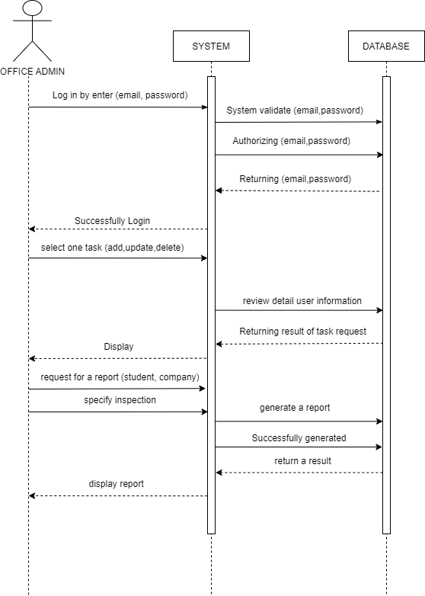

1. Sequence diagram for company admin add, update and delete job.

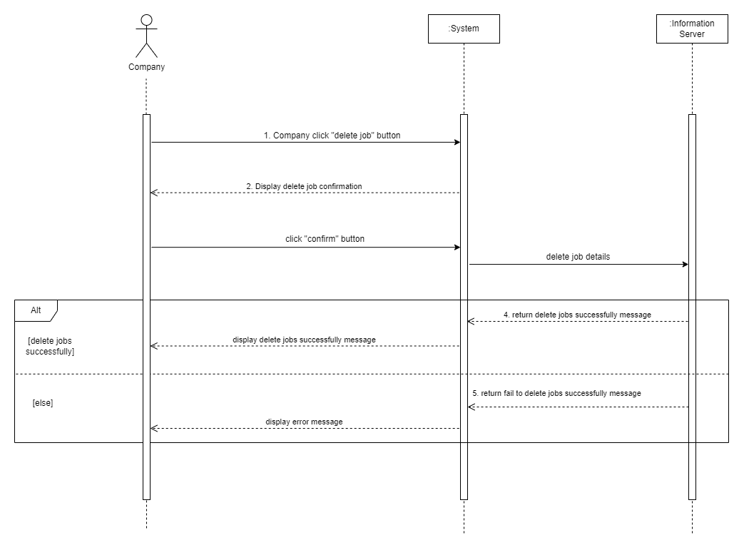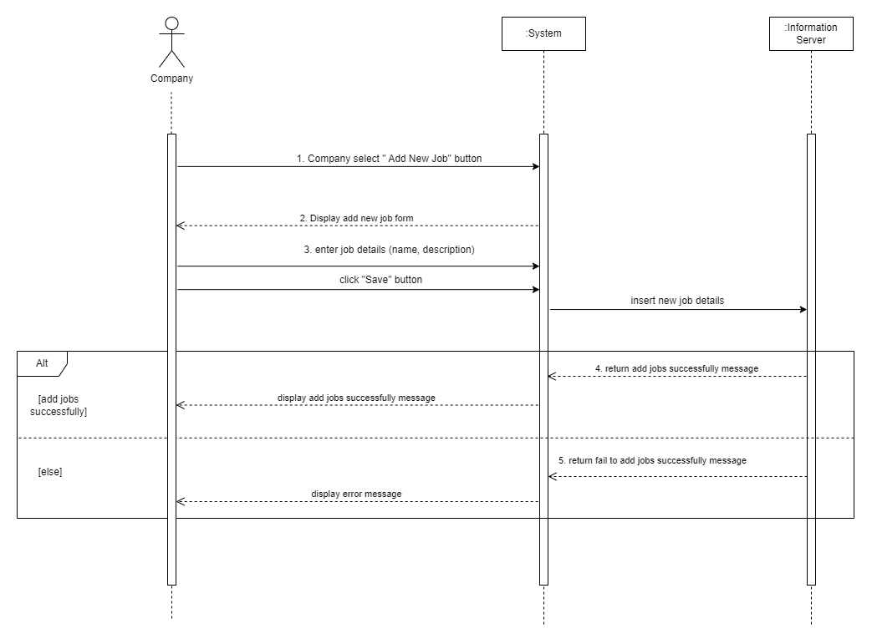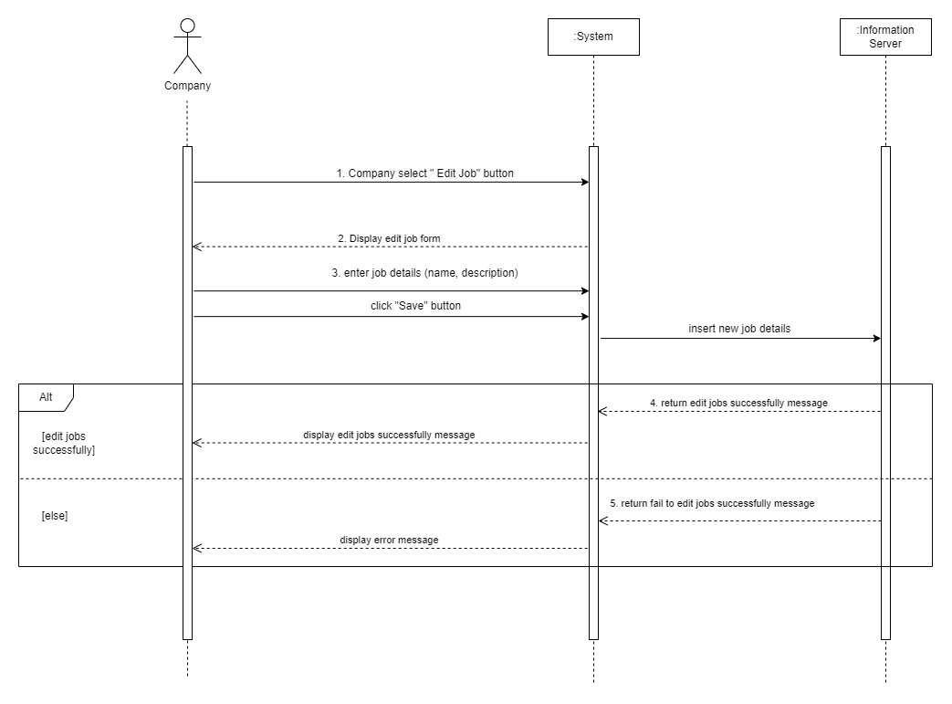

APPENDIX 3

